**MINISTRY OF EDUCATION AND TRAINING**

**FPT UNIVERSITY**

Capstone Project Document

Equipment’s Classroom Management

|  |  |
| --- | --- |
| Group 10 | |
| **Group member** | Tran Vinh Quang – SE61078  Tang Viet Hung – SE61019  Doan Nguyen Minh Chi – SE60717 |
| **Supervisor** | Kieu Trong Khanh |
| **Ext. Supervisor** | N/A |
| **Capstone Project Code** | ECRM |

-Ho Chi Minh City, May 11, 2015-

Table of Contents

Table of Contents 3

**List of Tables** 12

List of Figures 13

Definitions, Acronyms and Abbreviations 14

**A.** **Introduction** 15

**1.** **Project Information** 15

**2.** **Introduction** 15

**3.** **Current Situation** 15

**4.** **Problem Definition** 15

**5.** **Proposed Solution** 15

**5.1.** **Feature Function** 16

**5.2.** **Advantages and disadvantages** 17

**6.** **Functional Requirement** 17

**6.1.** **Equipment Management** 17

**6.2.** **Notification** 17

**6.3.** **Room Type Management** 17

**6.4.** **Classroom Management** 17

**6.5.** **Damaged Analysis And Recommendations** 18

**6.6.** **Suggest Available Classroom** 18

**6.7.** **Manage Account** 18

**6.8.** **Manage Equipment Category** 18

**6.9.** **Tracking Schedule** 18

**7.** **Role and Responsibility** 18

**B.** **Software Project Management Plan** 19

**1.** **Problem Definition** 19

**1.1.** **Name of this Capstone Project** 19

**1.2.** **Problem Abstract** 19

**1.3.** **Project Overview** 19

**1.3.1.** **Current Situation** 19

**1.3.2.** **The proposed system** 19

**1.3.2.1.** **Website application** 19

**1.3.2.2.** **Mobile application for teacher (ECRM Teacher)** 20

**1.3.2.3.** **Mobile application for staff (ECRM Staff)** 20

**1.3.3.** **Boundaries of the System** 21

**1.3.4.** **Development Environment** 21

**1.3.4.1.** **Hardware requirements** 21

**1.3.4.2.** **Software requirements** 21

**2.** **Project organization** 21

**2.1.** **Software Process Model** 21

**2.2.** **Roles and responsibilities** 22

**2.3.** **Tools and Techniques** 23

**3.** **Project Management Plan** 23

**3.1.** **Software development life cycle** 23

**3.2.** **Phase Detail** 25

**3.2.1.** **Phase 1: Room Type Management.** 25

**3.2.2.** **Phase 2: Classroom Management.** 26

**3.2.3.** **Phase 3: Equipment Management.** 26

**3.2.4.** **Phase 4: Account Management.** 27

**3.2.5.** **Phase 5: Tracking Schedule.** 28

**3.2.6.** **Phase 6: Report Management** 29

**3.2.7.** **Phase 7: Web Service** 29

**3.2.8.** **Phase 8: Android Application** 30

**3.3.** **All Meeting Minutes** 31

**4.** **Coding Convention** 31

**C.** **Software Requirement Specification** 32

**1.** **User Requirement Specification** 32

**1.1.** **Guest Requirement** 32

**1.2.** **User Requirement** 32

**1.3.** **Staff Requirement** 32

**1.4.** **Administrator Requirement** 33

**1.5.** **Authorize User Requirement** 33

**2.** **System Requirement Specification** 33

**2.1.** **External Interface Requirement** 33

**2.1.1.** **User Interface** 33

**2.1.2.** **Hardware Interface** 33

**2.1.3.** **Software Interface** 33

**2.1.4.** **Communication Protocol** 33

**2.2.** **System Overview Use Case** 33

**2.3.** **List of Use Case** 34

**2.3.1.** **<Guest> Overview Use Case** 34

**2.3.2.** **<Guest> Login** 35

2.3.3. <User> Overview Use Case 37

2.3.4. <User> View Report History 37

2.3.5. <User> View Room Map 39

2.3.6. <User> Create Report 41

**2.3.7.** **<User> Delete Report** 43

**2.3.8.** **<User> Edit Report** 45

2.3.9. <Staff> Use Case Overview 47

2.3.10. <Staff> Create New Room Type 48

2.3.11. <Staff> Update Room Type 51

2.3.12. <Staff> Remove Room Type 53

2.3.13. <Staff> Create Classroom 54

2.3.14. <Staff> Update Classroom 57

2.3.15. <Staff> Remove Classroom 59

2.3.16. <Staff> Resolve Report 60

2.3.18. <Staff> View Statistic 64

2.3.19. <Staff> Mapping Schedule Manual 65

2.3.20. <Staff> Mapping Schedule Import File 67

**2.3.21.** **<Staff> Create Equipment** 69

**2.3.22.** **<Staff> Remove Equipment** 71

**2.3.23.** **<Staff> Update Equipment** 72

**2.3.24.** **<Staff> Create Equipment Category** 74

**2.3.25.** **<Staff> Remove Equipment Category** 75

**2.3.26.** **<Staff> Update Equipment Category** 77

**2.3.27.** **<Staff> Changing Room** 78

**2.3.28.** **<Staff> Schedule Configuration** 80

**2.3.29.** **<Authorized Account> Use case overview** 82

2.3.30. <Authorized Account> Logout 82

2.3.31. <Authorized Account> Change Password 84

**2.3.32.** **<Administrator> Use case Overview** 86

**2.3.33.** **< Administrator> Add Account** 86

2.3.34. <Administrator> Activate/Deactivate Account 88

2.3.35. <Administrator> Update Account 89

**2.3.36.** **<Administrator> Remove Account** 91

**2.3.37.** **<System> Use case Overview** 93

**2.3.38.** **<System> Send SMS** 93

**2.3.39.** **<System> Suggest Available Room** 95

**2.3.40.** **<System> Notify about damaged** 96

**2.3.41.** **<System> Notify About Change Room** 97

3. Software System Attribute 98

**3.1.** **Usability** 98

**3.1.1.** **Graphic User Interface** 98

**3.1.2.** **Usability** 98

**3.1.3.** **Installation** 99

**3.2.** **Reliability** 99

**3.3.** **Availability** 99

**3.4.** **Security** 99

**3.5.** **Maintainability** 99

**3.6.** **Portability** 99

**3.7.** **Performance** 99

**4.** **Conceptual Diagram** 99

**D.** **Software Design Description** 101

**1.** **Design Overview** 101

**2.** **System Architecture Design** 101

**2.1.** **Web Application architecture description** 102

**2.2.** **Mobile Application architecture description** 103

**3.** **Component Diagram** 103

**4.** **Detail Description** 104

**4.1.** **Class Diagram** 104

**4.2.** **Class Diagram Explanation** 105

**4.2.1.** **User** 105

**4.2.2.** **Role** 106

**4.2.3.** **UserProfile** 106

**4.2.4.** **Schedule** 106

**4.2.5.** **Classroom** 107

**4.2.6.** **RoomType** 107

**4.2.7.** **EquipmentQuantity** 108

**4.2.8.** **EquipmentCategory** 109

**4.2.9.** **Equipment** 109

**4.2.10.** **ReportDetail** 110

**4.2.11.** **Report** 110

**4.2.12.** **Message** 111

**4.3.** **Interactive Diagram** 111

**4.3.1.** **Web Application** 111

**4.3.1.1.** **Staff** 111

**4.3.1.1.1.** **<Staff> Create Room Type** 111

**4.3.1.1.2.** **<Staff> Update Room Type** 112

**4.3.1.1.3.** **<Staff> Remove Room Type** 112

**4.3.1.1.4.** **<Staff> Change Room** 113

**4.3.1.1.5.** **<Staff> Resolve Report** 113

**4.3.1.1.6.** **<Staff> Create Classroom** 114

**4.3.1.1.7.** **<Staff> Update Classroom** 115

**4.3.1.1.8.** **<Staff> Remove Classroom** 116

**4.3.1.1.9.** **<Staff> Create Equipment** 116

**4.3.1.2.** **Teacher** 117

**4.3.1.2.1.** **<Teacher> Create Report** 117

**4.3.2.** **Mobile Application** 118

**4.3.2.1.** **ECRM Staff** 118

**4.3.2.1.1.** **<Staff> Search Report** 118

**4.3.2.1.2.** **<Staff> Change Room** 119

**4.3.2.1.3.** **<Staff> View Report Information** 121

**4.3.2.1.4.** **<Staff> Resolve Report** 122

**4.3.2.1.5.** **<Staff> Remove Report** 123

**4.3.2.2.** **ECRM Teacher** 124

**4.3.2.2.1.** **<Teacher> Create Report** 124

**4.3.2.2.2.** **<Teacher> View Report** 125

**4.3.2.2.3.** **<Teacher> Edit Report** 126

**4.3.2.2.4.** **<Teacher> Remove Report** 128

**4.3.2.2.5.** **<Teacher> Change Password** 128

**5.** **Interface** 129

**5.1.** **Component Interface** 129

**5.1.1.** **Web Service Interface** 129

**5.2.** **Web Application Design** 134

**5.2.1.** **User Interface Design** 134

**5.2.1.1.** **Home Page Screen** 134

**5.2.1.2.** **Create Report Screen** 136

**5.2.2.** **Staff Interface Design** 137

**5.2.2.1.** **Manage Report Screen** 137

**5.2.2.2.** **Manage Classroom Screen** 139

**5.2.2.3.** **Schedule Screen** 140

**5.2.2.4.** **Manual Import Schedule Screen** 142

**5.2.3.** **Admin Interface Design** 143

**5.2.3.1.** **Manage Account Screen** 143

**5.2.3.2.** **Create Account Screen** 145

**5.3.** **ECRM Staff Design** 146

**5.3.1.** **List Report Newest Screen** 146

**5.3.2.** **Report Detail Screen** 147

**5.3.3.** **Room Manage Screen** 150

**5.4.** **ECRM Teacher Design** 151

**5.4.1.** **Login Screen.** 151

**5.4.2.** **Schedule Screen** 152

**5.4.3.** **Report Detail Screen** 154

**5.4.4.** **Create Report Screen** 156

**5.4.5.** **Change Password Screen** 158

**5.4.6.** **View Report History Screen** 158

**6.** **Database Design** 159

**6.1.** **Entity Relationship Diagram** 159

**6.2.** **Entity Dictionary** 160

**7.** **Algorithms** 160

**7.1.** **Notification** 160

**7.1.1.** **Definition** 160

**7.1.2.** **Notification methods** 160

**7.1.3.** **Notification use cases** 160

**7.2.** **System Scheduler Process** 161

**7.2.1.** **Definition** 161

**7.2.2.** **Define Problems** 161

**7.2.3.** **Solution** 161

**7.2.4.** **Flow Chart** 161

**7.3.** **Strategy for future plan** 161

**E.** **System Implementation & Test** 162

**1.** **Introduction** 162

**1.1.** **Overview** 162

**1.2.** **Test Approach** 162

**2.** **Database Relationship Diagram** 162

**2.1.** **Physical Diagram** 162

**2.2.** **Data Dictionary** 163

**3.** **Performance Measures** 167

**3.1.** **Web Application Page Load Speed** 167

**3.1.1.** **Definition** 167

**3.1.2.** **Test environment** 167

**3.1.3.** **Test cases** 167

**3.1.4.** **Test result** 168

**3.2.** **Mobile Application API Load Speed** 170

**3.2.1.** **Definition** 170

**3.2.2.** **Test environment** 170

**3.2.3.** **Test case** 170

**3.2.4.** **Test result** 171

**4.** **Test Plan** 172

**4.1.** **Feature to be tested** 172

**4.2.** **Feature no to be tested** 172

**5.** **System Testing Test Case** 174

**5.1.** **Create Report** 174

**5.1.1.** **Mobile Application** 174

**5.1.2.** **Web Application** 176

**G.** **Software User’s Manual** 178

**1.** **Installation Guide** 178

**1.1.** **Setting up environment at server side** 178

**1.1.1.** **Hardware requirement** 178

**1.1.2.** **Software requirement** 178

**1.2.** **Deployment at server side** 178

**1.2.1.** **Setup environment variable** 178

**1.2.2.** **Prepare deployment package** 179

**1.2.3.** **Configure Server before deploy** 179

**1.2.4.** **Deploy web application at server** 180

**1.3.** **Setting up environment at client side** 181

**1.3.1.** **Setting up for computer** 181

**1.3.2.** **Setting up for Android device** 181

**2.** **User Guide** 182

**List of Tables**

Table 1: Role and Responsibility 22

Table 2: Hardware Requirement for system 25

Table 3: Roles and Responsibilities Details 27

Table 4: Software development life cycle 29

Table 5: Phase 1: Room Type Management 30

Table 6: Phase 2: Classroom Management 30

Table 7: Phase 3: Equipment Management 31

Table 8: Phase4: Account Management 32

Table 9: Phase 5: Tracking Schedule. 33

Table 10: Phase 6: Report Management. 33

Table 11: Phase 7: Web Service 34

Table 12: Phase 8: Android Application 35

Table 13: <Guest> Login 41

Table 14: <User> View Report History 43

Table 15: <User> View Room Map 45

Table 16: <User> Create Report 47

Table 17: <User> Create Report 49

Table 18: <User> Edit Report 51

Table 19: <Staff> Create Room Type 55

Table 20: <Staff> Update Room Type 57

Table 21: <Staff> Remove Room Type 58

Table 22: <Staff> Create Classroom 61

Table 23: <Staff> Update Classroom 63

Table 24: <Staff> Remove Classroom 64

Table 25: <Staff> Resolve Report 67

Table 26: <Staff> Remove Report 68

Table 27: <Staff> Mapping Schedule Manual 71

Table 28: <Staff> Mapping Schedule Import File 73

Table 29: <Staff> Create Equipment 75

Table 30: <Staff> Remove Equipment 76

Table 31: <Staff> Update Equipment 78

Table 32: <Staff> Create Equipment Category 79

Table 33: <Staff> Remove Equipment Category 81

Table 34: <Staff> Update Equipment Category 82

Table 35: <Staff> Changing Room 84

Table 36: <Staff> Schedule Configuration 86

Table 37: <Authorized Account> Logout 88

Table 39: <Authorized User> Update Account 90

Table 40: <Administrator> Add New Account 92

Table 41: <Administrator> Activate/Deactivate Account 93

Table 42: <Administrator> Update Account 95

Table 43: <Administrator> Remove Account 97

Table 45: <System> Send SMS 99

Table 46: <System> Suggest Available Room 100

Table 47: <System> Notify about damaged 101

Table 46: Conceptual Diagram - Data Dictionary 104

Table 49: Component Dictionary 108

Table 50: Web Service Interface 137

Table 51: Web Service Interface - Entity 138

Table 52: Web Service Interface - Exceptions 138

Table 53: Home Page Screen – Fields 140

Table 54: Home Page Screen - Buttons 140

Table 55: Create Report Screen – Fields 141

Table 56: Create Report Screen - Buttons 141

Table 57: Manage Report Screen – Fields 142

Table 58: Manage Report Screen - Buttons 143

Table 59: Manage Classroom Screen - Fields 143

Table 60: Manage Classroom Screen - Buttons 144

Table 61: Schedule Screen – Fields 145

Table 62: Schedule Screen - Buttons 146

Table 63: Manual Import Schedule Screen – Fields 147

Table 64: Manual Import Schedule Screen - Buttons 147

Table 65: Manage Account Screen – Fields 148

Table 66: Manage Account Screen - Buttons 149

Table 67: Create Account Screen – Fields 150

Table 68: Create Account Screen - Buttons 150

Table 69: List Report Newest Screen – Fields 151

Table 70: List Report Newest Screen - Buttons 151

Table 71: Report Detail Screen – Fields 153

Table 72: Report Detail Screen - Buttons 154

Table 73: Room Manage Screen - Fields 154

Table 74: Room Manage Screen - Buttons 155

Table 75: Login Screen – Fields 156

Table 76: Login Screen - Buttons 156

Table 77: Schedule Screen - Fields 157

Table 78: Schedule Screen - Buttons 158

Table 79: Report Detail Screen - Fields 159

Table 80: View Report History Screen - Buttons 160

Table 81: Create Report Screen - Fields 161

Table 82: Create Report Screen - Buttons 161

Table 83: View Report History Screen – Fields 163

Table 84: View Report History Screen - Buttons 163

Table 85: Entity Dictionary 164

Table 86: Notification Use Cases 165

Table 87: Physical Diagram - Data Dictionary 171

Table 88: Web Application Page Load - Test Pages 172

Table 89: Web Application Page Load - Averange Page Load 173

# List of Figures

Figure 1: Iterative Development Model 24

Figure 2: System Overview Use Case 36

Figure 3: Guest Overview Use Case 37

Figure 4: <Guest> Login 37

Figure 5: <User> Overview Use Case 39

Figure 6: <User> View Report History 39

Figure 7: <User> View Room Map 42

Figure 8: <User> Create Report 43

Figure 9: <User> Delete Report 46

Figure 10: <User> Edit Report 47

Figure 11: <Staff> Use case Overview 50

Figure 12: <Staff> Create Room Type 51

Figure 13: <Staff> Update Room Type 53

Figure 14: <Staff> Remove Room Type 55

Figure 15: <Staff> Create Classroom 57

Figure 16: <Staff> Update Classroom 59

Figure 17: <Staff> Remove Classroom 61

Figure 18: <Staff> Resolve Report 62

Figure 19: <Staff> View Statistic 67

Figure 20: <Staff> Mapping Schedule Manual 67

Figure 21: <Staff> Mapping Schedule Import File 70

Figure 22: <Authorized Account> Logout 85

Figure 23: <Authorized User> Change Password 86

Figure 24: <Administrator> Add Account 88

Figure 25: <Administrator> Activate/Deactivate Account 90

Figure 26: <Administrator> Update Account 92

Figure 27: <Administrator> Remove Account 94

Figure 28: <System> Use case Overview 95

Figure 29: <System> Send SMS 96

Figure 30: <System> Suggest Available Room 97

Figure 31: <System> Notify about damaged 98

Figure 32: <System> Notify About Change Room 99

Figure 33: Conceptual Diagram 102

Figure 34: System Architecture Design 104

Figure 35: Android Application Architecture 105

Figure 36: Component Diagram 106

Figure 37: Class Diagram 107

Figure 38: <Staff> Create Room Type - Interactive Diagram 114

Figure 39: <Staff> Update Room Type - Interactive Diagram 114

Figure 40: <Staff> Remove Room Type - Interactive Diagram 115

Figure 41: <Staff> Change Room – Interactive Diagram 115

Figure 42: <Staff> Resolve Report – Interactive Diagram 116

Figure 43: <Staff> Create Classroom - Interactive Diagram 117

Figure 44: <Staff> Update Classroom - Interactive Diagram 117

Figure 45: <Staf> Remove Classroom - Interactive Diagram 118

Figure 46: <Staff> Create Equipment - Interactive Diagram 119

Figure 47: <Teacher> Create Report 120

Figure 48: <Staff> Search Report - Interactive Diagram 121

Figure 49: <Staff> Change Room for Report - Interactive Diagram 122

Figure 50: <Staff> Change Room Manual - Interactive Diagram 123

Figure 51: <Staff> View Report - Interactive Diagram 124

Figure 52: <Staff> Resolve Report - Interactive Diagram 125

Figure 53: <Staff> Remove Report - Interactive Diagram 126

Figure 54: <Teacher> Create Report - Interactive Diagram 127

Figure 55: <Teacher> View Report - Interactive Diagram 128

Figure 56: <Teacher> Update Report - Interactive Diagram 129

Figure 57: <Teacher> Remove Report - Interactive Diagram 130

Figure 58: <Teacher> Change Password - Interactive Diagram 131

Figure 59: Home Page Screen 137

Figure 60: Create Report Screen 138

Figure 61: Manage Report Screen 140

Figure 62: Manage Classroom Screen 141

Figure 63: Schedule Screen 142

Figure 64: Manual Import Schedule Screen 144

Figure 65: Manage Account Screen 146

Figure 66: Create Account Screen 147

Figure 67: List Report Newest Screen 148

Figure 68: Report Detail Screen 150

Figure 69: Room Manage Screen 152

Figure 70: ECRM Teacher Login Screen 153

Figure 71: Schedule Screen 155

Figure 72: Report Detail Screen 156

Figure 73: Create Report Screen 158

Figure 74: View Report History Screen 160

Figure 75: Entity Relationship Diagram 161

Figure 76: Physical Diagram 165

Figure 77: Web Application Page Load - Averange Page Load 171

Figure 78: Copy file to Tomcat Server 181

Figure 79: Create Schema 182

# Definitions, Acronyms and Abbreviations

|  |  |
| --- | --- |
| Name | Definitions |
| ECRM | Equipment’s Classroom Management |
| HTTP | Hyper Text Transfer Protocol |
| App | Application |
| API | Application Program Interface |
| SMS | Short Message Service |
| JRE | Java Runtime Environment |

1. **Introduction**
   1. **Project Information**

* Project Name**: Equipment’s Classroom Management.**
* Project Code**: ECRM.**
* Product Type**: Web Application, Mobile Application.**
* Start Date**: May 11, 2015.**
* End Date**:** 
  1. **Introduction**

Nowadays, numbers of equipment in school are increasing with the rising of students and makes equipment management becoming more important. Therefore, our project looks to meet the demand of managing equipment. We provide website and mobile application for staff to manage equipment of school. In the other hand, teacher can send report about damage equipment in their classroom, staff receives notification about damaged equipment, system automatic analyze damaged level to make recommendations, find available classroom and send SMS for related persons, view equipment statistics.

* 1. **Current Situation**

At the moment, all the equipment in the school is not managed by any software. Staff has to gather much information such as number of classroom, status of classroom, status of equipment in each room…., each 6 or 12 months they must check all the equipment about the damaged. All information had saved in excel files. When there is any problem occurred, teacher has to report directly to staff and it causes wasting time to report. After that, staff will track status, notice to fixer to fix this. In the other hand, staff must check which room is available if changing is needed.

* 1. **Problem Definition**

Advantages:

* Requires less human resources.

Disadvantages:

* Wasting time to report problem.
* Hard to manage equipment by document, book…
* Hard to find available room when needed.
  1. **Proposed Solution**

Building the application supports the staff manage the equipment’s classroom in school. The classroom type is present with position of equipment. Teacher can use web application or mobile application to do check schedule in each day. They can report about damage equipment when teaching or after that by choose equipment, fill information about damaged. After report sent, system will automatic analyze damaged level, check schedule of classroom and automatic change room if needed. The staff also receives notification about damaged.

* + 1. **Feature Function**

Staff can:

* Manage room type: Staff can create and mapping room type with each classroom in school.
* Manage equipment in school: Staff can manage equipment using web application.
* Create schedule by import schedule excel file or create manual.
* Statistic: Staff can see statistic about equipment of school.
* Manage current status of classroom: Staff easy to check status of classroom.
* Resolve report and notice to reporter: Staff can receive and resolve report about damage equipment.
* Change room when needed: Staff can change room or change schedule of teacher when needed.

Admin can:

* Manage account: Admin can create, manage all account of system
* Manage configuration of system.

Teacher can:

* Create report: Teacher can create report about damage equipment
* View schedule: Teacher can check schedule in each day.
* Receive notify about fixed or changing room: Teacher can receive notification about change room if damaged level of room is high.

System can:

* Find available classroom and suggest to staff: System will automatic find available classroom with same options with current class and suggest to staff when needed.
* Send SMS: System will automatic send SMS message to user when needed such as change room, send report…
* System will automatic analyze damaged level and give recommendations
* System will automatic count time remains of equipment and send notification to staff about maintain.
* System will automatic check status of classroom and change schedule of teacher if needed.
  + 1. **Advantages and disadvantages**
* Advantages
* The report is created easier and faster. Saving time for teacher.
* Easy to find the available room if changing room is needed.
* The notifications are received real-time, so the staff can easy to check or resolve.
* Easy to make decision thanks to recommendations from system.
* Staff easily finds the position of failure equipment which shows in classroom map.
* Equipment histories are researched exactly and quickly. (?)
* Show statistics about equipment’s status, using time and changing room in each month…
* All report will be automatic analyze by system.
* Teacher can report when internet connection breakdown.
* Requires less (Staff không cần làm nhiều việc)
* Disadvantages
* The system would not check the behavior of user, so if the report is not correct, the notification will be wrong.
* System can’t apply to complicated classroom likes discuss room…
* The system could not check validate data imported from excel file.
* Staff must have internet connection to use this application.
  1. **Functional Requirement**

Function requirements of the system are listed as below:

* + 1. **Equipment Management**
* Support to manage all equipment in school.
* Track status equipment.
  + 1. **Notification**
* Report the damage about equipment by checking. This also send notify to staff.
* Check the notification and fixing the equipment.
* Notify to reporter about that fix.
* Send SMS.
  + 1. **Room Type Management**
* Support staff to manage all type of room in school.
* Staff can create type of room and map with class in school.
  + 1. **Classroom Management**
* Support to manage all classrooms in school.
* Track status of classroom.
  + 1. **Damaged Analysis And Recommendations**
* Automatic analyze damaged level of classroom and give recommendations.
  + 1. **Suggest Available Classroom**
* Find a similar available classroom with the current classroom.
  + 1. **Manage Account**
* Admin can manage user’s account
* Admin is the person creates all account of system.
  + 1. **Manage Equipment Category**
* Staff can manage equipment category of school.
  + 1. **Tracking Schedule**
* Staff can create schedule manual or import excel file with template.
* Staff can tracking schedule of teacher in each day
* Teacher can see their schedule in each day.
  1. **Role and Responsibility**

|  |  |  |  |  |
| --- | --- | --- | --- | --- |
| No | Full Name | Role | Position | Contact |
| 1 | Kiều Trọng Khánh | Project Managers | Instructor | khanhkt@fpt.edu.vn |
| 2 | Trần Vĩnh Quang | Developer | Leader | quangtvse61078@fpt.edu.vn |
| 3 | Tăng Việt Hưng | Developer | Member | hungtvse61019@fpt.edu.vn |
| 4 | Đoàn Nguyễn Minh Chí | Developer | Member | chidnmse60717@fpt.edu.vn |
|  |  |  |  |  |

Table : Role and Responsibility

1. **Software Project Management Plan**
   1. **Problem Definition**
      1. **Name of this Capstone Project**

* **Official Name:** Equipment’s Classroom Management.
* **Vietnamese Name:** Ứng dụng hỗ trợ quản lí trang thiết bị cho các phòng học.
* **Abbreviation:** ECRM.
  + 1. **Problem Abstract**

Reporting damaged equipment in classroom is very important. It affects the quality of teaching badly since it caused wasting time. If we can optimize it, the quality of teaching will improve. So the ECRM system will provide the platform where people can reduce reporting damaged equipment time, manage equipment and receive suggestions via web site and mobile application.

* + 1. **Project Overview**
       1. **Current Situation**

The ECRM is the system that helps manages equipment in classroom more convenient way. With teacher, they just click (with web app version) or touch (with mobile app version) on the equipment which is damaged and system will notify to the staff immediately. With staff, they can see specific equipment was damaged in which classroom and who reported it. They can also check which classroom is available due to the schedule excel file imported to the system. Staff can read the statistic about equipment in school if they want to.

The system also has restrictions and it comes from the data in schedule excel file. If staff imports incorrect data but match the template, the result will be wrong. One more thing is the system couldn’t check user’s behaviors. So if teacher report wrong position of the damaged equipment, there are no way the system can deal with it.

* + - 1. **The proposed system**

Our system includes three main subsystems: an online website application for teacher and staff, a mobile application for teacher and a mobile application for staff.

* + - * 1. **Website application**
* **Classroom management:**
* Staff can manage classroom of school.
* Staff can apply each classroom with the specific room type.
* **Room type management:**
  + Staff can manage room type of school.
* **Account management:**
  + Admin can manage all account of system.
  + Admin can activate or deactivate specific account.
* **Report management:**
* Staff can receive report about the damaged equipment from teacher.
* Teacher can send report about damaged equipment when they are teaching and after teach in class.
* **Equipment management:**
* Staff can manage equipment.
* Staff can manage equipment category in school.
* Staff can tracking time remain of specific equipment.
* **Tracking schedule:**
* Staff can create manual schedule for teacher or import schedule by excel file.
* Staff can track schedule of all teacher in system.
* Teacher can see schedule in each day.
* **Statistic:**
* Staff can read statistic about the equipment likes life time, current status…
* **Analysis:**
  + System automatic analyzes the damaged level and gives suggestions.
* **Send SMS:**
  + System sends SMS to related peoples.
* **Suggest available classroom:**
  + System find similar available classroom base on some conditional and give suggestion.
    - * 1. **Mobile application for teacher (ECRM Teacher)**
* Teacher sends report about damaged equipment.
* Teacher sees the map of room with interactive graphic in their account.
* Teacher sees the schedule in current date.
* Teacher receives notification and SMS about changing room if needed.
* Teacher can edit or remove report.
  + - * 1. **Mobile application for staff (ECRM Staff)**
* Staff can get notification from damaged equipment which reported by teacher.
* Staff can send notification to teacher about fixing equipment of changing room if needed
* Staff can send SMS to relative people such as: teacher, security…
* Staff can resolve report when needed.
* Staff can change room when system suggests room fail (?).
  + - 1. **Boundaries of the System**
* The ECRM is used by teacher and staff, run in laptop, PC and android smart phone.
* Language: Vietnamese.
* The lasted product contain:
* The website application for staff and teacher.
* The android application for staff (ECRM Staff).
* The android application for teacher (ECRM Teacher).
  + - 1. **Development Environment**
         1. **Hardware requirements**

**For system**

|  |  |  |
| --- | --- | --- |
| Windows | Minimum Requirements | Recommended |
| Operating System | Window Sever 2008 | Window Server 2012 |
| Computer Processor | 1GB RAM | 2GB RAM or more |
| Computer Memory | Intel**®** Core 2 duo | Intel**®** Core™ i5 CPU, M460 @2.53 GHz |
| Internet Connection | Cable, WIFI (2 Mbps) | Cable, WIFI (4Mbps) |

Table : Hardware Requirement for system

* + - * 1. **Software requirements**
* Window Server 2008: Operating system for deploy web service.
* MySQL 5.6: used to create and manage the database for system.
* StarUML v5.0: used to created models and diagrams.
* Skype 7.0: used for communication and meeting.
* IntelliJ IDEA 14.0.3, Android Studio, JDK 7, Apache Tomcat 7, Apache Maven, Android SDK 14: used to implement web application, web service, and mobile application.
* Github & TortoiseSVN 1.8: used for source control.
  1. **Project organization**
     1. **Software Process Model**

The model for project is: Iterative Development Model



Figure : Iterative Development Model

Source: <http://en.wikipedia.org/wiki/Iterative_and_incremental_development>

The reasons for choose iterative development are:

* Members are active but lack of experience so we need to receive feedback during project evolving.
* We have 14 weeks for this project. So we can defined this is small project. Iterative model is suitable for this project to approaching the user thinking.
* This project does not exist, so we must take the survey to customer to know the equipment management in each school.
* In each phase, members only focus for their function. This will make the result better.
* Customer is more actively involved, get higher priority.
* Requirement changed frequently.
  + 1. **Roles and responsibilities**

|  |  |  |  |
| --- | --- | --- | --- |
| **No** | **Full name** | **Role in Group** | **Responsibilities** |
| **1** | Kieu Trong Khanh | Project manager | * Specify user requirement * Control the development process * Give out technique and business analysis support |
| **2** | Tran Vinh Quang | Team Leader, BA, Developer, Tester | * Managing process * Designing database * Clarifying requirements * Prepare documents * GUI design * Create test plan * Coding * Testing |
| **3** | Tang Viet Hung | Team Member, Developer, Tester | * Designing database * Clarifying requirements * Prepare documents * GUI design * Create test plan * Coding * Testing |
| **4** | Doan Nguyen Minh Chi | Team Member, Developer, Tester | * Designing database * Clarifying requirements * Prepare documents * GUI design * Create test plan * Coding * Testing |

Table : Roles and Responsibilities Details

* + 1. **Tools and Techniques**
* Front-end: HTML 5, Bootstrap, CSS3, JavaScript, jQuery.
* Back-end: RESTful Web service, Spring MVC, Hibernate, JSP.
* Web-server: Apache Tomcat 7.0.
* Development Tools: IntelliJ IDEA 14
* Database Management System: MySQL 5.6
  1. **Project Management Plan**
     1. **Software development life cycle**

|  |  |  |  |  |  |
| --- | --- | --- | --- | --- | --- |
| **Phase** | **Description** | **Deliverables** | **Resource needed** | **Dependencies and Constrains** | **Risk** |
| **Room Type Management** | * Support to create, edit room type. | * Website application allowed creating, editing room type of school. * Related document (SRS, SDD, User Guide…) |  | N/A | * Lack of experience. * Technology is difficult. * Not have a clear understanding about business process. |
| **Classroom Management** | * Support to create, edit classroom with room type. * Support to import, mapping schedule. * Support to remove, update classroom. | * Website application allowed creating, editing, removing classroom. * Related document (SRS, SDD, User Guide…) |  | Dependence on “Room Type Management” | * Lack of experience. * Technology is difficult. * Not have a clear understanding about business process. |
| **Equipment**  **Management** | * Support to manage equipment on school. * Support to check time remain, position in classroom… of equipment. * Support to manage equipment category on school. * Support to mapping equipment to each classroom on school. | * Website application allowed managing equipment. * Related document (SRS, SDD, User Guide…) |  | Dependence on “Classroom Management” | * Lack of experience. * Technology is difficult. * Not have a clear understanding about business process. |
| **Account Management** | * Support admin to create, update or remove account from system * Support admin to activate or deactivate account from system | * Website application allows manage account. * Related document (SRS, SDD, User Guide…) |  | N/A | * Lack of experience. * Technology is difficult. * Not have a clear understanding about business process. |
| **Tracking Schedule** | * Support staff to create schedule manual or import excel file * Support staff to check schedule of user * Support user to view schedule in each day. | * Website application allow import schedule, check schedule. * Related document (SRS, SDD, User Guide…) |  | Dependence on “Account Management”, “Classroom Management”. | * Lack of experience. * Technology is difficult. * Not have a clear understanding about business process. |
| **Report Management** | * Support user to create report about damaged equipment. * Support staff to notify about fixing. * Support user to edit or remove report. | * Website application allowed user create and receive report. * Related document (SRS, SDD, User Guide…) |  | Dependence on “Classroom Management”, “Equipment Management” | * Lack of experience. * Technology is difficult. * Not have a clear understanding about business process. |
| **Web Service** | * Build web service to develop android application. | * Web service provides API. * Related document (SRS, SDD, User Guide…) |  | Dependence on “Notify damage and fixing” | * Lack of experience. * Technology is difficult. * Not have a clear understanding about business process. |
| **Android Application** | * Support user to notify about damaged equipment and receive notification in their smartphone using Android OS with internet connection. | * Android application allow user send notify about damage. * Related document (SRS, SDD, User Guide…) |  | Dependence on “Web Service” | * Lack of experience. * Technology is difficult. * Not have a clear understanding about business process. |

Table : Software development life cycle

* + 1. **Phase Detail**
       1. **Phase 1: Room Type Management.**

|  |  |  |
| --- | --- | --- |
| **Task** | **Description** | **Author** |
| **Planning** | * Identify start date, end date of iteration. * Identify what team should implement in this iteration. | Tran Vinh Quang |
| **Requirements** | * Collect requirements from customer * Identify and clarify requirements | Tran Vinh Quang, Tang Viet Hung, Doan Nguyen Minh Chi |
| **Analysis & Design** | * Research and identify technology to implement function * Identify how to implements function * Create ER diagram, database * Create detail design for this function | Tran Vinh Quang, Tang Viet Hung, Doan Nguyen Minh Chi |
| **Implementation** | * Implement function base on detail design, technology had research. | Tran Vinh Quang, Tang Viet Hung, Doan Nguyen Minh Chi |
| **Deployment** | * Create deployment documents, user guide. * Deploy this function to server | Tran Vinh Quang, Tang Viet Hung, Doan Nguyen Minh Chi |
| **Testing** | * Write and run test case for this function * Do unit test and integration test. * Create testing document | Tran Vinh Quang, Tang Viet Hung, Doan Nguyen Minh Chi |
| **Evaluation** | * Receive feedback | Tran Vinh Quang |

Table : Phase 1: Room Type Management

* + - 1. **Phase 2: Classroom Management.**

|  |  |  |
| --- | --- | --- |
| **Task** | **Description** | **Author** |
| **Planning** | * Identify start date, end date of iteration. * Identify what team should implement in this iteration. * Notice about feed of customer about previous iteration to team member. | Tran Vinh Quang |
| **Requirements** | * Collect requirements from customer * Identify and clarify requirements | Tran Vinh Quang, Tang Viet Hung, Doan Nguyen Minh Chi |
| **Analysis & Design** | * Research and identify technology to implement function * Identify how to implements function * Create, update ER diagram, database * Create detail design for this function | Tran Vinh Quang, Tang Viet Hung, Doan Nguyen Minh Chi |
| **Implementation** | * Implement function base on detail design, technology had research. | Tran Vinh Quang, Tang Viet Hung, Doan Nguyen Minh Chi |
| **Deployment** | * Create deployment documents, user guide. * Deploy this function to server | Tran Vinh Quang, Tang Viet Hung, Doan Nguyen Minh Chi |
| **Testing** | * Write and run test case for this function * Do unit test and integration test. * Update testing document | Tran Vinh Quang, Tang Viet Hung, Doan Nguyen Minh Chi |
| **Evaluation** | * Receive feedback | Tran Vinh Quang |

Table : Phase 2: Classroom Management

* + - 1. **Phase 3: Equipment Management.**

|  |  |  |
| --- | --- | --- |
| **Task** | **Description** | **Author** |
| **Planning** | * Identify start date, end date of iteration. * Identify what team should implement in this iteration. * Notice about feed of customer about previous iteration to team member. | Tran Vinh Quang |
| **Requirements** | * Collect requirements from customer * Identify and clarify requirements | Tran Vinh Quang, Tang Viet Hung, Doan Nguyen Minh Chi |
| **Analysis & Design** | * Research and identify technology to implement function * Identify how to implements function * Create, update ER diagram, database * Create detail design for this function | Tran Vinh Quang, Tang Viet Hung, Doan Nguyen Minh Chi |
| **Implementation** | * Implement function base on detail design, technology had research. | Tran Vinh Quang, Tang Viet Hung, Doan Nguyen Minh Chi |
| **Deployment** | * Create deployment documents, user guide. * Deploy this function to server | Tran Vinh Quang, Tang Viet Hung, Doan Nguyen Minh Chi |
| **Testing** | * Write and run test case for this function * Do unit test and integration test. * Update testing document | Tran Vinh Quang, Tang Viet Hung, Doan Nguyen Minh Chi |
| **Evaluation** | * Receive feedback | Tran Vinh Quang |

Table : Phase 3: Equipment Management

* + - 1. **Phase 4: Account Management.**

|  |  |  |
| --- | --- | --- |
| **Task** | **Description** | **Author** |
| **Planning** | * Identify start date, end date of iteration. * Identify what team should implement in this iteration. * Notice about feed of customer about previous iteration to team member. | Tran Vinh Quang |
| **Requirements** | * Collect requirements from customer * Identify and clarify requirements | Tran Vinh Quang, Tang Viet Hung, Doan Nguyen Minh Chi |
| **Analysis & Design** | * Research and identify technology to implement function * Identify how to implements function * Create, update ER diagram, database * Create detail design for this function | Tran Vinh Quang, Tang Viet Hung, Doan Nguyen Minh Chi |
| **Implementation** | * Implement function base on detail design, technology had research. | Tran Vinh Quang, Tang Viet Hung, Doan Nguyen Minh Chi |
| **Deployment** | * Create deployment documents, user guide. * Deploy this function to server | Tran Vinh Quang, Tang Viet Hung, Doan Nguyen Minh Chi |
| **Testing** | * Write and run test case for this function * Do unit test and integration test. * Update testing document | Tran Vinh Quang, Tang Viet Hung, Doan Nguyen Minh Chi |
| **Evaluation** | * Receive feedback | Tran Vinh Quang |

Table : Phase4: Account Management

* + - 1. **Phase 5: Tracking Schedule.**

|  |  |  |
| --- | --- | --- |
| **Task** | **Description** | **Author** |
| **Planning** | * Identify start date, end date of iteration. * Identify what team should implement in this iteration. * Notice about feed of customer about previous iteration to team member. | Tran Vinh Quang |
| **Requirements** | * Collect requirements from customer * Identify and clarify requirements | Tran Vinh Quang, Tang Viet Hung, Doan Nguyen Minh Chi |
| **Analysis & Design** | * Research and identify technology to implement function * Identify how to implements function * Create, update ER diagram, database * Create detail design for this function | Tran Vinh Quang, Tang Viet Hung, Doan Nguyen Minh Chi |
| **Implementation** | * Implement function base on detail design, technology had research. | Tran Vinh Quang, Tang Viet Hung, Doan Nguyen Minh Chi |
| **Deployment** | * Create deployment documents, user guide. * Deploy this function to server | Tran Vinh Quang, Tang Viet Hung, Doan Nguyen Minh Chi |
| **Testing** | * Write and run test case for this function * Do unit test and integration test. * Update testing document | Tran Vinh Quang, Tang Viet Hung, Doan Nguyen Minh Chi |
| **Evaluation** | * Receive feedback | Tran Vinh Quang |

Table : Phase 5: Tracking Schedule.

* + - 1. **Phase 6: Report Management**

|  |  |  |
| --- | --- | --- |
| **Task** | **Description** | **Author** |
| **Planning** | * Identify start date, end date of iteration. * Identify what team should implement in this iteration. * Notice about feed of customer about previous iteration to team member. | Tran Vinh Quang |
| **Requirements** | * Collect requirements from customer * Identify and clarify requirements | Tran Vinh Quang, Tang Viet Hung, Doan Nguyen Minh Chi |
| **Analysis & Design** | * Research and identify technology to implement function * Identify how to implements function * Create, update ER diagram, database * Create detail design for this function | Tran Vinh Quang, Tang Viet Hung, Doan Nguyen Minh Chi |
| **Implementation** | * Implement function base on detail design, technology had research. | Tran Vinh Quang, Tang Viet Hung, Doan Nguyen Minh Chi |
| **Deployment** | * Create deployment documents, user guide. * Deploy this function to server | Tran Vinh Quang, Tang Viet Hung, Doan Nguyen Minh Chi |
| **Testing** | * Write and run test case for this function * Do unit test and integration test. * Update testing document | Tran Vinh Quang, Tang Viet Hung, Doan Nguyen Minh Chi |
| **Evaluation** | * Receive feedback | Tran Vinh Quang |

Table : Phase 6: Report Management.

* + - 1. **Phase 7: Web Service**

|  |  |  |
| --- | --- | --- |
| **Task** | **Description** | **Author** |
| **Planning** | * Identify start date, end date of iteration. * Identify what team should implement in this iteration. * Notice about feed of customer about previous iteration to team member. | Tran Vinh Quang |
| **Requirements** | * Collect requirements from customer * Identify and clarify requirements | Tran Vinh Quang, Tang Viet Hung, Doan Nguyen Minh Chi |
| **Analysis & Design** | * Research and identify technology to implement function * Identify how to implements function * Create, update ER diagram, database * Create detail design for this function | Tran Vinh Quang, Tang Viet Hung, Doan Nguyen Minh Chi |
| **Implementation** | * Implement function base on detail design, technology had research. | Tran Vinh Quang, Tang Viet Hung, Doan Nguyen Minh Chi |
| **Deployment** | * Create deployment documents, user guide. * Deploy this function to server | Tran Vinh Quang, Tang Viet Hung, Doan Nguyen Minh Chi |
| **Testing** | * Write and run test case for this function * Do unit test and integration test. * Update testing document | Tran Vinh Quang, Tang Viet Hung, Doan Nguyen Minh Chi |
| **Evaluation** | * Receive feedback | Tran Vinh Quang |

Table : Phase 7: Web Service

* + - 1. **Phase 8: Android Application**

|  |  |  |
| --- | --- | --- |
| **Task** | **Description** | **Author** |
| **Planning** | * Identify start date, end date of iteration. * Identify what team should implement in this iteration. * Notice about feed of customer about previous iteration to team member. | Tran Vinh Quang |
| **Requirements** | * Collect requirements from customer * Identify and clarify requirements | Tran Vinh Quang, Tang Viet Hung, Doan Nguyen Minh Chi |
| **Analysis & Design** | * Research and identify technology to implement function * Identify how to implements function * Create, update ER diagram, database * Create detail design for this function | Tran Vinh Quang, Tang Viet Hung, Doan Nguyen Minh Chi |
| **Implementation** | * Implement function base on detail design, technology had research. | Tran Vinh Quang, Tang Viet Hung, Doan Nguyen Minh Chi |
| **Deployment** | * Create deployment documents, user guide. * Deploy this function to server | Tran Vinh Quang, Tang Viet Hung, Doan Nguyen Minh Chi |
| **Testing** | * Write and run test case for this function * Do unit test and integration test. * Update testing document | Tran Vinh Quang, Tang Viet Hung, Doan Nguyen Minh Chi |
| **Evaluation** | * Receive feedback | Tran Vinh Quang |

Table : Phase 8: Android Application

* + 1. **All Meeting Minutes**

Refer to Meeting Minutes folder

<https://github.com/tranquang9a1/ECRM>

* 1. **Coding Convention**

Java: Using to develop desktop application.

Summary:

* Naming Convention.
  + Use camel case for both variable and function name.
  + Use Pascal case for class, interface name.
  + The names of variables declared constants should be all uppercase with words separated by under-scores (“_”).
* Four spaces should be used as the unit of indentation. The exact construction of the indentation (spaces vs. tabs) is unspecified. Tabs must be set exactly every 8 spaces (not 4).
* When an expression will not fit on a single line, break it according to these general principles:
  + Break after a comma.
  + Break before an operator.
  + Align the new line with the beginning of the expression at the same level on the previous line.
* Declaration.
  + One declaration per line is recommended slice it encourages commenting.
  + In absolutely no case should variables and functions be declared on the same line
  + Do not put different types on the same line.
* Code Examples

Follow “Code Conventions for the Java TM Programming Language, by Sun Microsystems, rev April 20, 1999”.

<http://www.oracle.com/technetwork/java/codeconventions-150003.pdf>.

1. **Software Requirement Specification**
   1. **User Requirement Specification**
      1. **Guest Requirement**

Guest is a person who does not login to the system. Guest can use some function in the system. These are some functions guest can use:

* Login
  + 1. **User Requirement**

User is guest, who uses his account to login to the system. In this system, we can define user is a teacher. Member can use some additional function, such as:

* View Report History
* View Room Map
* Create Report
* View Schedule
  + 1. **Staff Requirement**

Staff is manager of the system, we can define staff is an equipment manager in school. Staff can use these function:

* Manage Room Type include:
  + Create New Room Type.
  + Update Room Type.
  + Delete Room Type.
* Manage Classroom include:
  + Create Classroom.
  + Update Classroom.
  + Remove Classroom.
* Manage Schedule include:
  + Map Schedule by Import File.
  + Map Schedule by Manual.
* Statistic.
* Configuration schedule.
* Manage Report include:
  + Resolve Report.
  + Remove Report.
  + Changing Room
* Manage Equipment include:
  + Create Equipment.
  + Remove Equipment.
  + Update Equipment.
  + Map equipment to classroom.
* Manage Equipment Category include:
  + Create equipment category.
  + Remove equipment category.
  + Update equipment category.
    1. **Administrator Requirement**

Admin is the person who manages the system. Admin is super user can use following functions:

* Manage Account include:
  + Add New Account
  + Update Account
  + Remove Account
  + Activate/Deactivate Account
* Manage configuration
  + 1. **Authorize User Requirement**

Authorize User is the person who login to system include user, staff, administrator. Authorize user can use following functions:

* Logout.
* Update Profile.
  1. **System Requirement Specification**
     1. **External Interface Requirement**
        1. **User Interface**
* The user interface uses language Vietnamese
* The user interface display best on 1024x768-screen size for web application and 4-inches for mobile application.
  + - 1. **Hardware Interface**
* N/A
  + - 1. **Software Interface**
* Web Apllication: Firefox (v30 or above), Chrome (v14 or above) browser, enable JavaScript
* Mobile Application: Smartphone with Android operating system (v4.0 or above).
  + - 1. **Communication Protocol**
* Website using HTTP protocol for communication between the web browser and the web server.
* Mobile app using HTTP protocol for communication between app and web service.
  + 1. **System Overview Use Case**

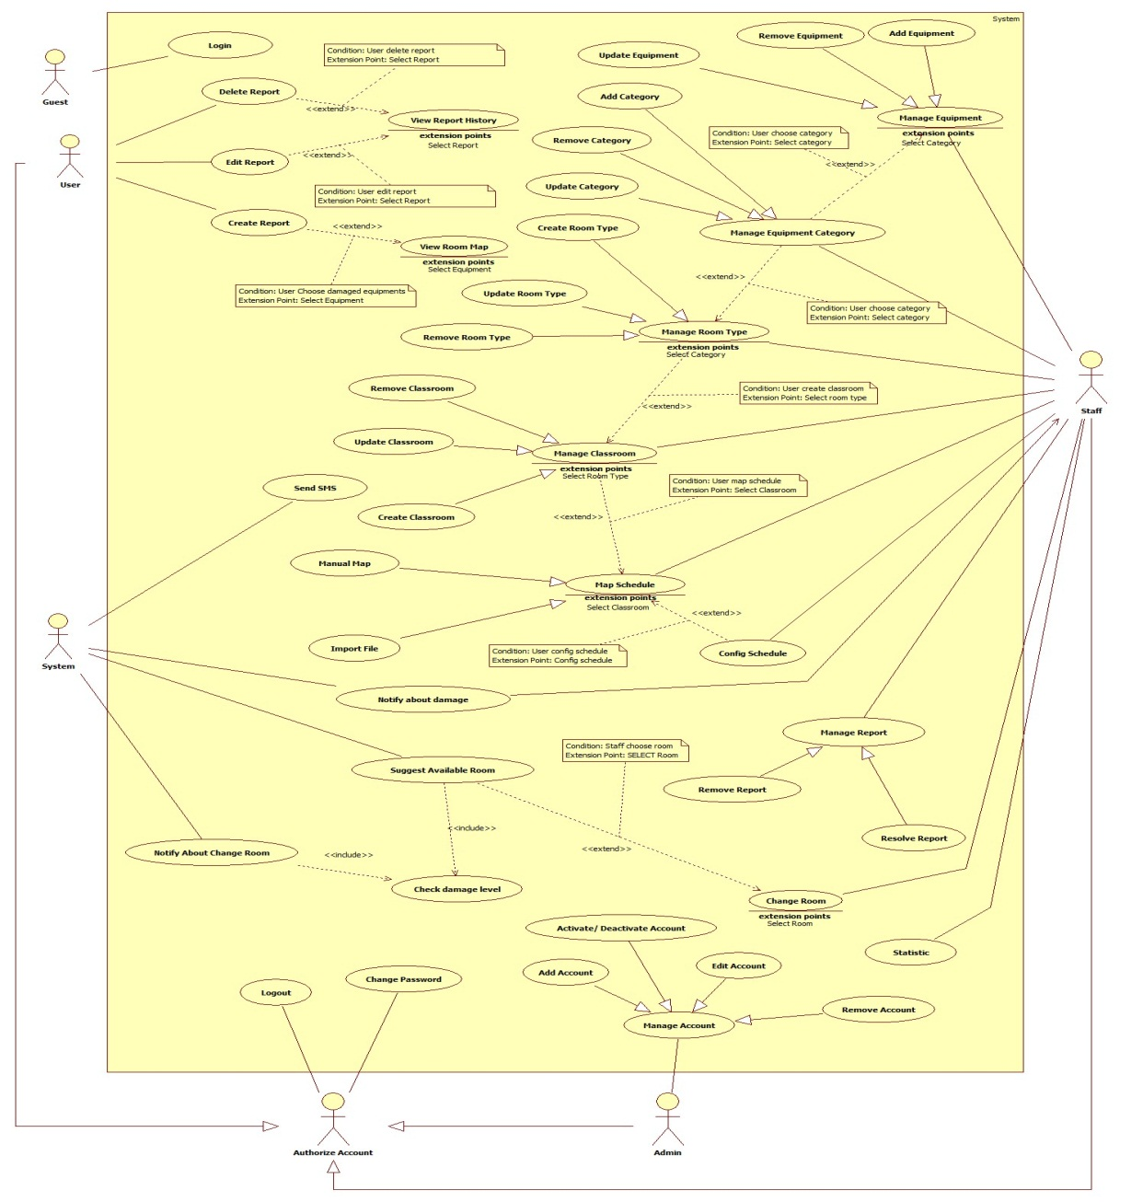

Figure : System Overview Use Case

* + 1. **List of Use Case**
       1. **<Guest> Overview Use Case**



Figure : Guest Overview Use Case

* + - 1. **<Guest> Login**



Figure : <Guest> Login

Use case Specification

|  |  |  |  |
| --- | --- | --- | --- |
| **USE CASE – ECRM001** | |  |  |
| **Use Case No.** | ECRM001 | **Use Case Version** | 2.0 |
| **Use Case Name** | Login |  |  |
| **Author** | Tang Viet Hung |  |  |
| **Date** | 05/21/2015 | **Priority** | Normal |
| **Actor:** Guest | |  |  |
| **Summary:** This use case allows guest to login.  **Goal:** Authentication and authorization  **Triggers:** Guest send “Đăng nhập” request to system.  **Preconditions:**   * N/A   **Post Conditions:**   * **Success:** Guest will be logged in system with their roles. Show welcome message. * **Fail:** Unsuccessful message will be shown.   **Main Success Scenario:**   |  |  |  | | --- | --- | --- | | Step | Actor Action | System Response | | 1 | Guest send Login request. | System navigates to “Đăng nhập” page.   * Username: free text input, min length: 6, max length: 20 required. * Password: free text input, min length: 6, max length: 20, required. * Đăng nhập: command | | 2 | Input field. |  | | 3 | Guest send “Đăng nhập” request. | Guest will login system with their roles.  [Exception 1,2,3] |     **Alternative Scenario:** N/A    **Exceptions:**   |  |  |  | | --- | --- | --- | | No | Cause | System Response | | 1 | Wrong username or password. | Show unsuccessful message: “Sai username hoặc password. Hãy thử lại!” | | 2 | “Username” field or “Password” field is empty | Show error message: “Bạn chưa nhập Username or Password. Hãy thử lại” | | 3 | “Username” or “Password” field data length is longer than 20 character or lower than 6 character | Show error message: “Username và Password phải lớn hơn 6 và nhỏ hơn 20 ký tự!” |     **Relationships:** N/A  **Business Rules:**   * After login successfully, guest will login with their role: user, staff and administrator. * Only active user can login to system. * If it is first time user login to system. They will be redirect to “Change Password” page to change password. * On mobile application, user can only login ECRM User App. Staff can only login ECRM Staff App. * On website application, if guest login with role user will be redirect to homepage. If guest is staff, they will be redirected to admin page. | | | |

Table : <Guest> Login

* + - 1. <User> Overview Use Case



Figure : <User> Overview Use Case

* + - 1. <User> View Report History



Figure : <User> View Report History

**Use case specification**

|  |  |  |  |
| --- | --- | --- | --- |
| **USE CASE – ECRM002** | | | |
| **Use Case No.** | ECRM002 | **Use Case Version** | 2.0 |
| **Use Case Name** | View Report History | | |
| **Author** | Doan Nguyen Minh Chi | | |
| **Date** | 05/21/2015 | **Priority** | Low |
| **Actor:**   * User   **Summary:**   * This use case allows user to view detail resolve for them report.   **Goal:**   * User can view report detail is resolved.   **Triggers:**   * User send request view report history.   **Preconditions:**   * User must be teacher. * This report must be created by user.   **Post Conditions:**   * **Success:** Show report detail and resolve of staff. * **Fail:** Show error message.   **Main Success Scenario:**   |  |  | | --- | --- | | Actor Action | System Response | | User send request view report history.  [Alternative 1] |  | |  | System will show report with two part:   * Part “Thông tin:   + “Phòng”: label   + “Người báo cáo”: label   + “Trạng thái”: label, list status[“Chưa sửa”, “Đang sửa”, “Đã sửa”]   + “Thiết bị”: label + “Xem bản đồ” send command   + “Thời gian báo cáo”: label   + “Mô tả từ giáo viên”: label * Part “Sơ đồ phòng”: list equipment and they position in the room. “Quay lại” send command   [Exception 1][Exception 2] |   **Alternative Scenario:**   |  |  |  | | --- | --- | --- | | No | Actor Action | System Response | | 1 | User send request in resolve notify when report is resolved. |  | |  | System will show report with two part:   * Part “Thông tin:   + “Phòng”: label   + “Người báo cáo”: label   + “Trạng thái”: label, list status[“Chưa sửa”, “Đang sửa”, “Đã sửa”]   + “Thiết bị”: label + “Xem bản đồ” send command   + “Thời gian báo cáo”: label   + “Mô tả từ giáo viên”: label * Part “Sơ đồ phòng”: list equipment and they position in the room. * “Quay lại” send command |   **Exceptions:**   |  |  |  | | --- | --- | --- | | No | Cause | System Response | | 1 | Report history not exist |  | |  | Show warning message: “Báo cáo hiện không tìm thấy.” | | 2 | User view report of other user |  | |  | Show warning message: “Bạn không có quyền truy cập báo cáo này”. |   **Relationships:** extend by Delete Report, Edit Report.  **Business Rules:**   * User only views them report. | | | |

Table : <User> View Report History

* + - 1. <User> View Room Map



Figure : <User> View Room Map

**Use case specification**

|  |  |  |  |
| --- | --- | --- | --- |
| **USE CASE – ECRM003** | |  |  |
| **Use Case No.** | ECRM003 | **Use Case Version** | 2.0 |
| **Use Case Name** | View Room Map |  |  |
| **Author** | Tran Vinh Quang |  |  |
| **Date** | 05/21/2015 | **Priority** | Normal |
| **Actor:** User | |  |  |
| **Summary:** This use case allows user to view map of classroom they teach.  **Goal:** View map of classroom user teaching. (Apply for web application and mobile application)  **Triggers:** User send “View Room Map” request in Home page.  **Preconditions:**   * User has successfully logged in system. * User must teaching in that time.   **Post Conditions:**   * **Success:** User will see map of classroom they teaching. * **Fail:** Unsuccessful message will be shown.   **Main Success Scenario:**   |  |  |  | | --- | --- | --- | | Step | Actor Action | System Response | | 1 | User send “View Room Map” request. | System navigates to “Map” page.  It contains the following information   * Map of room they teaching, show location of all equipment in class include board, table, chair, projector, fan…. * Cancel: button   [Exception 1,2] |     **Alternative Scenario:** N/A  **Exceptions:**     |  |  |  | | --- | --- | --- | | Step | Actor Action | System Response | | 1 | Connection error | Show error message: “Lỗi kết nối, vui lòng tải lại” | | 2 | User does not teach any class | Show error message: “Bạn không dạy lớp nào! Vui lòng thử lại sau hoặc liên hệ với quản lí”. | | 3 | Classroom did not had type | Show error message: “Hiện tại chưa có sơ đồ phòng học này, vui lòng liên hệ với quản lí”. |   **Relationships:** extend by Create Report  **Business Rules:**   * From map page, user can create report about damage equipment by click to equipment in map. * Only user have teaching in class can see map of room. * If class had damaged equipment, that equipment will be showed with red color. Other equipment will be showed with white color * System will check type of classroom and show map to screen. | | | |

Table : <User> View Room Map

* + - 1. <User> Create Report



Figure : <User> Create Report

**Use case specification**

|  |  |  |  |
| --- | --- | --- | --- |
| **USE CASE – ECRM004** | | | |
| **Use Case No.** | ECRM004 | **Use Case Version** | 2.0 |
| **Use Case Name** | Create report | | |
| **Author** | Doan Nguyen Minh Chi | | |
| **Date** | 05/21/2015 | **Priority** | High |
| **Actor:**   * User   **Summary:**   * In this use case allows user to send report for staff about damaged equipment.   **Goal:**   * Staff will be received damaged report from user. * Teacher sends report about damaged equipment.   **Triggers:**   * User send “Tạo Báo Cáo” request in website.   **Preconditions:**   * User has login successful on system with role teacher. * User has teaching schedule in this classroom.   **Post Conditions:**   * **Success:** Report must be send to staff. * **Fail:** Show error message.   **Main Success Scenario:**   |  |  | | --- | --- | | Actor Action | System Response | | 1. User send “Tạo Báo Cáo” request. |  | |  | 1. System will show room detail with two part:    1. “Phòng”: value list (list room can be reported)    2. Part “Thông tin”: list equipment by category and status report of equipment.       1. Equipment image       2. “Hư hại”: checkbox       3. Equipment evaluate: value list [“Hư hại nặng”, “Hư hại trung bình”, “Hư hại nhẹ”, “Không biết”]       4. Equipment status    3. “Đánh giá của bạn”: value list [“Không thể dạy được”, “Vẫn dạy được”]    4. Part “Sơ đồ phòng”: list equipment and they position in the room.    5. “Gửi báo cáo”: send command    6. “Quay lại”: send command | | 1. User must choose damaged equipment, and send “Gửi báo cáo” request.   [Alternative 1] [Alternative 2] |  | |  | 1. Report will be saved.   [Exception 1]   1. Notify to staff about report. |   **Alternative Scenario:**   |  |  |  | | --- | --- | --- | | No | Actor action | System Response | | 1 | User choose other room in list “Phòng” |  | |  | System will show this room detail. | | 2 | User send “Quay lại” command |  | |  | System will show history report page. |   **Exceptions:**   |  |  |  | | --- | --- | --- | | No | Cause | System Response | | 1 | User haven’t teaching in class |  | |  | Show message: “Báo cáo không thể gửi vì bạn không có lịch dạy trong lớp này”. |   **Relationships: N/A**  **Business Rules:**   * Only user can report equipment in classroom which they are teaching. * If equipment evaluate is “Hư hại nặng”, you must input damaged description. * System will get value of “Đánh giá của bạn”, equipment evaluates, and priority of equipment, before calculate damage level of them. It will be notify for staff in resolve form. * If damage level is larger than 50%, system will call Suggest Available Room. | | | |

Table : <User> Create Report

* + - 1. **<User> Delete Report**



Figure : <User> Delete Report

**Use case specification**

|  |  |  |  |
| --- | --- | --- | --- |
| **USE CASE – ECRM005** | |  |  |
| **Use Case No.** | ECRM005 | **Use Case Version** | 2.0 |
| **Use Case Name** | Delete Report |  |  |
| **Author** | Tran Vinh Quang |  |  |
| **Date** | 05/21/2015 | **Priority** | Normal |
| **Actor:** User  **Summary:**   * This use case allows user to remove existed report (applied for web application and mobile application)   **Goal:** Remove existed report to system.  **Triggers:** User sends request “Xóa” in report management page.  **Preconditions:**   * User must login into the system with user role. * Report must be existed in system   **Post Conditions:**   * **Success:** Report will be removed from system. Success message will be shown. * **Fail:** Error message will be shown.   **Main Success Scenario:**   |  |  |  | | --- | --- | --- | | Step | Actor Action | System Response | | 1 | User sends request “Xóa” in report manage page.  [Alternative 1] | System shows confirm box:   * Bạn có muốn xóa báo cáo: message. * Xóa: command. * Thoát: command. | | 2 | User sends “Xóa” request. | System shows successful message: “Báo cáo đã bị xóa khỏi hệ thống!” |     **Alternative Scenario:**   |  |  |  | | --- | --- | --- | | No | Actor Action | System Response | | 1 | User clicks “Thoát” | System navigation to “Report Management Page” |   **Exceptions:** N/A  **Relationships:** N/A  **Business Rules:**   * All the equipment in the report that is deleted will be change status to usable (Có thể sử dụng được) * All the report detail will be check delete. * The report will be check delete * Update damage level of classroom has report | | | |

Table : <User> Create Report

* + - 1. **<User> Edit Report**



Figure : <User> Edit Report

**Use case specification**

|  |  |  |  |
| --- | --- | --- | --- |
| **USE CASE – ECRM006** | | | |
| **Use Case No.** | ECRM006 | **Use Case Version** | 2.0 |
| **Use Case Name** | Edit report | | |
| **Author** | Doan Nguyen Minh Chi | | |
| **Date** | 05/21/2015 | **Priority** | High |
| **Actor:**   * User   **Summary:**   * In this use case allows user to edit report and send it to staff about damaged equipment.   **Goal:**   * Staff will be received damaged report from user. * Teacher edits report about damaged equipment.   **Triggers:**   * User send “Sửa Báo Cáo” report manage page.   **Preconditions:**   * User has login successful on system with role teacher. * User has teaching schedule in this classroom.   **Post Conditions:**   * **Success:** Report must be edit and send to staff. * **Fail:** Show error message.   **Main Success Scenario:**   |  |  | | --- | --- | | Actor Action | System Response | | User send “Sửa Báo Cáo” request. |  | |  | System will show room detail with two part:   * “Phòng”: value list (list room can be reported) * Part “Thông tin”: list equipment by category and status report of equipment. * Equipment image * “Hư hại”: checkbox * Equipment evaluate: value list [“Hư hại nặng”, “Hư hại trung bình”, “Hư hại nhẹ”, “Không biết”] * Equipment status * “Đánh giá của bạn”: value list [“Không thể dạy được”, “Vẫn dạy được”]   Part “Sơ đồ phòng”: list equipment and they position in the room.  “Gửi báo cáo”: send command  “Quay lại”: send command | | User must choose damaged equipment, and send “Gửi báo cáo” request.  [Alternative 1] [Alternative 2] |  | |  | Report will be saved.  [Exception 1]  Notify to staff about report. |   **Alternative Scenario:**   |  |  |  | | --- | --- | --- | | No | Actor action | System Response | | 1 | User choose other room in list “Phòng” |  | |  | System will show this room detail. | | 2 | User send “Quay lại” command |  | |  | System willshow history report page. |   **Exceptions:**   |  |  |  | | --- | --- | --- | | No | Cause | System Resonse | | 1 | User haven’t teaching in class |  | |  | Show message: “Báo cáo không thể gửi vì bạn không có lịch dạy trong lớp này”. |   **Relationships:** N/A  **Business Rules:**   * Only user can edit report equipment in classroom which they are teaching. * If equipment evaluate is “Hư hại nặng”, you must input damaged description. * System will get value of “Đánh giá của bạn”, equipment evaluates, and priority of equipment, before calculate damage level of them. It will be notify for staff in resolve form. * If damage level is larger than 50%, system will call Suggest Available Room. | | | |

Table : <User> Edit Report

* + - 1. <Staff> Use Case Overview

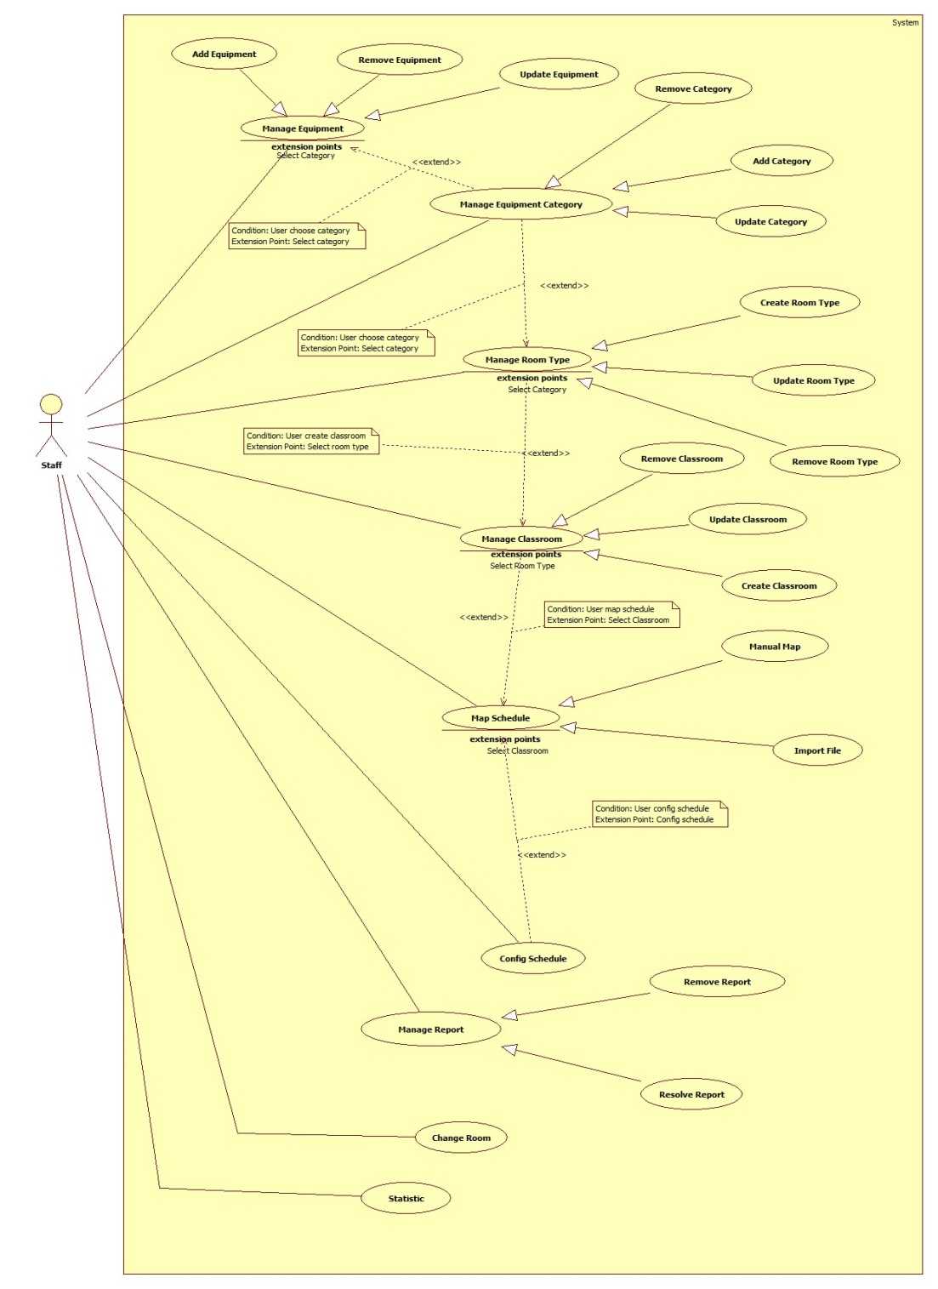

Figure : <Staff> Use case Overview

* + - 1. <Staff> Create New Room Type



Figure : <Staff> Create Room Type

**Use case specification**

|  |  |  |  |
| --- | --- | --- | --- |
| **USE CASE – ECRM007** | |  |  |
| **Use Case No.** | ECRM007 | **Use Case Version** | 2.0 |
| **Use Case Name** | Create Room Type |  |  |
| **Author** | Tang Viet Hung |  |  |
| **Date** | 05/21/2015 | **Priority** | Normal |
| **Actor:** Staff | |  |  |
| **Summary:** This use case allows staff to create new room type.  **Goal:** Create room type to the system.  **Triggers:** Staff sends request “Tạo Loại Phòng” in “Loại Phòng” page.  **Preconditions:**   * User login as staff role.   **Post Conditions:**   * **Success:** New room type will be created and show successful message. * **Fail:** Unsuccessful message will be shown.   **Main Success Scenario:**   |  |  |  | | --- | --- | --- | | Step | Actor Action | System Response | | 1 | Staff clicks on “Phòng Học” and then clicks on tab “Loại phòng”. | System navigates to “Kiểu Phòng” page. Page includes:   * Table with columns: * Loại phòng * Số chỗ ngồi * Quản lý * Xem: command. * Xóa: command * Tạo loại phòng: command | | 2 | Staff sends “Tạo loại phòng” request.  [Alternative 1] | System open pop-up to “Tạo loại phòng”. Pop-up includes:   * Tên loại phòng: free text input, max length: 20, required. * List of equipments: check box * Số dãy bàn: value list. * Số hàng: value list. * Số ghế: value list. * Xem trước: command. * Thoát: command. | | 3 | Staff sends “Xem trước” request.  [Alternative 2] | System will show:   * Classroom map. * Tạo mẫu: command. * Quay lại: command. | | 4 | Staff sends “Tạo mẫu” request. | System show successful message: “Tạo loại phòng thành công!” and navigate to “Kiểu Phòng” page.  [Exception 1 |     **Alternative Scenario:**     |  |  |  | | --- | --- | --- | | No | Actor Action | System Respnse | | 1 | Staff sends “Thoát” request. | System closes pop-up. | | 2 | Staff send request “Quay lại”. | Re-open previous pop-up. |   **Exceptions:**   |  |  |  | | --- | --- | --- | | No | Actor Action | System Response | | 1 | “Tên loại phòng” is empty. | Show error message: “Tên loại phòng không được bỏ trống!” | | 2 | “Tên loại phòng” is existed. | Show confirm message: “Tên loại phòng đã tồn tại, bạn có muốn cập nhật?” |   **Relationships:** N/A  **Business Rules:**   * List of equipment is loaded from database in EquipmentCategory table. * If staff creates new room type with existed room type name, system will update the room type with that room type name. * Each room type is created with list of equipment quantity that are presented the equipment in that room type. If staff didn’t choose any equipment, the room type wouldn’t have any equipment. | | | |

Table : <Staff> Create Room Type

* + - 1. <Staff> Update Room Type



Figure : <Staff> Update Room Type

**Use case specification**

|  |  |  |  |
| --- | --- | --- | --- |
| **USE CASE – ECRM008** | |  |  |
| **Use Case No.** | ECRM008 | **Use Case Version** | 2.0 |
| **Use Case Name** | Update Room Type |  |  |
| **Author** | Tang Viet Hung |  |  |
| **Date** | 05/21/2015 | **Priority** | Normal |
| **Actor:** Staff | |  |  |
| **Summary:** This use case allows staff to update room type.  **Goal:** Update room type to the system.  **Triggers:** Staff sends request “Cập nhật” in “Loại Phòng” page.  **Preconditions:**   * User login as staff role.   **Post Conditions:**   * **Success:** Room type will be updated and show successful message. * **Fail:** Unsuccessful message will be shown.   **Main Success Scenario:**   |  |  |  | | --- | --- | --- | | Step | Actor Action | System Response | | 1 | Staff clicks on “Phòng Học” and then clicks on tab “Loại phòng”. | System navigates to “Kiểu Phòng” page. Page includes:   * Table with columns: * Loại phòng * Số chỗ ngồi * Quản lý * Xem: command. * Xóa: command * Tạo loại phòng: command | | 2 | Staff sends “Xem” command.  [Alternative 1] | System open pop-up includes:   * Tên loại phòng: label. * Classroom map. * Chỉnh sửa: command. * Thoát: command. | | 3 | Staff sends “Chỉnh sửa” request.  [Alternative 2] | System open pop-up includes:   * Tên loại phòng: free text input, max length: 20, required. * List of equipments: check box * Số dãy bàn: value list. * Số hàng: value list. * Số ghế: value list. * Xem trước: command. * Thoát: command. | | 4 | Staff sends “Xem trước” request.  [Alternative 3] | System will show:   * Classroom map. * Tạo mẫu: command. * Quay lại: command. | | 5 | Staff sends “Cập nhật” request. | System show successful message: “Cập nhật loại phòng thành công!” and navigate to “Kiểu Phòng” page.  [Exception 1] |     **Alternative Scenario:**     |  |  |  | | --- | --- | --- | | No | Actor Action | System Response | | 1 | Staff ends “Thoát” request. | System closes pop-up. | | 2 | Staff sends “Thoát” request. | System closes pop-up. | | 3 | Staff send request “Quay lại”. | Re-open previous pop-up. |   **Exceptions:**   |  |  |  | | --- | --- | --- | | No | Actor Action | System Response | | 1 | “Tên loại phòng” is empty. | Show error message: “Tên loại phòng không được bỏ trống!” | | 2 | “Tên loại phòng” is existed. | Show confirm message: “Tên loại phòng đã tồn tại, bạn có muốn cập nhật?” |   **Relationships:** N/A  **Business Rules:**   * List of equipment is loaded from database in EquipmentCategory table. * If staff updates new room type with existed room type name, system will update the room type with that room type name. * All the old equipment quantity in the updated room type will be deleted. In the other hand, the new equipment quantity will be created. * If there are any classroom is using the updated room type, all the equipment in that classroom will be removed. Staff has to add new equipment into that classroom by sending “Cập nhật thiết bị” command. | | | |

Table : <Staff> Update Room Type

* + - 1. <Staff> Remove Room Type



Figure : <Staff> Remove Room Type

**Use case specification**

|  |  |  |  |
| --- | --- | --- | --- |
| **USE CASE – ECRM009** | |  |  |
| **Use Case No.** | ECRM009 | **Use Case Version** | 2.0 |
| **Use Case Name** | Remove Room Type |  |  |
| **Author** | Tang Viet Hung |  |  |
| **Date** | 05/21/2015 | **Priority** | Normal |
| **Actor:** Staff | |  |  |
| **Summary:** This use case allows staff to remove room type.  **Goal:** Update room type to the system.  **Triggers:** Staff sends request “Xóa” in “Loại Phòng” page.  **Preconditions:**   * User login as staff role.   **Post Conditions:**   * **Success:** Room type will be removed and show successful message. * **Fail:** Unsuccessful message will be shown.   **Main Success Scenario:**   |  |  |  | | --- | --- | --- | | Step | Actor Action | System Response | | 1 | Staff clicks on “Phòng Học” and then clicks on tab “Loại phòng”. | System navigates to “Kiểu Phòng” page. Page includes:   * Table with columns: * Loại phòng * Số chỗ ngồi * Quản lý * Xem: command. * Xóa: command * Tạo loại phòng: command | | 2 | Staff sends “Xóa” command. | System show successful message: “Xóa loại phòng thành công!” and navigate to “Kiểu Phòng” page.  [Exception 1] |     **Alternative Scenario:**  **Exceptions:**   |  |  |  | | --- | --- | --- | | No | Actor Action | System Response | | 1 | There is at least one classroom is using this room type. | Show error message: “Không thể xóa loại phòng này! Bạn phải gỡ ra khỏi phòng học trước!” |   **Relationships:** N/A  **Business Rules:**   * List of equipment is loaded from database in EquipmentCategory table. * Staff can only delete one room type when there is no classroom is using this room type. | | | |

Table : <Staff> Remove Room Type

* + - 1. <Staff> Create Classroom



Figure : <Staff> Create Classroom

**Use case specification**

|  |  |  |  |
| --- | --- | --- | --- |
| **USE CASE – ECRM010** | |  |  |
| **Use Case No.** | ECRM010 | **Use Case Version** | 2.0 |
| **Use Case Name** | Create Classroom |  |  |
| **Author** | Tang Viet Hung |  |  |
| **Date** | 05/21/2015 | **Priority** | Normal |
| **Actor:**   * Staff | |  |  |
| **Summary:**   * This use case allows staff to create new classroom (applied for web application)   **Goal:** Add new classroom to system.  **Triggers:** Staff sends request “Thêm Lớp Học” in classroom management page.  **Preconditions:**   * User must login into the system with staff role.   **Post Conditions:**   * **Success:** New classroom will be added to database. Success message will be shown. * **Fail:** Error message will be shown.   **Main Success Scenario:**   |  |  |  | | --- | --- | --- | | Step | Actor Action | System Response | | 1 | Staff sends request “Tạo phòng học” in tab “Phòng học” in manage page.  [Alternative 1] | System shows pop-up with information:   * Số phòng: free text input, min length: 1, max length: 4, numeric required. * Chọn: command. * Tạo phòng: command * Thoát: command | | 2 | Staff fills necessary information into the form. |  | | 3 | Staff sends “Chọn” request.  [Alternative 2] | System shows pop-up includes:   * Loại phòng: list of values (Loại 30 chỗ, loại 25 chỗ…). * Classroom map. * Chọn: command. * Thoát command. | | 4 | Staff sends “Chọn” request and then sends “Tạo phòng” request. | Classroom is added to database, success message “Thêm mới lớp học thành công” is shown.  System is navigation to “Classroom Management Page”.  [Exception 1,2,3] |     **Alternative Scenario:**   |  |  |  | | --- | --- | --- | | No | Actor Action | System Response | | 1 | Staff click “Thoát” | System navigation to “Classroom Management Page” | | 2 | Staff click “Thoát” | System navigation to “Classroom Management Page” |   **Exceptions:**   |  |  |  | | --- | --- | --- | | No | Cause | System Response | | 1 | “Số phòng” field is empty | Error message “Số phòng không được để trống!” is shown. | | 2 | “Số phòng” is not numeric type. | Error message “Số phòng không hợp lệ!”. | | 3 | “Số phòng” field is duplicated in database | Confirm message “Bạn có muốn cập nhật cho phòng này!” is shown. | | 4 | Staff didn’t choose any room type and then send “Tạo phòng” request. | Error message “Phải chọn loại phòng!” is shown. |   **Relationships:** N/A  **Business Rules:**   * Each classroom will have only 1 type. * The new classroom is created don’t have any equipment in it. There are “Cập nhật thiết bị” commands to insert equipment into the classroom. | | | |

Table : <Staff> Create Classroom

* + - 1. <Staff> Update Classroom



Figure : <Staff> Update Classroom

**Use case specification**

|  |  |  |  |
| --- | --- | --- | --- |
| **USE CASE – ECRM011** | |  |  |
| **Use Case No.** | ECRM011 | **Use Case Version** | 2.0 |
| **Use Case Name** | Update Classroom |  |  |
| **Author** | Tang Viet Hung |  |  |
| **Date** | 05/21/2015 | **Priority** | Normal |
| **Actor:**   * Staff | |  |  |
| **Summary:**   * This use case allows staff to update existed classroom (applied for web application)   **Goal:** Update existed classroom to system.  **Triggers:** Staff sends request “Cập nhật” in classroom management page.  **Preconditions:**   * User must login into the system with staff role. * Classroom must be existed in system   **Post Conditions:**   * **Success:** Classroom will be updated to database. Success message will be shown. * **Fail:** Error message will be shown.   **Main Success Scenario:**   |  |  |  | | --- | --- | --- | | Step | Actor Action | System Response | | 1 | Staff sends request “Xem sơ đồ” in tab “Phòng học” in manage page.  [Alternative 1] | System shows pop-up with information:   * “Sơ đồ phòng”: title. * Classroom map. * Chỉnh sửa: command. * Thoát: command. | | 2 | Staff sends “Chỉnh sửa” request.  [Alternative 2] | System shows pop-up with information:   * Số phòng: free text input, min length: 1, max length: 4, numeric required. * Chọn: command. * Tạo phòng: command * Thoát: command | | 2 | Staff fills necessary information into the form. |  | | 3 | Staff sends “Chọn” request.  [Alternative 3] | System shows pop-up includes:   * Loại phòng: list of values (Loại 30 chỗ, loại 25 chỗ…). * Classroom map. * Chọn: command. * Thoát command. | | 3 | Staff sends “Chọn” request and then sends “Cập nhật” request. | Classroom is added to database, success message “Cập nhật lớp học thành công” is shown.  System is navigation to “Classroom Management Page”.  [Exception 1,2,3] |     **Alternative Scenario:**   |  |  |  | | --- | --- | --- | | No | Actor Action | System Response | | 1 | Staff clicks “Thoát” | System navigation to “Classroom Management Page” | | 2 | Staff clicks “Thoát” | System navigation to “Classroom Management Page” | | 3 | Staff clicks “Thoát” | System navigation to “Classroom Management Page” |   **Exceptions:**   |  |  |  | | --- | --- | --- | | No | Cause | System Response | | 1 | “Số phòng” field is empty | Error message “Số phòng không được để trống!” is shown. | | 2 | “Số phòng” is not numeric type. | Error message “Số phòng không hợp lệ!”. | | 3 | “Số phòng” field is duplicated in database | Confirm message “Bạn có muốn cập nhật cho phòng này!” is shown. | | 4 | Staff didn’t choose any room type and then send “Cập nhật” request. | Error message “Phải chọn loại phòng!” is shown. |   **Relationships:** N/A  **Business Rules:**   * Each classroom will have only 1 type. * All the equipment in the updated classroom will be removed out of it. There are “Cập nhật thiết bị” commands to insert equipment into the classroom. | | | |

Table : <Staff> Update Classroom

* + - 1. <Staff> Remove Classroom



Figure : <Staff> Remove Classroom

**Use case specification**

|  |  |  |  |
| --- | --- | --- | --- |
| **USE CASE – ECRM012** | |  |  |
| **Use Case No.** | ECRM012 | **Use Case Version** | 2.0 |
| **Use Case Name** | Remove Classroom |  |  |
| **Author** | Tang Viet Hung |  |  |
| **Date** | 05/21/2015 | **Priority** | Normal |
| **Actor:**   * Staff | |  |  |
| **Summary:**   * This use case allows staff to remove existed classroom (applied for web application)   **Goal:** Remove existed classroom to system.  **Triggers:** Staff sends request “Xóa” in classroom management page.  **Preconditions:**   * User must login into the system with staff role. * Classroom must be existed in system   **Post Conditions:**   * **Success:** Classroom will be removed from system. Success message will be shown. * **Fail:** Error message will be shown.   **Main Success Scenario:**   |  |  |  | | --- | --- | --- | | Step | Actor Action | System Response | | 1 | Staff sends request “Xóa” in tab “Phòng học” in manage page.  [Alternative 1] | System shows confirm box:   * Bạn có muốn xóa phòng học: message. * Xóa: command. * Thoát: command. | | 2 | Staff sends “Xóa” request. | System shows successful message: “Phòng học được xóa thành công!” |     **Alternative Scenario:**   |  |  |  | | --- | --- | --- | | No | Actor Action | System Response | | 1 | Staff clicks “Thoát” | System navigation to “Classroom Management Page” |   **Exceptions:** N/A  **Relationships:** N/A  **Business Rules:**   * All the equipment in the classroom that is deleted will be removed out of this classroom. | | | |

Table : <Staff> Remove Classroom

* + - 1. <Staff> Resolve Report



Figure : <Staff> Resolve Report

**Use case specification**

|  |  |  |  |
| --- | --- | --- | --- |
| **USE CASE – ECRM013** | | | |
| **Use Case No.** | ECRM013 | **Use Case Version** | 2.0 |
| **Use Case Name** | Resolve report | | |
| **Author** | Doan Nguyen Minh Chi | | |
| **Date** | 05/21/2015 | **Priority** | High |
| **Actor:**   * Staff   **Summary:**   * This use case allows staff to resolve damaged equipment of this report, or all of damaged equipment in room.   **Goal:**   * Report will be resolved, and user will receive notify.   **Triggers:**   * Staff send request view new report notification.   **Preconditions:**   * User must be staff.   **Post Conditions:**   * **Success:** Report must be resolved and user receives resolved massage. * **Fail:** Show error message.   **Main Success Scenario:**   |  |  | | --- | --- | | Actor Action | System Response | | 1. Staff send request view new report notification. |  | |  | 1. System will show report detail of notify with three part:  * Part “Thông tin”: information of reports in room.   + “Phòng”: label   + “Người báo cáo”: label   + “Thiết bị”: label, list damaged equipment   + “Thời gian báo cáo”: label, the time of last report   + “Mô tả từ giáo viên”: label   + “Đề nghị đổi phòng”: label, suggest the best room + “Đổi phòng” send command   + “Mức độ hư hại”: value ranges [0-100] * Part “Sơ đồ phòng”: list equipment and they position in the room. * Part “Danh sách thiết bị”: list damaged equipment category.   + Equipment image   + Equipment name   + Number of damaged equipment in category   + List real equipment have serial number in category. * “Khắc phục” send command * “Khắc phục tất cả” send command * “Quay lại” send command | | 1. Staff choose equipment and send “Khắc phục” request   [Alternative 1] [Alternative 2]  [Alternative 3] [Alternative 4] |  | |  | 1. System saves resolve data.   [Exception 1] |   **Alternative Scenario:**   |  |  |  | | --- | --- | --- | | No | Actor Action | System Response | | 1 | Staff send “Xem bản đồ” command |  | |  | Show classroom map with position of damaged equipment | | 2 | 1. Staff send “Đổi phòng” request |  | |  | 1. Show change room form with:  * “Phòng trống”: label * “Phòng khác”: send command * “Đổi phòng” send command * “Thoát” send command | | 1. Staff send “Đổi phòng” request in this form |  | |  | 1. Change to new classroom, and show success message | | 3 | Staff send “Quay lại” command |  | |  | Show list report page. | | 4 | 1. Staff send “Khắc phục tất cả” request |  | |  | 1. System will show message: “Bạn muốn khắc phục tất cả thiết bị”.    * “Khắc phục” send command    * “Thoát” send command | | 1. Staff send “Khắc phục” request |  | |  | 1. System saves resolve data. |   **Exceptions:**   |  |  |  | | --- | --- | --- | | No | Cause | System Response | | 1 | Staff sends “Khắc phục” request but the report has already resolved. |  | |  | Show message: “Báo cáo đã được xử lý bởi một nhân viên khác.” |   **Relationships:** extend Suggest Available Room, extend Notify about fixed, and extend by View Report.  **Business Rules:**   * All damaged equipment always update when user report other equipment in this room. * If damaged level of room is higher than 50%, the system will show available rooms. * When staff resolves a report, it notifies for other staff. * Equipment in other report are fixed in report, it will update in other report. * Report’s status will change to “going” when all the damaged equipment was not fixed. A damaged equipment change to “finish” status after it was fixed. * After change other room, report’s status will change “going”. * Report’s status will be changed to “finish” when all damaged equipment was fixed. | | | |

Table : <Staff> Resolve Report

* + - 1. **<Staff> Reject Report**



|  |  |  |  |
| --- | --- | --- | --- |
| **USE CASE – ECRM014** | | | |
| **Use Case No.** | ECRM014 | **Use Case Version** | 2.0 |
| **Use Case Name** | Reject Report | | |
| **Author** | Tran Vinh Quang | | |
| **Date** | 05/21/2015 | **Priority** | High |
| **Actor:**   * Staff   **Summary:**   * This use case allows staff to reject report   **Goal:**   * Report will be removed * User will be added penalty to account   **Triggers:**   * Staff sends request reject report   **Preconditions:**   * User must login to system with role staff.   **Post Conditions:**   * **Success:** Report must be removed. Show success message * **Fail:** Show error message.   **Main Success Scenario:**   |  |  | | --- | --- | | Actor Action | System Response | | Staff sends request view all report |  | |  | System will navigate user to report management page includes:   * List report with status “NEW” and “GOING” * “Báo cáo sai”: command * “Xem”: command | | Staff sends “Báo cáo sai” request |  | |  | System change status report to remove.  Add penalty for user created report  [Exeption 1] |   **Alternative Scenario:**   |  |  |  | | --- | --- | --- | | No | Actor Action | System Response | | 1 | Staff sends “Xem” request |  | |  | Navigate to view detail report screen.  Reference: <Staff> Resolve Report. |   **Exceptions: N/A**  **Relationships:** N/A  **Business Rules:**   * Report will be change status to remove. * Add penalty for user create report * All report detail will be changed status to fixed * All equipment of report will be changed status to fixed * If user has 5 penalty, user will be banned from system. | | | |

Table : <Staff> Remove Report

* + - 1. <Staff> View Statistic

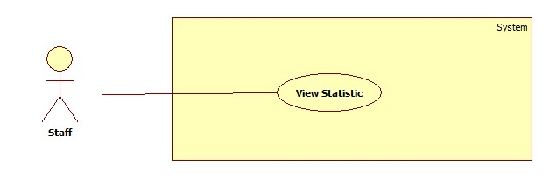

Figure : <Staff> View Statistic

**Use case specification**

* + - 1. <Staff> Mapping Schedule Manual



Figure : <Staff> Mapping Schedule Manual

**Use case specification**

|  |  |  |  |
| --- | --- | --- | --- |
| **USE CASE – ECRM015** | |  |  |
| **Use Case No.** | ECRM015 | **Use Case Version** | 2.0 |
| **Use Case Name** | Mapping Schedule Manual |  |  |
| **Author** | Tang Viet Hung |  |  |
| **Date** | 21/05/2015 | **Priority** | Normal |
| **Actor:** Staff | |  |  |
| **Summary:** This use case allows staff to import file schedule.  **Goal:** Import a schedule file.  **Triggers:** Staff sends “Manual” request on “Nhập Lịch” page.  **Preconditions:**   * User login as staff role.   **Post Conditions:**   * **Success:** Schedule file will be imported and show successful message. * **Fail:** Unsuccessful message will be shown.   **Main Success Scenario:**   |  |  |  | | --- | --- | --- | | Step | Actor Action | System Response | | 1 | Staff sends “Nhập Lịch” request.  [Alternative 1] | System navigates to “Xếp lịch” page. Page includes:   * Tạo mới: command. * Nhập file: command. | | 2 | Staff sends “Tạo mới” request. | System shows pop-up includes:   * Giáo viên: text input, min length: 6, max length: 30, required. * Tiết bắt đầu: list of value (1-7:00:00, 2-8:45:00…) * Số tiết: list of value (1, 2, 3, 4…) * Từ ngày: text input, date type, required. * Đến ngày: text input, date type. * Số lượng học sinh: text input, number type, required. * Tìm phòng trống: command. * Phòng học: free text input or dropdown list, required. * Gửi tin nhắn: check box. * Tạo: command. * Thoát: command.   [Exception 1, 2, 3, 4 ,5, 6, 7, 8] | | 3 | Staff fills all require information and sends “Tạo” request.  [Alternative 1, 2] | System shows successful message. |     **Alternative Scenario:**   |  |  |  | | --- | --- | --- | | No | Actor Action | System Response | | 1 | Staff sends “Tìm phòng trống” request. | System will find available classroom based on information that staff inputted and then change “Phòng học” text input to dropdown list and put list of available classroom to dropdown list.  If staff sends “Tìm phòng trống” again, “Phòng học” will be changed to text input and so on. | | 2 | Staff sends “Thóat” command. | System close current pop-up. |   **Exceptions:**   |  |  |  | | --- | --- | --- | | No | Actor Action | System Response | | 1 | “Giáo viên” field is empty. | System shows error message: “Giáo viên không được bỏ trống!” | | 2 | “Giáo viên” field is not existed in database. | System shows error message: “Giáo viên không tồn tại!” | | 3 | “Số học sinh” field is empty. | System shows error message: “Số học sinh không được bỏ trống!” | | 4 | “Số học sinh” field is not numeric. | System shows error message: “Số học sinh không hợp lệ!” | | 5 | “Từ ngày” text input is empty or not date type. | System shows error message: “Ngày dạy bắt đầu không hợp lệ!” | | 6 | “Đến ngày” text input is not date type. | System shows error message: “Ngày dạy kết thúc” không hợp lệ!” | | 7 | “Từ ngày” field is bigger than “Đến ngày” field. | System shows error message: “Ngày bắt đầu không được nhỏ hơn nagyf kết thúc!” | | 8 | “Phòng học” is empty. | System shows error message: “Phòng học không được bỏ trống!” | | 9 | Staff sends “Tìm phòng trống” but didn’t fill all require field. | System shows error message: “Phải điền đầy đủ thông tin!” |   **Relationships:** N/A  **Business Rules:**   * If check box “Gửi tin nhắn” is checked, system will send SMS to user in “Giáo viên” field. * If in database has one schedule that has the same teacher with the inserted schedule­ but different classroom and in the same time, system will delete the old one and insert the new one with note. * If in database has one schedule that has the same classroom in the same time but different teacher, system will delete the old one and insert the new one with note. * Every schedule is unique by its schedule configuration, classroom and teacher. | | | |

Table : <Staff> Mapping Schedule Manual

* + - 1. <Staff> Mapping Schedule Import File



Figure : <Staff> Mapping Schedule Import File

Use case specification

|  |  |  |  |
| --- | --- | --- | --- |
| **USE CASE – ECRM016** | |  |  |
| **Use Case No.** | ECRM016 | **Use Case Version** | 2.0 |
| **Use Case Name** | Mapping schedule by import file |  |  |
| **Author** | Tang Viet Hung |  |  |
| **Date** | 21/05/2015 | **Priority** | Normal |
| **Actor:** Staff | |  |  |
| **Summary:** This use case allows staff to import file schedule.  **Goal:** Import a schedule file.  **Triggers:** Staff sends “Nhập lịch” request on “Xếp Lịch” page.  **Preconditions:**   * User login as staff role.   **Post Conditions:**   * **Success:** All schedules on file will be imported and save in database and show successful message. * **Fail:** Unsuccessful message will be shown.   **Main Success Scenario:**   |  |  |  | | --- | --- | --- | | Step | Actor Action | System Response | | 1 | Staff sends “Nhập Lịch” request.  [Alternative 1] | System navigates to “Xếp lịch” page. Page includes:   * Tạo mới: command. * Nhập file: command. | | 2 | Staff sends “Nhập file” request. | System shows pop-up includes:   * Bấm vào để tải mẫu: command. * Chọn file excel: command. * Nhập lịch: command. * Thoát: command. | | 3 | Staff sends “Chọn file excel” request and choose schedule excel file from their computer. | System shows the name of schedule file. | | 4 | Staff clicks “Nhập lịch”button. | System shows successful message.  [Exception 1, 2, 3] |     **Alternative Scenario:**   |  |  |  | | --- | --- | --- | | No | Actor Action | System Response | | 1 | Staff sends “Bấm vào để tải mẫu” request. | Staff will get template excel file from server. |   **Exceptions:**   |  |  |  | | --- | --- | --- | | No | Actor Action | System Respone | | 1 | Staff import a wrong template excel file. | System shows error message. | | 2 | Teacher name is not existed in database. | Error message “Giáo viên không tồn tại!” is shown. | | 3 | Classroom number is not existed in database. | Error message “Phòng học không tồn tại!” is shown. |   **Relationships:** N/A  **Business Rules:**   * After receiving request, system will check validate the file that got from user. If it’s incorrect template, system will show error. The new schedule will be saved in database. * If staff imports one more teacher has more than two schedule in the same class in the same time, system will not save the newest one. * If staff import one teacher has more than two schedule in different class but in the same time, system will not save the newest one. * Every schedule is unique by its schedule configuration, classroom and teacher. | | | |

Table : <Staff> Mapping Schedule Import File

* + - 1. **<Staff> Create Equipment**

**Use case specification**

|  |  |  |  |
| --- | --- | --- | --- |
| **USE CASE – ECRM017** | |  |  |
| **Use Case No.** | ECRM017 | **Use Case Version** | 2.0 |
| **Use Case Name** | Create Equipment |  |  |
| **Author** | Tang Viet Hung |  |  |
| **Date** | 05/21/2015 | **Priority** | Normal |
| **Actor:**   * Staff | |  |  |
| **Summary:**   * This use case allows staff to create new equipment (applied for web application)   **Goal:** Add new equipment to system.  **Triggers:** Staff sends request “Tạo thiết bị” in equipment management page.  **Preconditions:**   * User must login into the system with staff role.   **Post Conditions:**   * **Success:** New equipment will be added to database. Success message will be shown. * **Fail:** Error message will be shown.   **Main Success Scenario:**   |  |  |  | | --- | --- | --- | | Step | Actor Action | System Response | | 1 | Staff sends request “Tạo thiết bị” in tab “Thiết bị” in manage equipment page.  [Alternative 1] | System shows pop-up with information:   * Loại thiết bị: list of value (Máy chiếu, máy lạnh…). * Tên thiết bị: free text input, min length 1, max length 30, required. * Số seri: free text input, min length 1, max length 30, required. * Thời gian sử dụng: free text input, min length 1, max length 5, numeric required. * Tạo: command * Thoát: command | | 2 | Staf fills necesary information into the form. |  | | 3 | Staff sends “Tạo” request. | System shows successful message “Thiết bị đã được tạo thành công!”  [Exception 1, 2, 3, 4, 5] |     **Alternative Scenario:**   |  |  |  | | --- | --- | --- | | No | Actor Action | System Response | | 1 | Staff click “Thoát” | Sytem closes urrent pop-up. |   **Exceptions:**   |  |  |  | | --- | --- | --- | | No | Cause | System Response | | 1 | “Tên thiết bị” field is empty | Error message “Tên thiết bị không được để trống!” is shown. | | 2 | “Số seri” field is empty | Error message “Số seri không được để trống!” | | 3 | “Thời gian sử dụng” field is emty. | Error message “Thời gian sử dụng không được để trống!” | | 4 | “Thời gian sử dụng” is not numeric type. | Error message “Số phòng không hợp lệ!”. | | 5 | “Số seri” field is duplicated in database | Confirm message “Số seri đã tồn tại” is shown. |   **Relationships:** N/A  **Business Rules:**   * Staff only create equipment that has equipment category with property “Quản lý” is checked. * “Loại thiết bị” field is loaded from “equipment category”. * Each equipment has only one equipment category. * “Thời gian sử dụng” presents for life time of this equipment. * “Thời gian sử dụng” field can be 0. “Thời gian sử dụng” and “Thời gian còn lại” is only equal every time the equipment is created. | | | |

Table : <Staff> Create Equipment

* + - 1. **<Staff> Remove Equipment**

**Use case specification**

|  |  |  |  |
| --- | --- | --- | --- |
| **USE CASE – ECRM018** | |  |  |
| **Use Case No.** | ECRM018 | **Use Case Version** | 2.0 |
| **Use Case Name** | Remove Equipment |  |  |
| **Author** | Tang Viet Hung |  |  |
| **Date** | 05/21/2015 | **Priority** | Normal |
| **Actor:**   * Staff | |  |  |
| **Summary:**   * This use case allows staff to delete an existed equipment (applied for web application)   **Goal:** Update existed equipment to system.  **Triggers:** Staff sends request “Xóa” in equipment management page.  **Preconditions:**   * User must login into the system with staff role. * The equipment must be existed in system.   **Post Conditions:**   * **Success:** Equipment will be delete from database. Success message will be shown. * **Fail:** Error message will be shown.   **Main Success Scenario:**   |  |  |  | | --- | --- | --- | | Step | Actor Action | System Response | | 1 | Staff sends request “Xóa” in tab “Thiết bị” in manage equipment page.  [Alternative 1] | System shows confirm message: “Bạn có muốn xóa thiết bị?” | | 3 | Staff sends request “Xóa”. | System shows successful message “Thiết bị đã được xóa thành công!” |     **Alternative Scenario:**   |  |  |  | | --- | --- | --- | | No | Actor Action | System Response | | 1 | Staf sends requst “Xóa” while equipment is using by one classroom. | System show confirm message: “Bạn có muốn gỡ thiết bị ra khỏi phòng?” |   **Exceptions:**  **Relationships:** N/A  **Business Rules:**   * If equipment is using by one classroom, the equipment will not be deleted but removed out of this classroom. If not, equipment will be deleted. | | | |

Table : <Staff> Remove Equipment

* + - 1. **<Staff> Update Equipment**

**Use case specification**

|  |  |  |  |
| --- | --- | --- | --- |
| **USE CASE – ECRM019** | |  |  |
| **Use Case No.** | ECRM019 | **Use Case Version** | 2.0 |
| **Use Case Name** | Update Equipment |  |  |
| **Author** | Tang Viet Hung |  |  |
| **Date** | 05/21/2015 | **Priority** | Normal |
| **Actor:**   * Staff | |  |  |
| **Summary:**   * This use case allows staff to update an existed equipment (applied for web application)   **Goal:** Update an existed equipment to system.  **Triggers:** Staff sends request “Cập nhật” in equipment management page.  **Preconditions:**   * User must login into the system with staff role. * The equipment must be existed in system.   **Post Conditions:**   * **Success:** Equipment will be updated to database. Success message will be shown. * **Fail:** Error message will be shown.   **Main Success Scenario:**   |  |  |  | | --- | --- | --- | | Step | Actor Action | System Response | | 1 | Staff sends request “Cập nhật” in tab “Thiết bị” in manage equipment page.  [Alternative 1] | System shows pop-up with information:   * Loại thiết bị: list of value (Máy chiếu, máy lạnh…). * Tên thiết bị: free text input, min length 1, max length 30, required. * Số seri: free text input, min length 1, max length 30, required. * Thời gian sử dụng: free text input, min length 1, max length 5, numeric required. * Thời gian còn lại: free text input, min length 1, max length 5. * Cập nhật: command * Thoát: command | | 2 | Staff fills necessary information into the form. |  | | 3 | Staff sends “Cập nhật” request. | System shows successful message “Thiết bị đã được tạo thành công!”  [Exceptio 1, 2, 3, 4, 5, 6, 7, 8] |     **Alternative Scenario:**   |  |  |  | | --- | --- | --- | | No | Actor Action | System Response | | 1 | Staff click “Thoát” | System closes current pop-up. |   **Exceptions:**   |  |  |  | | --- | --- | --- | | No | Cause | System Response | | 1 | “Tên thiết bị” field is empty | Error message “Tên thiết bị không được để trống!” is show. | | 2 | “Số seri” field is empty | Error message “Số seri không được để trống!” | | 3 | “Thời gian sử dụng” field is empty. | Error message “Thời gian sử dụng không được để trống!” | | 4 | “Thời gian sử dụng” is not numeric type. | Error message “Thời gian sử dụng khng hợplệ!” | | 6 | “Thời gian còn lại” field is empty. | Error message “Thời gian sử dụng không được để trống!” | | 7 | “Thời gian còn lại” is not numeric type. | Error message “Thời gian còn lại không hợp lệ!” | | 8 | “Thời gian còn lại” is bigger than “Thời gian sử dụng”. | Error message “Thời gian còn lại không được lớn hơn thời gian sử dụng!” |   **Relationships:** N/A  **Business Rules:**   * “Loại thiết bị” field is loaded from “equipment category”. * Each equipment has only one equipment category. * “Thời gian sử dụng” presents life time of this equipment. * “Thời gian còn lại” presents using time remain till the expired date of this equipment. * If “Thời gian sử dụng” is equal 0, it means this equipment doesn’t have expired time. | | | |

Table : <Staff> Update Equipment

* + - 1. **<Staff> Create Equipment Category**

**Use case specification**

|  |  |  |  |
| --- | --- | --- | --- |
| **USE CASE – ECRM020** | |  |  |
| **Use Case No.** | ECRM020 | **Use Case Version** | 2.0 |
| **Use Case Name** | Create Equipment category |  |  |
| **Author** | Tang Viet Hung |  |  |
| **Date** | 05/21/2015 | **Priority** | Normal |
| **Actor:**   * Staff | |  |  |
| **Summary:**   * This use case allows staff to create new equipment category(applied for web application)   **Goal:** Add new equipment category to system.  **Triggers:** Staff sends request “Tạo loại thiết bị” in equipment management page.  **Preconditions:**   * User must login into the system with staff role.   **Post Conditions:**   * **Success:** New equipment category will be added to database. Success message will be shown. * **Fail:** Error message will be shown.   **Main Success Scenario:**   |  |  |  | | --- | --- | --- | | Step | Actor Action | System Response | | 1 | Staff sends request “Tạo loại thiết bị” in tab “Thiết loại bị” in manage equipment page.  [Alternative 1] | System shows pop-up with information:   * Tên loại: free text input, min length 1, max length 30, required. * Hình ảnh: image file input. * Quản lý: check box. * Tạo: command * Thoát: command | | 2 | Staff fills necessary information into the form. |  | | 3 | Staff sends “Tạo” request. | System shows successful message “Thiết bị đã được tạo thành công!”  [Exception 1, 2, 3] |     **Alternative Scenario:**   |  |  |  | | --- | --- | --- | | No | Actor Action | System Response | | 1 | Staff click “Thoát” | System closes current pop-up. |   **Exceptions:**   |  |  |  | | --- | --- | --- | | No | Cause | System Response | | 1 | “Tên loại” field is empty | Error message “Tên loại thiết bị không được để trống!” is shown. | | 2 | “Hình ảnh” field is empty or not image type. | Error message “Hãy chọn tập tin có đuôi là: .jpg, .jpeg, .png, .gif!” | | 3 | “Tên loại” field is duplicated in database | Confirm message “Tên loại đã tồn tại” is shown. |   **Relationships:** N/A  **Business Rules:**   * If “Quản lý” field is checked, staff can create new equipment has that equipment category. | | | |

Table : <Staff> Create Equipment Category

* + - 1. **<Staff> Remove Equipment Category**

**Use case specification**

|  |  |  |  |
| --- | --- | --- | --- |
| **USE CASE – ECRM021** | |  |  |
| **Use Case No.** | ECRM021 | **Use Case Version** | 2.0 |
| **Use Case Name** | Remove Equipment category |  |  |
| **Author** | Tang Viet Hung |  |  |
| **Date** | 05/21/2015 | **Priority** | Normal |
| **Actor:**   * Staff | |  |  |
| **Summary:**   * This use case allows staff to remove an existed equipment category(applied for web application)   **Goal:** Remove an existed equipment category to system.  **Triggers:** Staff sends request “Xóa” in equipment management page.  **Preconditions:**   * User must login into the system with staff role.   **Post Conditions:**   * **Success:** Equipment category will be remove from database. Success message will be shown. * **Fail:** Error message will be shown.   **Main Success Scenario:**   |  |  |  | | --- | --- | --- | | Step | Actor Action | System Response | | 1 | Staff sends request “Xóa” in tab “Thiết loại bị” in manage equipment page.  [Alternative 1] | System shows confirm message “Bạn có muốn xóa loại thiết bị ra khỏi hệ thống? Điều này sẽ ảnh hưởng tới các thiết bị xung quanh!”   * Xóa: command. * Đóng: command. | | 2 | Staff sends “Xóa” request. | System shows successful message “Loại thiết bị đã được xóa thành công!” |     **Alternative Scenario:**   |  |  |  | | --- | --- | --- | | No | Actor Action | System Response | | 1 | Staff click “Thoát” | System closes current confirm message. |   **Exceptions:** N/A  **Relationships:** N/A  **Business Rules:**   * Before equipment category is removed, all equipment have this category will be remove out of classroom and then remove from database. | | | |

Table : <Staff> Remove Equipment Category

* + - 1. **<Staff> Update Equipment Category**

**Use case specification**

|  |  |  |  |
| --- | --- | --- | --- |
| **USE CASE – ECRM022** | |  |  |
| **Use Case No.** | ECRM022 | **Use Case Version** | 2.0 |
| **Use Case Name** | Update Equipment category |  |  |
| **Author** | Tang Viet Hung |  |  |
| **Date** | 05/21/2015 | **Priority** | Normal |
| **Actor:**   * Staff | |  |  |
| **Summary:**   * This use case allows staff to update an existed equipment category(applied for web application)   **Goal:** Update an existed equipment category to system.  **Triggers:** Staff sends request “Cập nhật” in equipment management page.  **Preconditions:**   * User must login into the system with staff role.   **Post Conditions:**   * **Success:** Equipment category will be updated to database. Success message will be shown. * **Fail:** Error message will be shown.   **Main Success Scenario:**   |  |  |  | | --- | --- | --- | | Step | Actor Action | System Response | | 1 | Staff sends request “Cập nhật” in tab “Thiết loại bị” in manage equipment page.  [Alternative 1] | System shows pop-up with information:   * Tên loại: free text input, min length 1, max length 30, required. * Hình ảnh: image file input. * Tạo: command * Thoát: command | | 2 | Staff fills necessary information into the form. |  | | 3 | Staff sends “Cập nhật” request. | System shows successful message “Thiết bị đã được cập nhật thành công!”  [Exception 1, 2] |     **Alternative Scenario:**   |  |  |  | | --- | --- | --- | | No | Actor Action | System Response | | 1 | Staff click “Thoát” | System closes current pop-up. |   **Exceptions:**   |  |  |  | | --- | --- | --- | | No | Cause | System Response | | 1 | “Tên loại” field is empty | Error message “Tên loại thiết bị không được để trống!” is shown. | | 2 | “Hình ảnh” field is empty or not image type. | Error message “Hãy chọn tập tin có đuôi là: .jpg, .jpeg, .png, .gif!” | | 3 | “Tên loại” field is different from current “Tên loại” and duplicated in database | Confirm message “Tên loại đã tồn tại” is shown. |   **Relationships:** N/A  **Business Rules:** N/A | | | |

Table : <Staff> Update Equipment Category

* + - 1. **<Staff> Changing Room**

**Use case specification**

|  |  |  |  |
| --- | --- | --- | --- |
| **USE CASE – ECRM023** | |  |  |
| **Use Case No.** | ECRM023 | **Use Case Version** | 2.0 |
| **Use Case Name** | Changing room |  |  |
| **Author** | Tang Viet Hung |  |  |
| **Date** | 05/21/2015 | **Priority** | Normal |
| **Actor:**   * Staff | |  |  |
| **Summary:**   * This use case allows staff to change specific classroom to another classroom in system in a certain period time(applied for web application)   **Goal:** Add new equipment category to system.  **Triggers:** Staff sends request “Đổi” in classroom management page.  **Preconditions:**   * User must login into the system with staff role.   **Post Conditions:**   * **Success:** Change specific classroom to another classroom in system in a certain period time. Success message will be shown. * **Fail:** Error message will be shown.   **Main Success Scenario:**   |  |  |  | | --- | --- | --- | | Step | Actor Action | System Response | | 1 | Staff sends request “Đổi phòng” in tab “Phòng học” in manage equipment page.  [Alternative 1] | System shows pop-up with information:   * Từ ngày: free text input, date type required. * Đến ngày: free text input, date type. * Tìm phòng trống: command * Thoát: command | | 2 | Staff fills necessary information into the form. |  | | 3 | Staff sends “Tìm phòng trống” request.  [Alternative 2] | System shows pop-up with information:   * Phòng trống cho buổi sáng: list of number of classroom. * Phòng trống cho buổi chiều: list of number of classroom. * Đổi: command. * Quay lại: command.   [Exception 1, 2] | | 4 | Staff sends “Đổi” request. | System shows successful message “Đã đổi phòng thành công!”  [Exception 3] |     **Alternative Scenario:**   |  |  |  | | --- | --- | --- | | No | Actor Action | System Response | | 1 | Staff sends “Thoát” command. | System closes current pop-up. | | 2 | Staff sends “Quay lại” command. | System close current pop-up and re-open previous pop-up. |   **Exceptions:**   |  |  |  | | --- | --- | --- | | No | Cause | System Response | | 1 | “Từ ngày” field is empty or not date type. | Error message “Sai kiểu ngày tháng yyyy-mm-dd!” is shown. | | 2 | “Đến ngày” field is not date type. | Error message “Sai kiểu ngày tháng yyyy-mm-dd!” is shown. | | 3 | Staff didn’t choose any value in list “Phòng trống cho buổi sáng” and “Phòng trống cho buổi chiều”. | Error message “Không có gì thay đổi!” is shown. |   **Relationships:** N/A  **Business Rules:**   * Changing room is simply move all schedule in morning classes or noon classes or both of them in current classroom to another classroom that staff choose. * If staff chooses the date range when current classroom don’t have any schedule, instead of show list of number classroom, system will show “Không có phòng cho buổi sáng (chiều) hoặc không có lịch dạy!” * If system can’t find any available classroom for morning classes or noon classes or even both of them, system will show “Không có phòng cho buổi sáng (chiều) hoặc không có lịch dạy!” | | | |

Table : <Staff> Changing Room

* + - 1. **<Staff> Schedule Configuration**

**Use case specification**

|  |  |  |  |
| --- | --- | --- | --- |
| **USE CASE – ECRM024** | |  |  |
| **Use Case No.** | ECRM024 | **Use Case Version** | 2.0 |
| **Use Case Name** | Schedule configuration |  |  |
| **Author** | Tang Viet Hung |  |  |
| **Date** | 21/05/2015 | **Priority** | Normal |
| **Actor:** Staff | |  |  |
| **Summary:** This use case allows staff to manage schedule configuration in system.  **Goal:** Import a schedule file.  **Triggers:** Staff sends “Lưu” request on “Tiết học” page.  **Preconditions:**   * User login as staff role.   **Post Conditions:**   * **Success:** Schedule configuration will be save and show successful message. * **Fail:** Unsuccessful message will be shown.   **Main Success Scenario:**   |  |  |  | | --- | --- | --- | | Step | Actor Action | System Response | | 1 | Staff sends “Tiết học” request.  [Alternative 1] | System navigates to “Cấu hình tiết học” page. Page includes:   * Cập nhật: command. * Số phút mỗi tiết: free text input, numeric, disabled. * List of slot in database. Each slot has:   + Time from: free text input, time type, disabled.  + Time to: free text input, time type, disabled. | | 2 | Staff sends “Cập nhật” request. | System shows pop-up includes:   * Số phút mỗi tiết: free text input, min length 1, max length 3, time type, required. * OK: command. * Thoát: command. | | 3 | Staff fills all require information and sends “OK” request.  [Alternative 1] | System close pop-up and page now includes:   * Xóa tiết: command. * Thêm tiết: command. * Số phút mỗi tiết: free text input, numeric, disabled. * List of slot in database. Each slot has:   + Time from: free text input, time type.  + Time to: free text input, time type, disabled.   * Lưu: command. * Hủy: command.   [Exception 1] | | 4 | Staff fills in “Time from” field and then sends “Lưu” request.  [Alternative 2, 3, 4] | System show successful message.  [Exception 2] |     **Alternative Scenario:**   |  |  |  | | --- | --- | --- | | No | Actor Action | System Response | | 1 | Staff sends “Thoát” request. | System closes current pop-up. | | 2 | Staff sends “Xóa tiết” command. | System will remove the last element of list slot.  [Exception 4] | | 3 | Staff sends “Thêm tiết” command. | System will add new slot to the last element. | | 4 | Staff sends “Hủy” command. | System will reload page. |   **Exceptions:**   |  |  |  | | --- | --- | --- | | No | Actor Action | System Response | | 1 | “Số phút mỗi tiết” field is empty or not numeric type. | System shows error message: “Số phút không hợp lệ!” | | 2 | “Time from” is empty or not time type. | System shows error message: “Kiểu giờ phải là hh:MM:ss!” | | 3 | Staff sends “Xóa tiết” but there are no slots left. | System shows error message: “Không còn tiết nào để xóa!” |   **Relationships:** N/A  **Business Rules:**   * After staff had inputted “Time from” field, “Time to” field will be automatically generated based on “Time from” and value of “Số phút mỗi tiết”. “Time to” is equal “Time to” plus value of “Số phút mỗi tiết”. | | | |

Table : <Staff> Schedule Configuration

* + - 1. **<Authorized Account> Use case overview**



* + - 1. <Authorized Account> Logout



Figure : <Authorized Account> Logout

**Use case specification**

|  |  |  |  |
| --- | --- | --- | --- |
| **USE CASE – ECRM025** | |  |  |
| **Use Case No.** | ECRM025 | **Use Case Version** | 2.0 |
| **Use Case Name** | Logout |  |  |
| **Author** | Tang Viet Hung |  |  |
| **Date** | 05/21/2015 | **Priority** | Normal |
| **Actor:** Guest | |  |  |
| **Summary:** This use case allows user to logout.  **Goal:** Logout of the system  **Triggers:** User click on “Logout” button  **Preconditions:**   * User has successfully logged in system.   **Post Conditions:**   * **Success:** User will be logged out of system. * **Fail:** Unsuccessful message will be shown.   **Main Success Scenario:**   |  |  |  | | --- | --- | --- | | Step | Actor Action | System Response | | 1 | User send “Đăng xuất” request. | System show dialog: “Bạn có chắc muốn đăng xuất?” | | 2 | User clicks “Yes” button. | System navigates to login screen. |   **Alternative Scenario:**   |  |  |  | | --- | --- | --- | | Step | Actor Action | System Response | | 1 | User clicks “No” button in dialog. | System remains user in current page. |   **Exceptions:** N/A  **Relationships:** N/A  **Business Rules:**   * After logout successfully, guest cannot use the system. | | | |

Table : <Authorized Account> Logout

* + - 1. <Authorized Account> Change Password



Figure : <Authorized User> Change Password

**Use case specification**

|  |  |  |  |
| --- | --- | --- | --- |
| **USE CASE – ECRM026** | | | |
| **Use Case No.** | ECRM026 | **Use Case Version** | 2.0 |
| **Use Case Name** | Change Password | | |
| **Author** | Doan Nguyen Minh Chi | | |
| **Date** | 08/08/2015 | **Priority** | Low |
| **Actor:**   * Teacher and staff   **Summary:**   * This use case allows user to change them password.   **Goal:**   * User will have a new password for account.   **Triggers:**   * User send change password request in user page.   **Preconditions:**   * User must login into the system.   **Post Conditions:**   * **Success:** Password was updated. And success message will be shown. * **Fail:** Show error message.   **Main Success Scenario:**   |  |  | | --- | --- | | Actor Action | System Response | | 1. User send “Thay đổi mật khẩu” request. |  | |  | 1. System will show change password form:  * “Mật khẩu mới”: free text input, min length 6, required. * “Xác nhận mật khẩu”: free text input, min length 6, required. * “Đổi mật khẩu” send command. * “Thoát” send command. | | 1. Input form and “Đổi mật khẩu” request. |  | |  | 1. System update user’s password   [Exception 1][Exception 2]  [Exception 3] | | 1. User send “Thay đổi mật khẩu” request. |  | |  | 1. System will show change password form:  * “Mật khẩu mới”: free text input, min length 6, required. * “Xác nhận mật khẩu”: free text input, min length 6, required. * “Đổi mật khẩu” send command.   “Thoát” send command. | | 1. Input form and “Đổi mật khẩu” request. |  | |  | 1. System update user’s password   [Exception 1][Exception 2]  [Exception 3] |   **Alternative Scenario: N/A**  **Exceptions:**   |  |  |  | | --- | --- | --- | | No | Cause | System Response | | 1 | Text input “Mật khẩu mới” has length least 6 characters. |  | |  | Show warning message: “Mật khẩu phải có ít nhất 6 ký tự.” | | 2 | Text input “Xác nhận mật khẩu” has value different to text input “Mật khẩu mới” |  | |  | Show warning message: “Xác nhận mật khẩu không giống nhau”. | | 3 | Text input “Mật khẩu mới” value is default password. |  | |  |  | Show warning message: “Mật khẩu mới phải khác mật khẩu mặt định”. |   **Relationships: N/A**  **Business Rules: N/A** | | | |

Table : <Authorized User> Update Account

* + - 1. **<Administrator> Use case Overview**



* + - 1. **< Administrator> Add Account**



Figure : <Administrator> Add Account

**Use case specification**

|  |  |  |  |
| --- | --- | --- | --- |
| **USE CASE – ECRM027** | |  |  |
| **Use Case No.** | ECRM027 | **Use Case Version** | 2.0 |
| **Use Case Name** | Add Account |  |  |
| **Author** | Tang Viet Hung |  |  |
| **Date** | 21/05/2015 | **Priority** | Normal |
| **Actor:** Administrator | |  |  |
| **Summary:** This use case allows administrator to add new account.  **Goal:** Add new account to the system.  **Triggers:** Administrator wants to add new account.  **Preconditions:**   * User login as administrator role.   **Post Conditions:**   * **Success:** New account will be created and show successful message. * **Fail:** Unsuccessful message will be shown.   **Main Success Scenario:**   |  |  |  | | --- | --- | --- | | Step | Actor Action | System Response | | 1 | Administrator focuses on “Account” and clicks “Tạo Tài Khoản” | System navigates to “Tạo Tài Khoản” page. Page includes form:   * Username: text input, min length: 6, max length: 30, required. * Họ tên: text input, min length: 6, max length: 50, required. * Số điện thoại: text input, min length: 10, max length: 11, type: number, required. * Thoát: command. * Tạo tài khoản: command   [Alternative 1] | | 2 | Administrator enters information and then sends “Tạo tài khoản” request. | Create new account and show successful message: “Tài khoản được tạo thành công”.[Exception 1, 2, 3, 4, 5, 6] |     **Alternative Scenario:**   |  |  |  | | --- | --- | --- | | No | Actor Action | System Response | | 1 | Administrator sends “Thoát” request. |  | |  | Close form and return management page |       **Exceptions:**   |  |  |  | | --- | --- | --- | | No | Actor Action | System Response | | 1 | Length of “username” is not in range. | Show unsuccessful message: “Username bao gồm từ 6 đến 10 ký tự. Xin thử lại!” | | 2 | “Số điện thoại” is empty or contain characters. | Show unsuccessful message: “Số điện thoại không hợp lệ. Xin thử lại!” | | 3 | “Họ tên” is empty. | Show unsuccessful message: “Họ tên không được bỏ trống. Xin thử lại!” | | 4 | “Username” have been already existed. | Show unsuccessful message: “Username đã tồn tại, vui lòng nhập lại!” | | 5 | “Số điện thoại” field data length is not in range | Show unsuccessful message: “Số điện thoại không hợp lệ. Xin thử lại!” | | 6 | “Password” field data legth is not in range | Show unsuccessful message: “Password không hợp lệ. Xin thử lại!” |     **Relationships:** N/A  **Business Rules:**   * Account is created with active status. * “Số điện thoại” field data must start by “0”. * Account is create with default password from system | | | |

Table : <Administrator> Add New Account

* + - 1. <Administrator> Activate/Deactivate Account



Figure : <Administrator> Activate/Deactivate Account

|  |  |  |  |
| --- | --- | --- | --- |
| **USE CASE – ECRM028** | | | |
| **Use Case No.** | ECRM028 | **Use Case Version** | 2.0 |
| **Use Case Name** | Activate/Deactivate Account | | |
| **Author** | Doan Nguyen Minh Chi | | |
| **Date** | 08/08/2015 | **Priority** | Low |
| **Actor:**   * Administrator   **Summary:**   * This use case allows admin to lock and reopen account.   **Goal:**   * User’s account can change to activate or deactivate.   **Triggers:**   * User send “Kích hoạt” request in admin page.   **Preconditions:**   * User must login into the system.   **Post Conditions:**   * **Success:** Password was updated. And success message will be shown. * **Fail:** Show error message.   **Main Success Scenario:**   |  |  | | --- | --- | | Actor Action | System Response | | 1. User send “Kích hoạt” request.   [Alternative 1] |  | |  | 1. System will change account status to activate.   [Exception 1]   1. And return admin page. |   **Alternative Scenario:**   |  |  |  | | --- | --- | --- | | No | Actor action | System Response | | 1 | User send “Khóa” request. |  | |  | System will change account status to deactivate.  [Exception 1] |   **Exceptions:**   |  |  |  | | --- | --- | --- | | No | Cause | System Response | | 1 | 1. User’s account not found |  | |  | 1. Show error message: “Tài khoản không tồn tại trong hệ thống.” 2. Return list account page. |   **Relationships: N/A**  **Business Rules: N/A** | | | |

Table : <Administrator> Activate/Deactivate Account

* + - 1. <Administrator> Update Account



Figure : <Administrator> Update Account

**Use case specification**

|  |  |  |  |
| --- | --- | --- | --- |
| **USE CASE – ECRM029** | |  |  |
| **Use Case No.** | ECRM029 | **Use Case Version** | 2.0 |
| **Use Case Name** | Update Account |  |  |
| **Author** | Tran Vinh Quang |  |  |
| **Date** | 05/21/2015 | **Priority** | Normal |
| **Actor:** Administrator | |  |  |
| **Summary:** This use case allows administrator to change information includes password, real-name, phone number, role of account.  **Goal:** Change information includes password, real-name, phone number, role of account.  **Triggers:** Administrator clicks on “Account” link in Account manage page.  **Preconditions:**   * Administrator has successfully logged in system.   **Post Conditions:**   * **Success:** Account will be changed information, show successful message. * **Fail:** Unsuccessful message will be shown.   **Main Success Scenario:**   |  |  |  | | --- | --- | --- | | Step | Actor Action | System Response | | 1 | Administrator clicks “Account” link. | System navigates to “Update Account” page.  It contains form with the following information:   * Username: textbox, min length: 6, max length: 30, required. * Password: textbox, min length: 6, max length: 20, required * Họ tên: textbox, min length: 6, max length: 50, required. * Số điện thoại: textbox, min length: 10, max length: 11, type: number, required. * Chức vụ: dropdown list, required. * Thay đổi: button | | 2 | Administrator fills information into the form and sends “Thay đổi” requet. | System show successful message and redirect to Profile page.  [Exception 1, 2, 3, 4, 5, 6] |     **Alternative Scenario:** N/A  **Exceptions:**     |  |  |  | | --- | --- | --- | | No | Actor Action | System Response | | 1 | Length of “username” is not in range. | Show unsuccessful message: “Username bao gồm từ 6 đến 10 ký tự. Xin thử lại!” | | 2 | “Số điện thoại” is empty or contain characters. | Show unsuccessful message: “Số điện thoại không hợp lệ. Xin thử lại!” | | 3 | “Họ tên” is empty. | Show unsuccessful message: “Họ tên không được bỏ trống. Xin thử lại!” | | 4 | “Username” have been already existed. | Show unsuccessful message: “Username đã tồn tại, vui lòng nhập lại!” | | 5 | “Số điện thoại” field data lenth is not in range | Show unsuccessful message: “Số điện thoại không hợp lệ. Xin thử lại!” | | 6 | “Password” field data ength is not in range | Show unsuccessful message: “Password không hợp lệ. Xin thử lại!” |   **Relationships:** N/A  **Business Rules:**   * Admin can update information of staff and user. | | | |

Table : <Administrator> Update Account

* + - 1. **<Administrator> Remove Account**

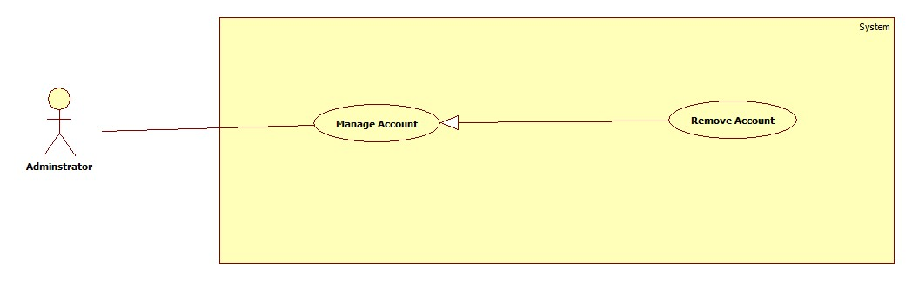

Figure : <Administrator> Remove Account

**Use case specification**

|  |  |  |  |
| --- | --- | --- | --- |
| **USE CASE – ECRM030** | |  |  |
| **Use Case No.** | ECRM030 | **Use Case Version** | 2.0 |
| **Use Case Name** | Remove Account |  |  |
| **Author** | Tang Viet Hung |  |  |
| **Date** | 21/05/2015 | **Priority** | Normal |
| **Actor:** Administrator | |  |  |
| **Summary:** This use case allows administrator to remove user’s account in system.  **Goal:** Remove user’s account  **Triggers:** Administrator wants to remove user’s account.  **Preconditions:**   * User must login with administrator role.   **Post Conditions:**   * **Success:** user’s account will be removing from system and show successful message. * **Fail:** Unsuccessful message will be shown.   **Main Success Scenario:**   |  |  |  | | --- | --- | --- | | Step | Actor Action | System Response | | 1 | Administrator focuses on “Account” | System navigates to “Manage Account” page.   * Table contains columns:   + - Username: Username of account     - Phone: Phone of account     - Status: Status of account * Remove: command | | 2 | Administrator selects account that they want to remove |  | | 3 | Administrator sends “remove” request. | Update status of account and show successful message: “Xóa tài khoản thành công!”  [Exception 1] |     **Alternative Scenario:** N/A  **Exceptions:** N/A  **Relationships:** N/A  **Business Rules:**   * After receiving request, system will change user’s status to “removed” * Only activated user can login to the system. | | | |

Table : <Administrator> Remove Account

* + - 1. **<System> Use case Overview**

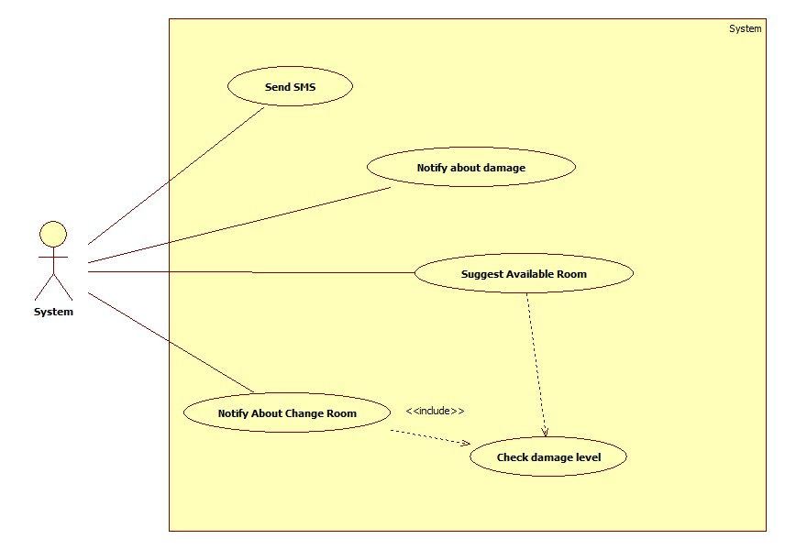

Figure : <System> Use case Overview

* + - 1. **<System> Send SMS**



Figure : <System> Send SMS

**Use case specification**

|  |  |  |  |
| --- | --- | --- | --- |
| USE CASE – ECRM031 | | | |
| Use Case No. | ECRM031 | **Use Case Version** | 2.0 |
| Use Case Name | Send SMS | | |
| Author | Tran Vinh Quang | | |
| Date | 21/05/2015 | **Priority** | Medium |
| Actor:   * System   Summary:   * This use case describes how the system sends SMS to users when necessary.   Goal:   * System will send SMS to users.   Triggers:   * System run a timer task that trigger check event.   Preconditions:   * Their must be at least one report has resolved in the system.   Post Conditions:   * Success: Show the status of report and notify to user. * Fail: System display error message.   Main Success Scenario:   |  |  |  | | --- | --- | --- | | Step | Actor Action | System Response | | 1 | System run timer task to check report state and sends SMS | System response:   * SMS that need to be sent to users.   [Exception 1] |   Exceptions:   |  |  |  | | --- | --- | --- | | No | Actor Action | System Response | | 1 | System timer task is interrupted | No notification will be sent. Error detail will be tracked in a log file. | | 2 | User do not have phone number | No SMS will be sent. Error tracked in log file. |   Relationships: N/A  Business rules:   * Using Twilio service to send and receive message. | | | |

Table : <System> Send SMS

* + - 1. **<System> Suggest Available Room**



Figure : <System> Suggest Available Room

**Use case specification**

|  |  |  |  |
| --- | --- | --- | --- |
| USE CASE – ECRM032 | | | |
| Use Case No. | ECRM032 | **Use Case Version** | 2.0 |
| Use Case Name | Sugges Available Room | | |
| Author | Tran Vinh Quang | | |
| Date | 21/05/2015 | **Priority** | Medium |
| Actor:   * System   Summary:   * This use case describes how the system suggests room to staff when necessary.   Goal:   * System will automatic check damage level and suggest room if necessary.   Triggers:   * System run a timer task that trigger check event.   Preconditions:   * Their must be at least one report has sent in the system.   Post Conditions:   * Success: Show the status of report and notify to user. * Fail: System display error message.   Main Success Scenario:   |  |  |  | | --- | --- | --- | | Step | Actor Action | System Response | | 1 | System run timer task to check damaged level. | System response:   * Damage level of report * System suggest available room if necessary   [Exception 1] | | 2 |  |  |   Exceptions:   |  |  |  | | --- | --- | --- | | No | Actor Action | System Response | | 1 | System timer task is interrupted | No notification will be sent. Error detail will be tracked in a log file. |   Relationships: include Check damage level  Business rules:   * If damaged level is larger than 50%, system will automatic suggest available room * Room change will be order by priority with current room. | | | |

Table : <System> Suggest Available Room

* + - 1. **<System> Notify about damaged**



Figure : <System> Notify about damaged

**Use case specification**

|  |  |  |  |
| --- | --- | --- | --- |
| USE CASE – ECRM033 | | | |
| Use Case No. | ECRM033 | **Use Case Version** | 2.0 |
| Use Case Name | Notify about damaged | | |
| Author | Tran Vinh Quang | | |
| Date | 21/05/2015 | **Priority** | Medium |
| Actor:   * System   Summary:   * This use case describes how the system notifies to staff when necessary.   Goal:   * System will send notification to staff.   Triggers:   * System run a timer task that trigger check event.   Preconditions:   * Their must be at least one report has sent in the system.   Post Conditions:   * Success: Show the status of report and notify to user. * Fail: System display error message.   Main Success Scenario:   |  |  |  | | --- | --- | --- | | Step | Actor Action | System Response | | 1 | System run timer task to check report state and sends notify | System response:   * Notifications that need to be sent to staff.   [Exception 1] |   Exceptions:   |  |  |  | | --- | --- | --- | | No | Actor Action | System Response | | 1 | System timer task is interrupted | No notification will be sent. Error detail will be tracked in a log file. |   Relationships: N/A  Business rules:   * System will send notify after report has sent. | | | |

Table : <System> Notify about damaged

* + - 1. **<System> Notify About Change Room**



Figure : <System> Notify About Change Room

**Use case specification**

|  |  |  |  |
| --- | --- | --- | --- |
| USE CASE – ECRM034 | | | |
| Use Case No. | ECRM034 | **Use Case Version** | 2.0 |
| Use Case Name | Notify about change room | | |
| Author | Tran Vinh Quang | | |
| Date | 21/05/2015 | **Priority** | Medium |
| Actor:   * System   Summary:   * This use case describes how the system notifies to staff when necessary.   Goal:   * System will send notification to teacher.   Triggers:   * System run a timer task that trigger check event.   Preconditions:   * Staff send request change room to server   Post Conditions:   * Success: Change room and send notification to teacher. * Fail: System display error message.   Main Success Scenario:   |  |  |  | | --- | --- | --- | | Step | Actor Action | System Response | | 1 | System run timer task to check report state and sends notify | System response:   * Check all schedule in room * Notifications that need to be sent to teacher.   [Exception 1] |   Exceptions:   |  |  |  | | --- | --- | --- | | No | Actor Action | System Response | | 1 | System timer task is interrupted | No notification will be sent. Error detail will be tracked in a log file. |   Relationships: N/A  Business rules: N/A | | | |

* 1. Software System Attribute
     1. **Usability**
        1. **Graphic User Interface**
* All the texts, labels should be written in Vietnamese
  + - 1. **Usability**
* Staff should need less 2 days of training to be productive with the system
* User need 2 hours of training to use mobile app or web application
* User Manual should be clear, easy to understand and increase experience for user.
  + - 1. **Installation**
* User can follow installation and manual guide for installation. If there are any problems, they can contact developer for help.
  + 1. **Reliability**
* System will notify staff about damaged equipment.
* System will notified or send SMS to user about fixing equipment.
* System will auto check about damage level to suggest how to resolve it.
* System will auto check status of room and change room if needed.
  + 1. **Availability**
* System should be online 24/7
  + 1. **Security**
* Privacy: Each role of user has a specific permission to interact with system
* System always checks authorization and authentication before doing anything
* All input data are validated before insert to database.
  + 1. **Maintainability**
* The system is divided into separated modules
* The code is easy to maintain and upgrade
  + 1. **Portability**
* Admin, Staff, User can use web application on every OS supported web browser.
* For mobile application, they must use Android smartphones that have version greater than 4.0.
  + 1. **Performance**
* The speed of suggestion should be less than 10 seconds
* The speed of report from user to staff should be less than 10 seconds
  1. **Conceptual Diagram**

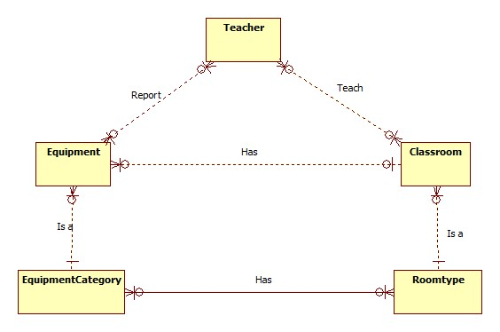

Figure : Conceptual Diagram

|  |  |
| --- | --- |
| Data dictionary | |
| Entity Name | **Description** |
| Teacher | Entity describes a user with role teacher in system |
| Equipement | Contain the equipment information. |
| Classroom | Contain the classroom information. |
| EquipmentCategory | Contain the equipment category information. |
| Roomtype | Contain the room type information. |

Table : Conceptual Diagram - Data Dictionary

1. **Software Design Description**
   1. **Design Overview**

* This document describes the technical and user interface design of ECRM system. It includes the architectural design, the detailed design of common functions, the business functions and the design of database model.
* The architectural design describes the overall architecture of the system and the architecture of each main component and subsystem.
* The detailed design describes static and dynamic structure for each component and functions. It includes class diagrams, class explanations and sequence diagrams for each use cases.
* The database design describes the relationships between entities and details of each entity.
* Document overview:
  + Section 1: gives an overall overview of this document.
  + Section 2: gives an overall description of the system architecture design.
  + Section 3: gives component diagrams that describe the connection and integration of the system.
  + Section 4: gives the detail design description, which includes class diagram, class explanation, and sequence diagram to details the application functions.
  + Section 5: describe a fully attributed Entity Relationship Diagram
  1. **System Architecture Design**



Figure : System Architecture Design

* + 1. **Web Application architecture description**

In Web Application, the system is developed under Spring MVC architecture style. We choose this architecture for Web application because of following advantages:

* Web app contains a Web service (public API for mobile app) with MVC architecture we can separate business code with Controller and View so we can use the business code in web service without repeat the code.
* In scope of 3-member team this, MVC architecture makes it easier to split the big project into small modules and make it easier to assign each module for members in our team.

This project follows MVC architecture with following components:

* **Web Service:** is the part of the application that acts like event handler for web and mobile communication via REST method.
* **Controller:** is the part of the application that acts like event handler to handles user interaction. Typically controller read data from a request and calls appropriate Business’s method then selects view to return to user.
* **JSP/HTML (View):** is the part of the application that handles the display of the data. The selection of View is under control of Controller.
* **Business:** is the part of the application that does business processing to solve domain problems.
* **Model:** is the part of the application that acts like a data transfer object between the system and database.
  + 1. **Mobile Application architecture description**

The application is developed as an Android native application. In general, the application architecture conforms to Android architecture.



Figure : Android Application Architecture

**Reference:** [Android Developer Guide - Application Fundamentals](http://developer.android.com/guide/components/fundamentals.html)

This project follows Android application architecture with following components:

* **Activity** is the basic core of an android application that handles user input, create thread to run asynchronous tasks, send request and receive data from server via web services ...
  1. **Component Diagram**



Figure : Component Diagram

|  |  |
| --- | --- |
| Component Dictionary: Describes components | |
| Web Application | Web application package: View, Controller. |
| Mobile Application | Mobile application package. |
| Web Service | Include all web API controllers of the system. Include all web API controllers of the system |
| Staff Component | Component to handle staff activities in the system |
| Teacher Component | Component to handle teacher activities in the system |
| Manage Account | Business logic for manage account processing. |
| Business Objects | Handle business operations for every component. |
| Suggest Room | Business logic for suggest room processing. |
| Check Damaged Level | Business logic for checking damaged level processing. |

Table : Component Dictionary

* 1. **Detail Description**
     1. **Class Diagram**

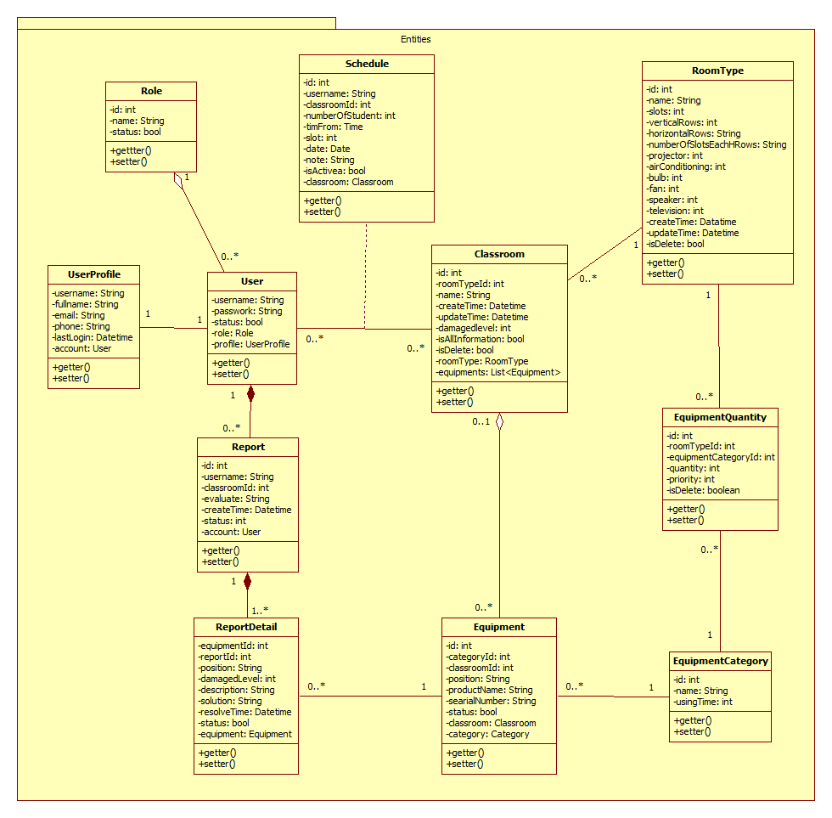

Figure : Class Diagram

* + 1. **Class Diagram Explanation**
       1. **User**

|  |  |  |  |
| --- | --- | --- | --- |
| Attribute | Type | Visibility | Description |
| Username | String | Private | Username of user in system |
| Password | String | Private | Password of user in system |
| Status | Boolean | Private | Status of account |
| Role | Role | Private | Role of user in system |
| Profile | UserProfile | Private | Detail profile of user |

|  |  |  |  |
| --- | --- | --- | --- |
| Method | Return Type | Visibility | Description |
| Getter | Attribute type | Public | Get attribute value. |
| Setter | Void | Public | Set value of attribute. |

* + - 1. **Role**

|  |  |  |  |
| --- | --- | --- | --- |
| Attribute | Type | Visibility | Description |
| Id | Integer | Private | Id of role in system |
| Name | String | Private | Name of role in system |
| Status | Boolean | Private | Status of role |

|  |  |  |  |
| --- | --- | --- | --- |
| Method | Return Type | Visibility | Description |
| Getter | Attribute type | Public | Get attribute value. |
| Setter | Void | Public | Set value of attribute. |

* + - 1. **UserProfile**

|  |  |  |  |
| --- | --- | --- | --- |
| Attribute | Type | Visibility | Description |
| Username | String | Private | Username of user in system |
| Fullname | String | Private | Full name of user in system |
| Email | String | Private | Email of user in system |
| Phone | String | Private | Phone number of user in system |
| LastLogin | Datetime | Private | Last login of user to system |

|  |  |  |  |
| --- | --- | --- | --- |
| Method | Return Type | Visibility | Description |
| Getter | Attribute type | Public | Get attribute value. |
| Setter | Void | Public | Set value of attribute. |

* + - 1. **Schedule**

|  |  |  |  |
| --- | --- | --- | --- |
| Attribute | Type | Visibility | Description |
| Id | Integer | Private | Id of schedule in system |
| Username | String | Private | Username of account in system |
| ClassroomId | Integer | Private | Classroom Id of schedule |
| NumberOfStudent | Integer | Private | Number of student is schedule |
| timeFrom | Time | Private | Time start schedule |
| Slot | Integer | Private | Slot of schedule in day |
| Date | Date | Private | Date of schedule |
| Note | String | Private | Note of schedule |
| IsActive | Boolean | Private | Status of schedule |

|  |  |  |  |
| --- | --- | --- | --- |
| Method | Return Type | Visibility | Description |
| Getter | Attribute type | Public | Get attribute value. |
| Setter | Void | Public | Set value of attribute. |

* + - 1. **Classroom**

|  |  |  |  |
| --- | --- | --- | --- |
| Attribute | Type | Visibility | Description |
| Id | Integer | Private | Id of classroom in system |
| RoomTypeId | Integer | Private | Id of room type of classroom |
| Name | String | Private | Name of classroom in system |
| CreateTime | Datetime | Private | Time create classroom in system |
| UpdateTime | Datetime | Private | Time update classroom in system |
| DamagedLevel | Integer | Private | Damage level of classroom |
| IsAllInformation | Boolean | Private | Classroom has all information or not |
| IsDelete | Boolean | Private | Classroom is deleted or not |

|  |  |  |  |
| --- | --- | --- | --- |
| Method | Return Type | Visibility | Description |
| Getter | Attribute type | Public | Get attribute value. |
| Setter | Void | Public | Set value of attribute. |

* + - 1. **RoomType**

|  |  |  |  |
| --- | --- | --- | --- |
| Attribute | Type | Visibility | Description |
| Id | Integer | Private | Id of room type in system |
| Name | String | Private | Name of room type in system |
| Slots | Integer | Private | Number of slot in room type |
| VerticalRows | Integer | Private | Number of vertical rows of room type |
| HorizontalRows | Integer | Private | Number of horizontal row of room type |
| NoSlotEachRows | Integer | Private | Number of slot in each row of room type |
| CreateTime | Datetime | Private | Time create room type in system |
| IsDelete | Boolean | Private | Check room type has deleted or not |
| UpdateTime | Datetime | Private | Time update room type in system |

|  |  |  |  |
| --- | --- | --- | --- |
| Method | Return Type | Visibility | Description |
| Getter | Attribute type | Public | Get attribute value. |
| Setter | Void | Public | Set value of attribute. |

* + - 1. **EquipmentQuantity**

|  |  |  |  |
| --- | --- | --- | --- |
| Attribute | Type | Visibility | Description |
| Id | Integer | Private | Id of tables |
| RoomTypeId | Integer | Private | Room type id of system |
| EquipmentCategoryId | Integer | Private | Id of equipment category in system |
| Quantity | Integer | Private | Quantity of equipment category in room type |
| Priority | Integer | Private | Priority of equipment category in roomtype |
| IsDelete | Boolean | Private | Check equipment quantity has deleted or not |

|  |  |  |  |
| --- | --- | --- | --- |
| Method | Return Type | Visibility | Description |
| Getter | Attribute type | Public | Get attribute value. |
| Setter | Void | Public | Set value of attribute. |

* + - 1. **EquipmentCategory**

|  |  |  |  |
| --- | --- | --- | --- |
| Attribute | Type | Visibility | Description |
| Id | Integer | Private | Id of category in system |
| Name | String | Private | Name of category in system |
| UsingTime | Integer | Private | Using time of category |
| IsManaged | Boolean | Private | Check category is managed or not |
| ImageUrl | String | Private | Link to image of category |
| IsDelete | Boolean | Private | Check category is deleted or not |
| UpdateTime | Datetime | Private | Update time of category in system |

|  |  |  |  |
| --- | --- | --- | --- |
| Method | Return Type | Visibility | Description |
| Getter | Attribute type | Public | Get attribute value. |
| Setter | Void | Public | Set value of attribute. |

* + - 1. **Equipment**

|  |  |  |  |
| --- | --- | --- | --- |
| Attribute | Type | Visibility | Description |
| Id | Integer | Private | Id of equipment in system |
| CategoryId | Integer | Private | Id of category in system |
| ClassroomId | Integer | Private | Id of classroom in system |
| Position | String | Private | Position of equipment in classroom |
| Status | Boolean | Private | Status of equipment in classroom |
| TimeRemain | Integer | Private | Time remain of equipment |
| Name | String | Private | Equipment name in system |
| SerialNumber | String | Private | Equipment serial number |
| IsDelete | Boolean | Private | Check equipment is delete or not |
| UsingTime | Integer | Private | Using time of equipment |

|  |  |  |  |
| --- | --- | --- | --- |
| Method | Return Type | Visibility | Description |
| Getter | Attribute type | Public | Get attribute value. |
| Setter | Void | Public | Set value of attribute. |

* + - 1. **ReportDetail**

|  |  |  |  |
| --- | --- | --- | --- |
| Attribute | Type | Visibility | Description |
| EquipmentId | Integer | Private | Id of equipment |
| ReportId | Integer | Private | Id of report |
| DamagedLevel | String | Private | Damage of equipment |
| Position | String | Private | Position of equipment |
| Description | String | Private | Description about damage equipment |
| Solution | String | Private | Solution to resolve equipment |
| ResolveTime | Datetime | Private | Time resolve equipment |
| Status | Boolean | Private | Status of report detail |

|  |  |  |  |
| --- | --- | --- | --- |
| Method | Return Type | Visibility | Description |
| Getter | Attribute type | Public | Get attribute value. |
| Setter | Void | Public | Set value of attribute. |

* + - 1. **Report**

|  |  |  |  |
| --- | --- | --- | --- |
| Attribute | Type | Visibility | Description |
| Id | Integer | Private | Id of report in system |
| Username | String | Private | Username of user report |
| CreateTime | Datetime | Private | Time create report |
| Evaluate | String | Private | Evaluate about report |
| Status | Boolean | Private | Status of report |
| ChangedRoom | String | Private | Room change |

|  |  |  |  |
| --- | --- | --- | --- |
| Method | Return Type | Visibility | Description |
| Getter | Attribute type | Public | Get attribute value. |
| Setter | Void | Public | Set value of attribute. |

* + - 1. **Message**

|  |  |  |  |
| --- | --- | --- | --- |
| Attribute | Type | Visibility | Description |
| Id | Integer | Private | Id of message in system |
| Username | String | Private | Username of user send message |
| Body | String | Private | Body of message |
| IsRead | Boolean | Private | Check status of message is read or not |

|  |  |  |  |
| --- | --- | --- | --- |
| Method | Return Type | Visibility | Description |
| Getter | Attribute type | Public | Get attribute value. |
| Setter | Void | Public | Set value of attribute. |

* + 1. **Interactive Diagram**
       1. **Web Application**
          1. **Staff**

**<Staff> Create Room Type**

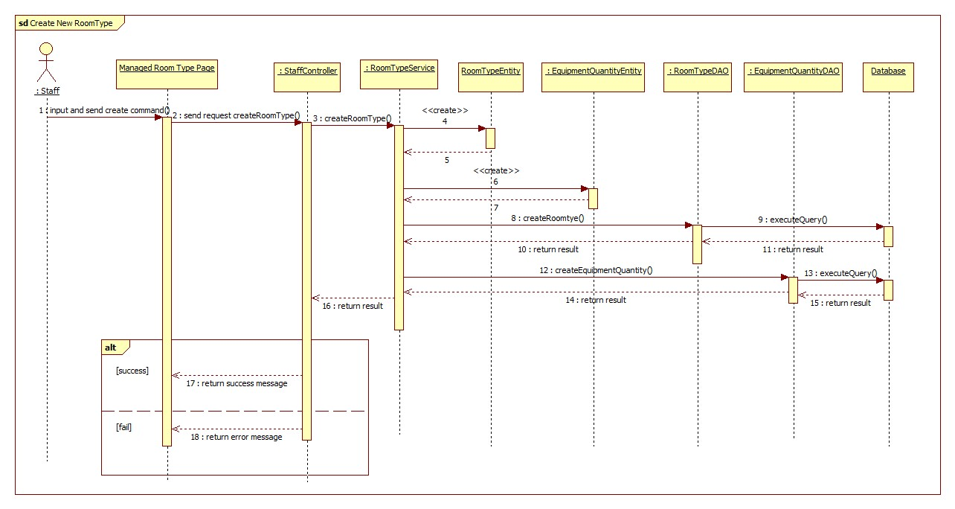

Figure : <Staff> Create Room Type - Interactive Diagram

**<Staff> Update Room Type**

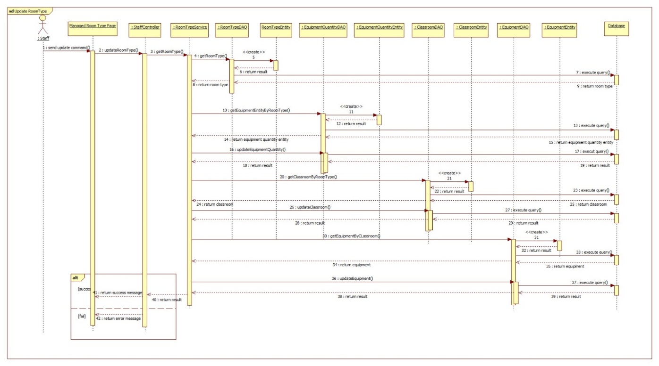

Figure : <Staff> Update Room Type - Interactive Diagram

**<Staff> Remove Room Type**

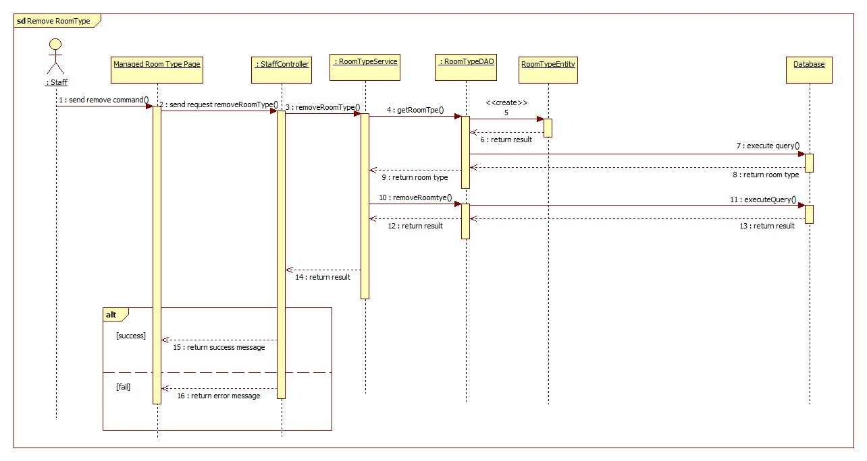

Figure : <Staff> Remove Room Type - Interactive Diagram

**<Staff> Change Room**

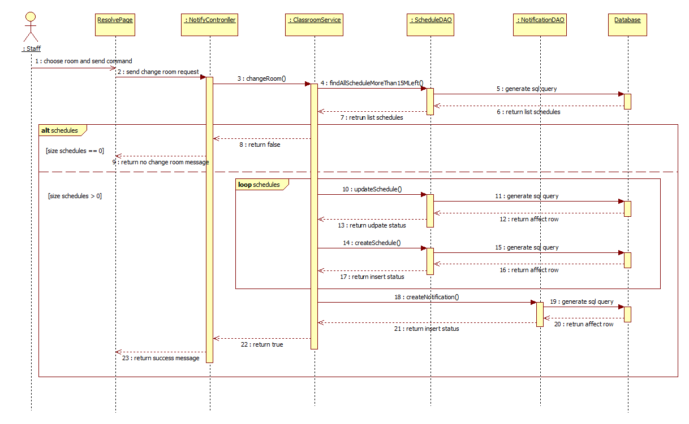

Figure : <Staff> Change Room – Interactive Diagram

**<Staff> Resolve Report**

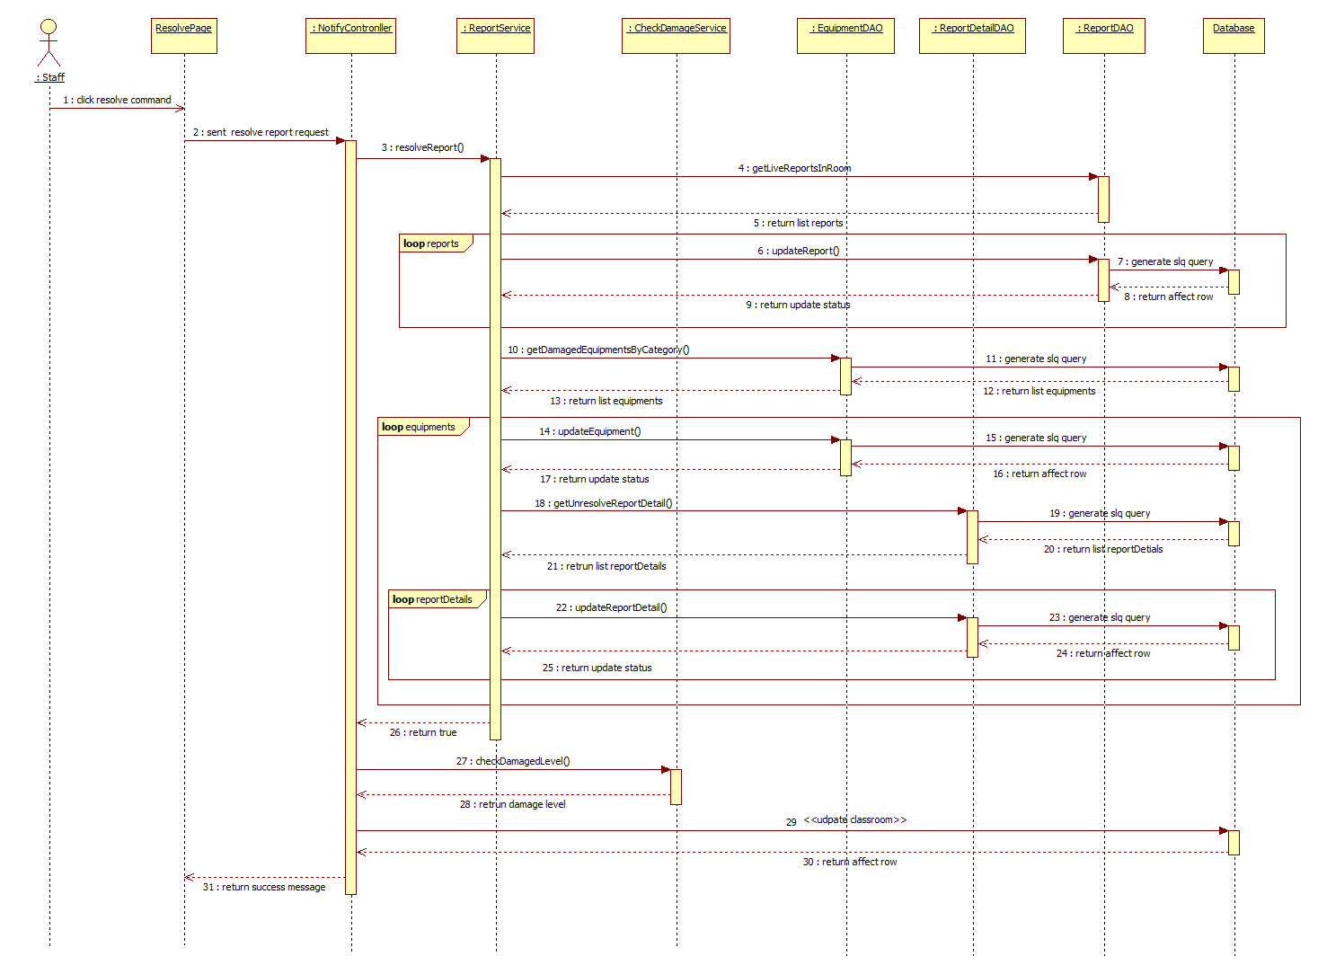

Figure : <Staff> Resolve Report – Interactive Diagram

**<Staff> Create Classroom**

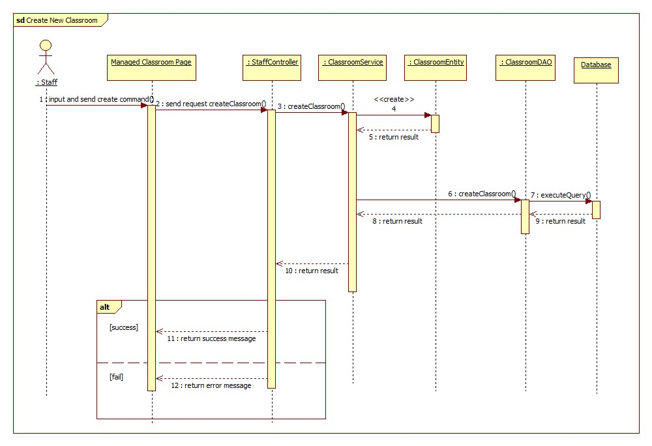

Figure : <Staff> Create Classroom - Interactive Diagram

**<Staff> Update Classroom**

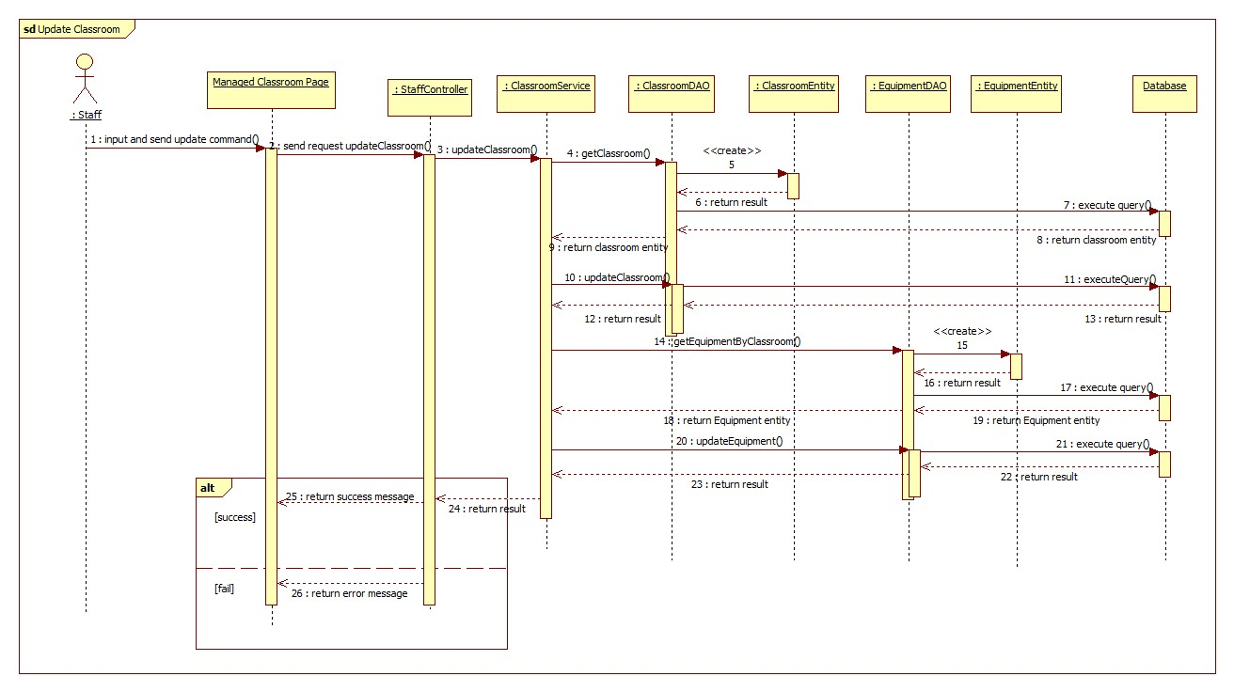

Figure : <Staff> Update Classroom - Interactive Diagram

**<Staff> Remove Classroom**

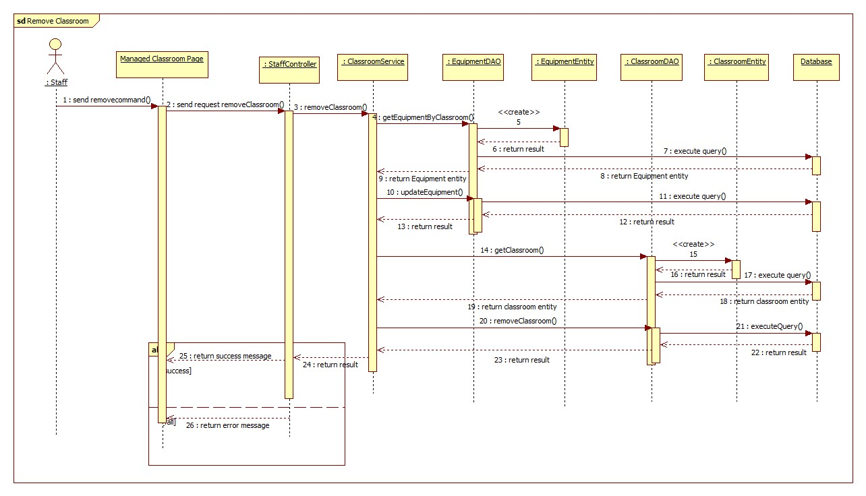

Figure : <Staf> Remove Classroom - Interactive Diagram

**<Staff> Create Equipment**

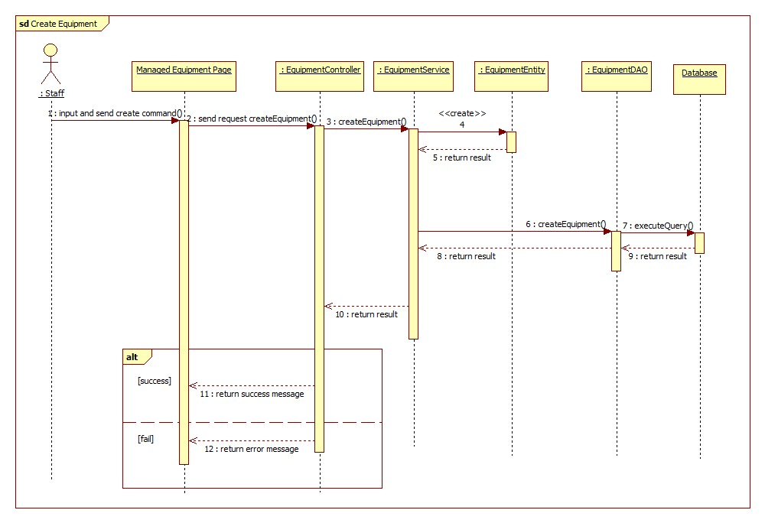

Figure : <Staff> Create Equipment - Interactive Diagram

* + - * 1. **Teacher**

**<Teacher> Create Report**

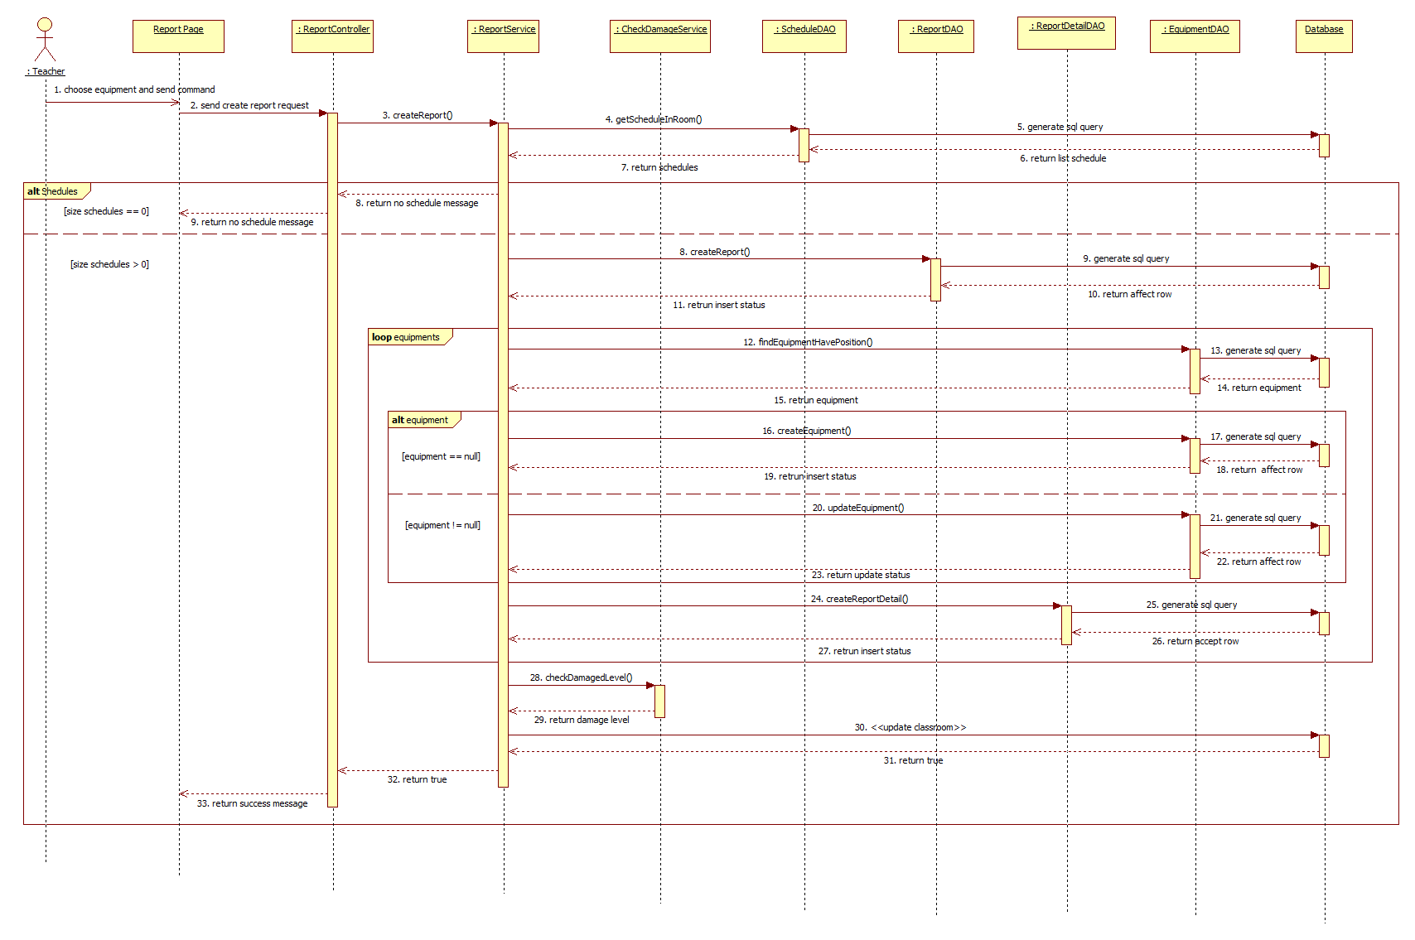

Figure : <Teacher> Create Report

* + - 1. **Mobile Application**
         1. **ECRM Staff**

**<Staff> Search Report**

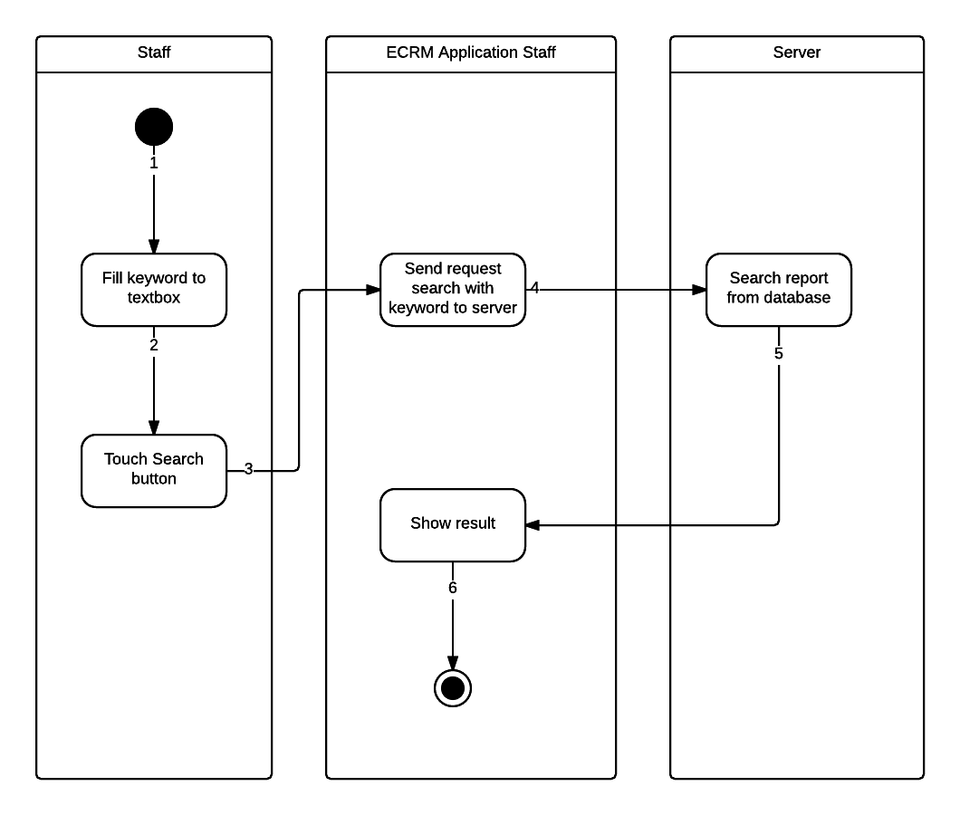

Figure : <Staff> Search Report - Interactive Diagram

**<Staff> Change Room**

There are two ways for staff to change room in mobile application:

* Change room for report:

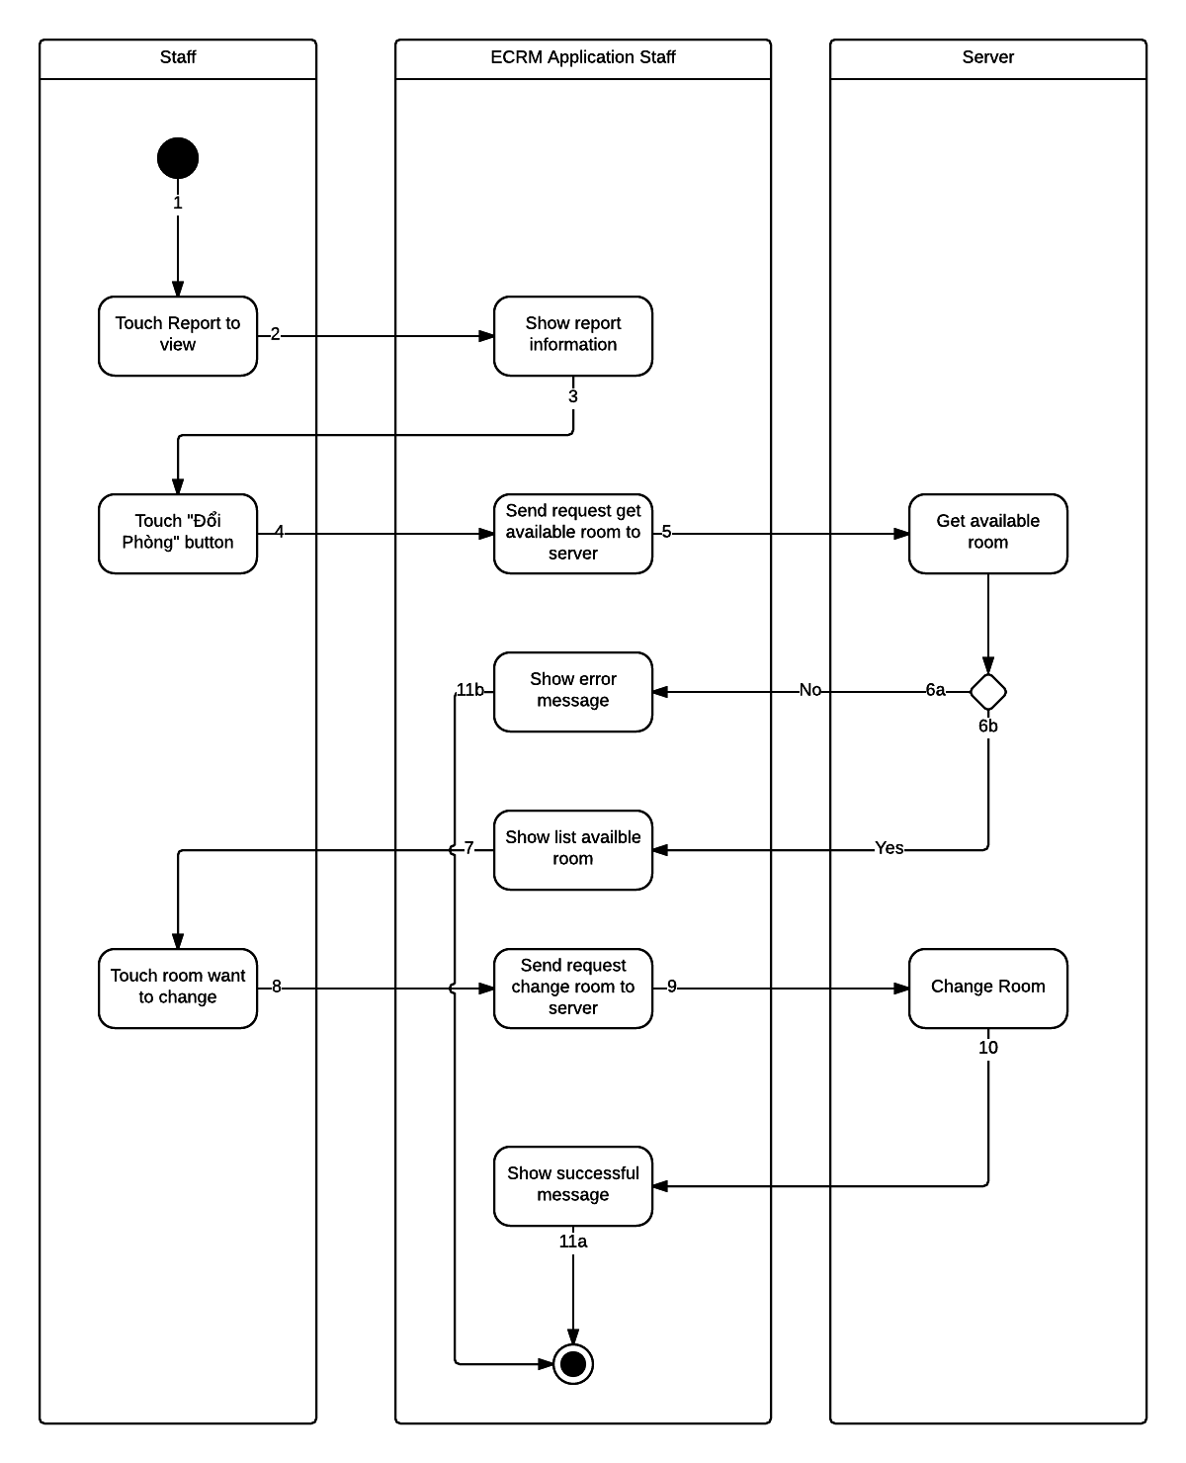

Figure : <Staff> Change Room for Report - Interactive Diagram

* Change room manual:

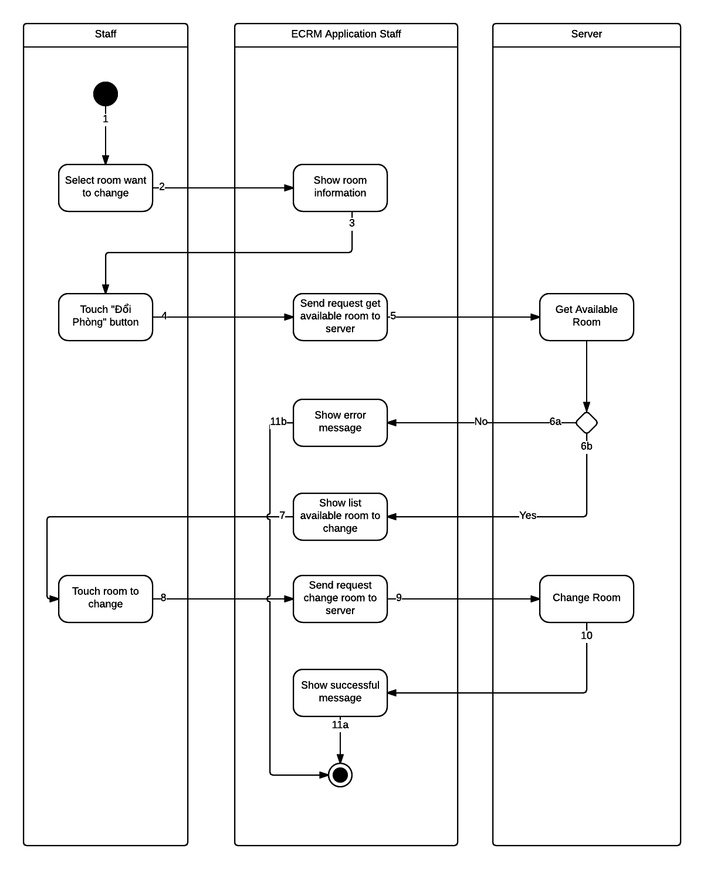

Figure : <Staff> Change Room Manual - Interactive Diagram

**<Staff> View Report Information**

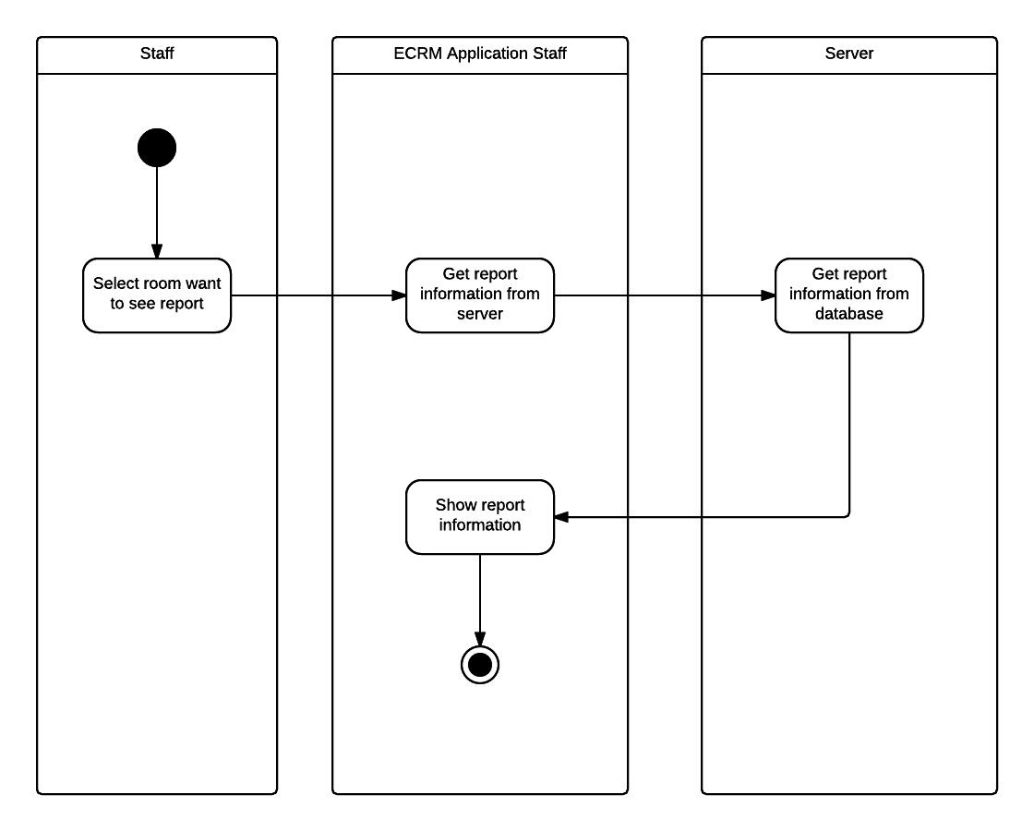

Figure : <Staff> View Report - Interactive Diagram

**<Staff> Resolve Report**

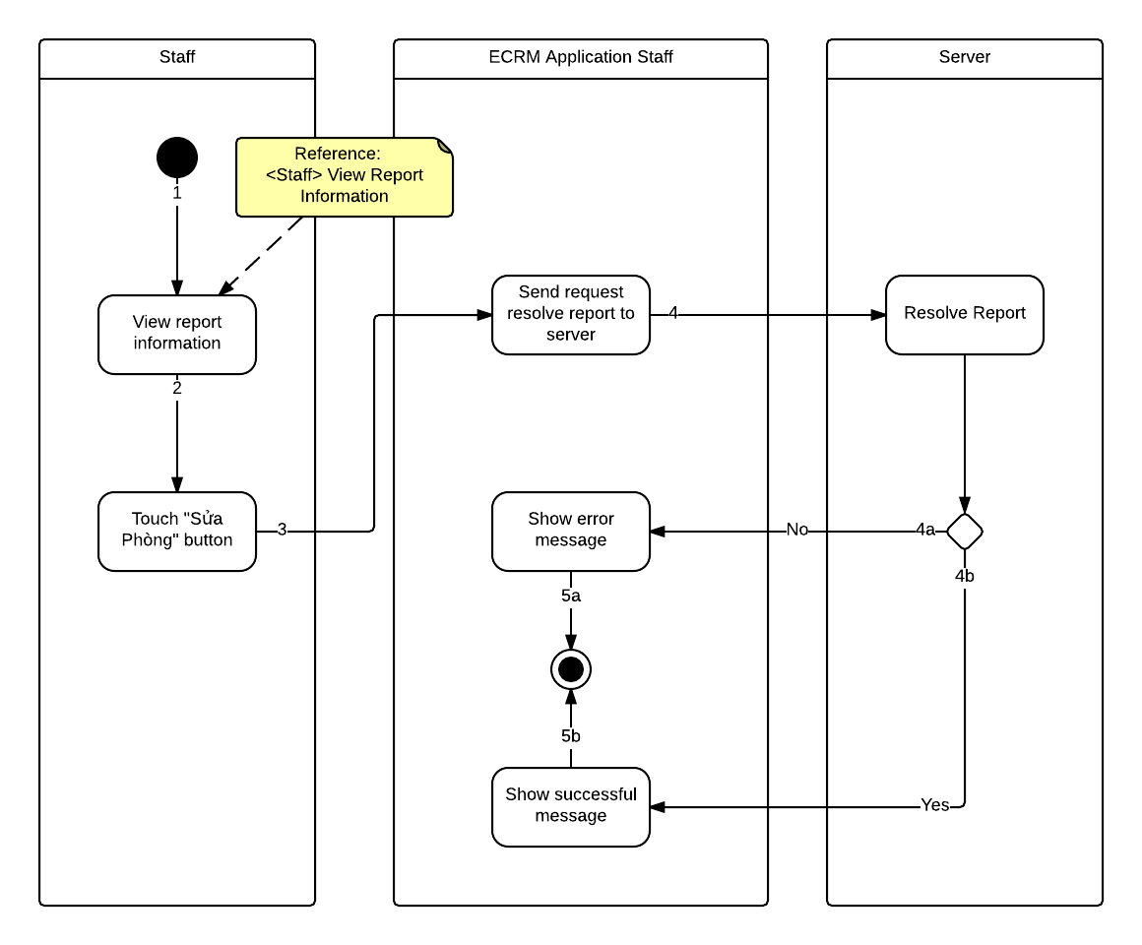

Figure : <Staff> Resolve Report - Interactive Diagram

**<Staff> Remove Report**

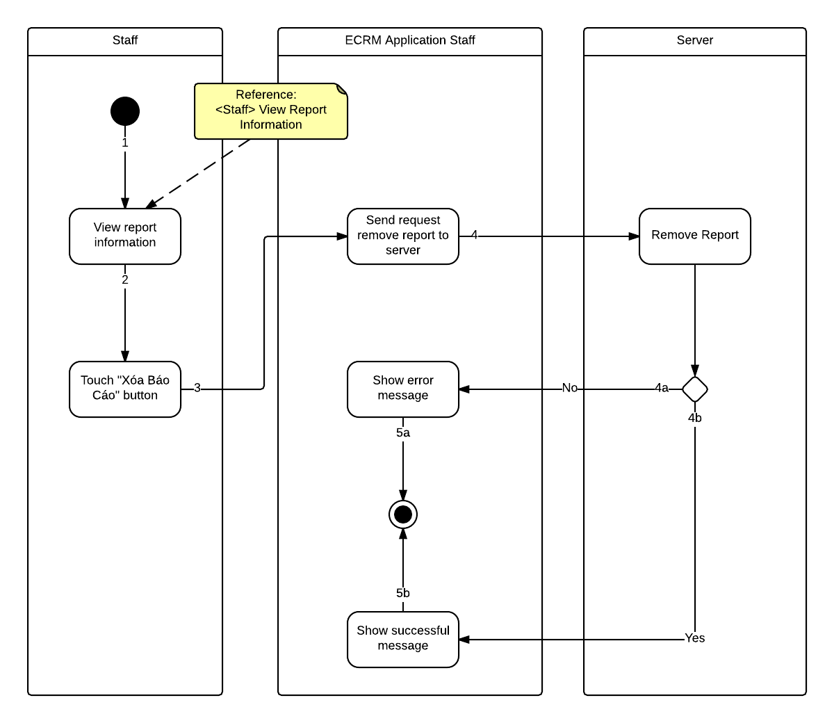

Figure : <Staff> Remove Report - Interactive Diagram

* + - * 1. **ECRM Teacher**

**<Teacher> Create Report**

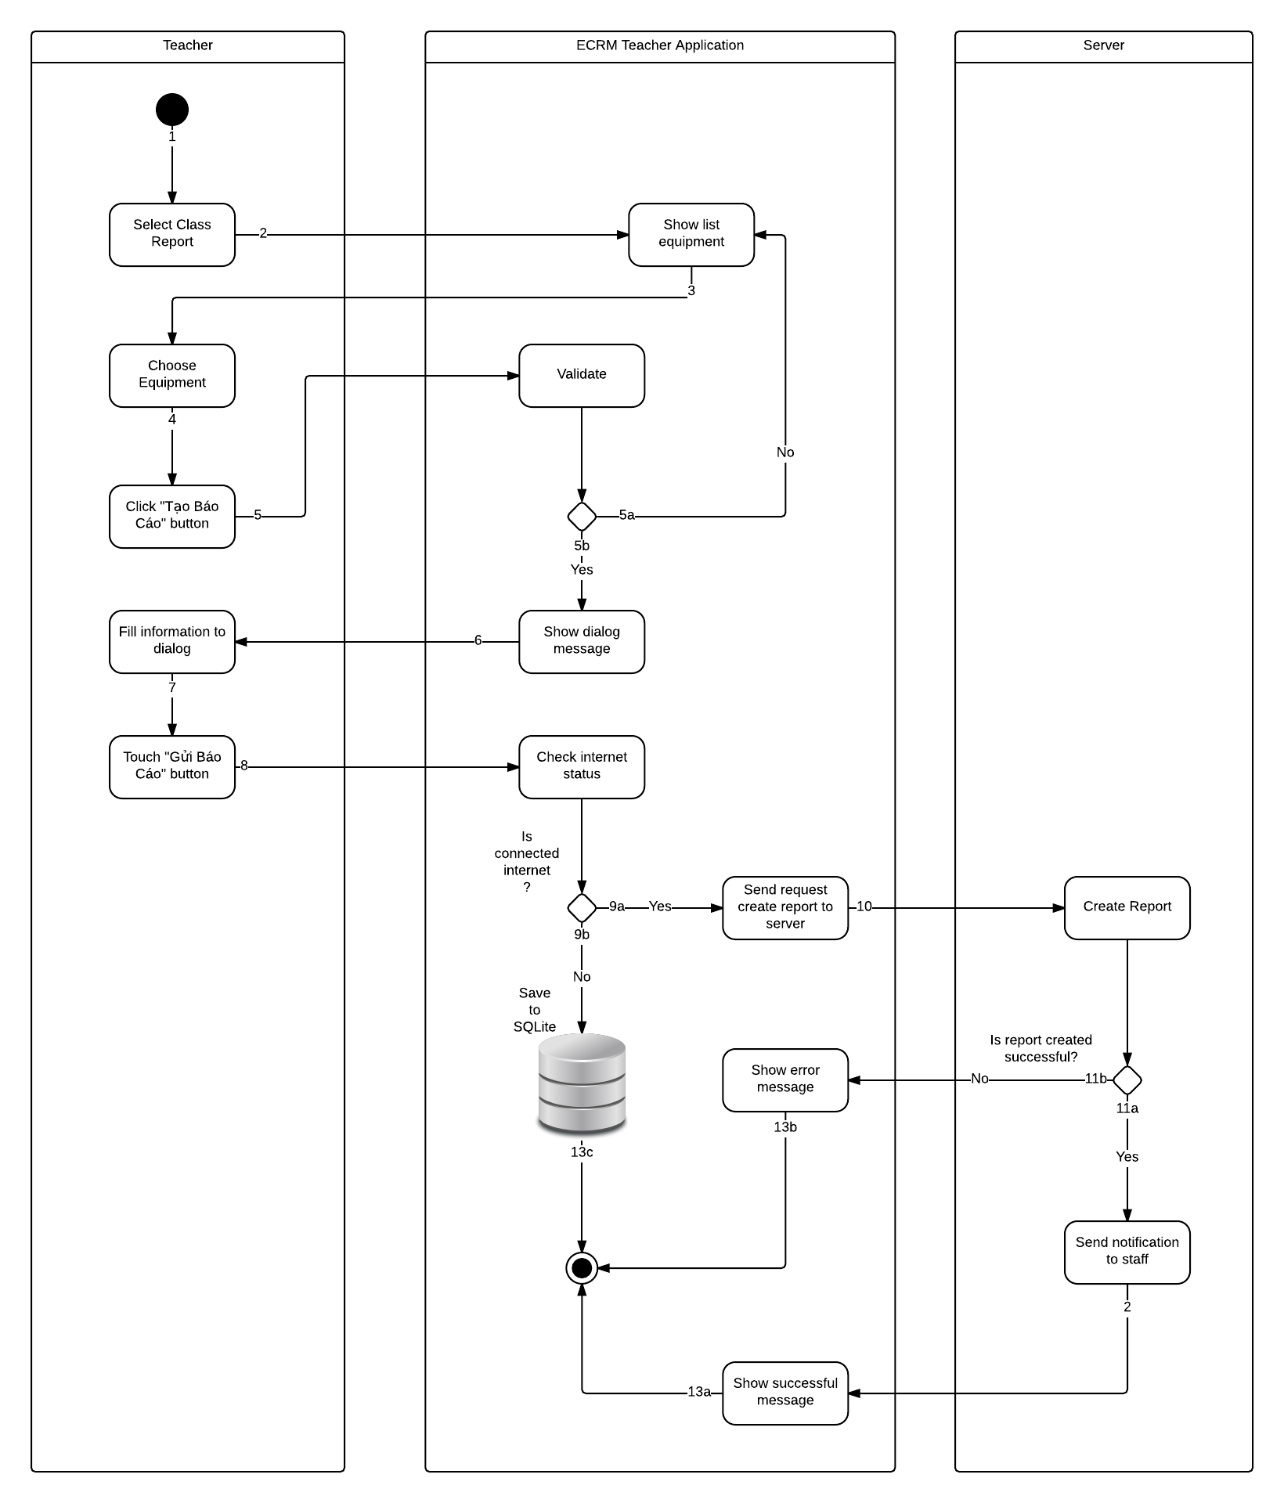

Figure : <Teacher> Create Report - Interactive Diagram

**<Teacher> View Report**



Figure : <Teacher> View Report - Interactive Diagram

**<Teacher> Edit Report**

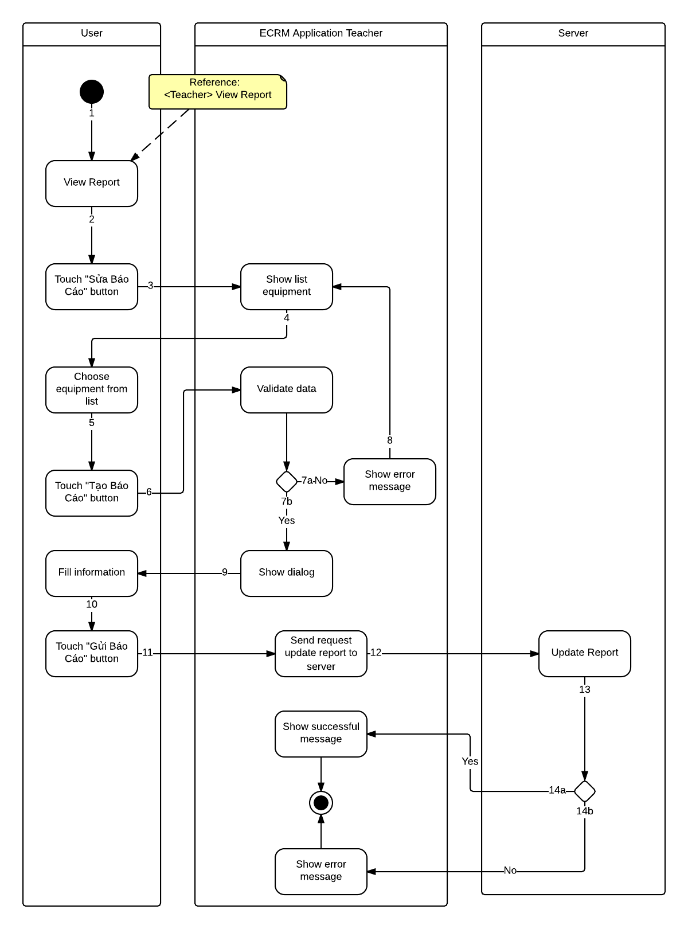

Figure : <Teacher> Update Report - Interactive Diagram

**<Teacher> Remove Report**

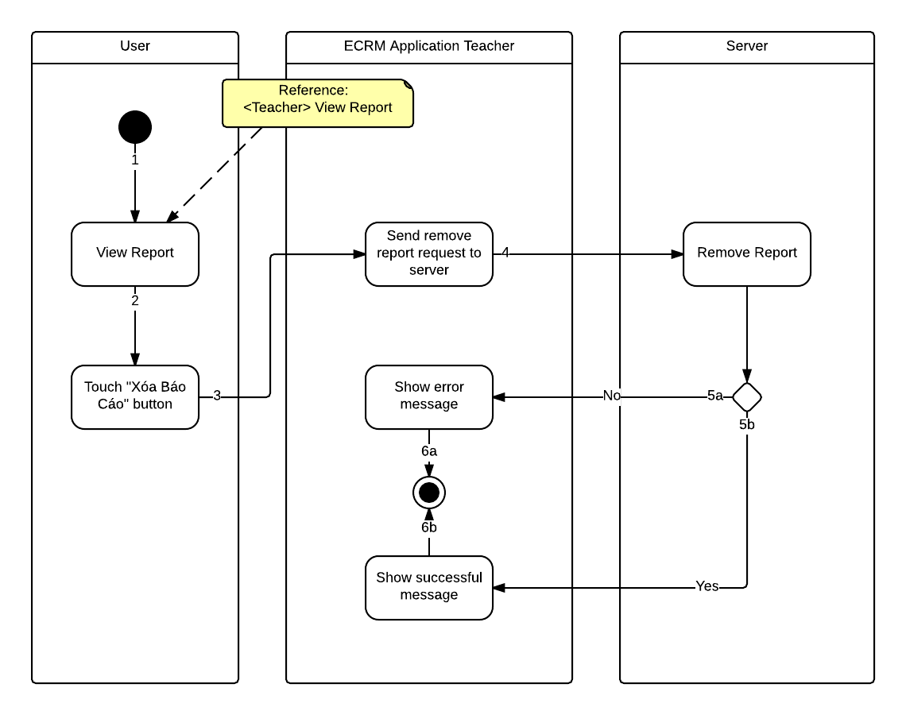

Figure : <Teacher> Remove Report - Interactive Diagram

**<Teacher> Change Password**

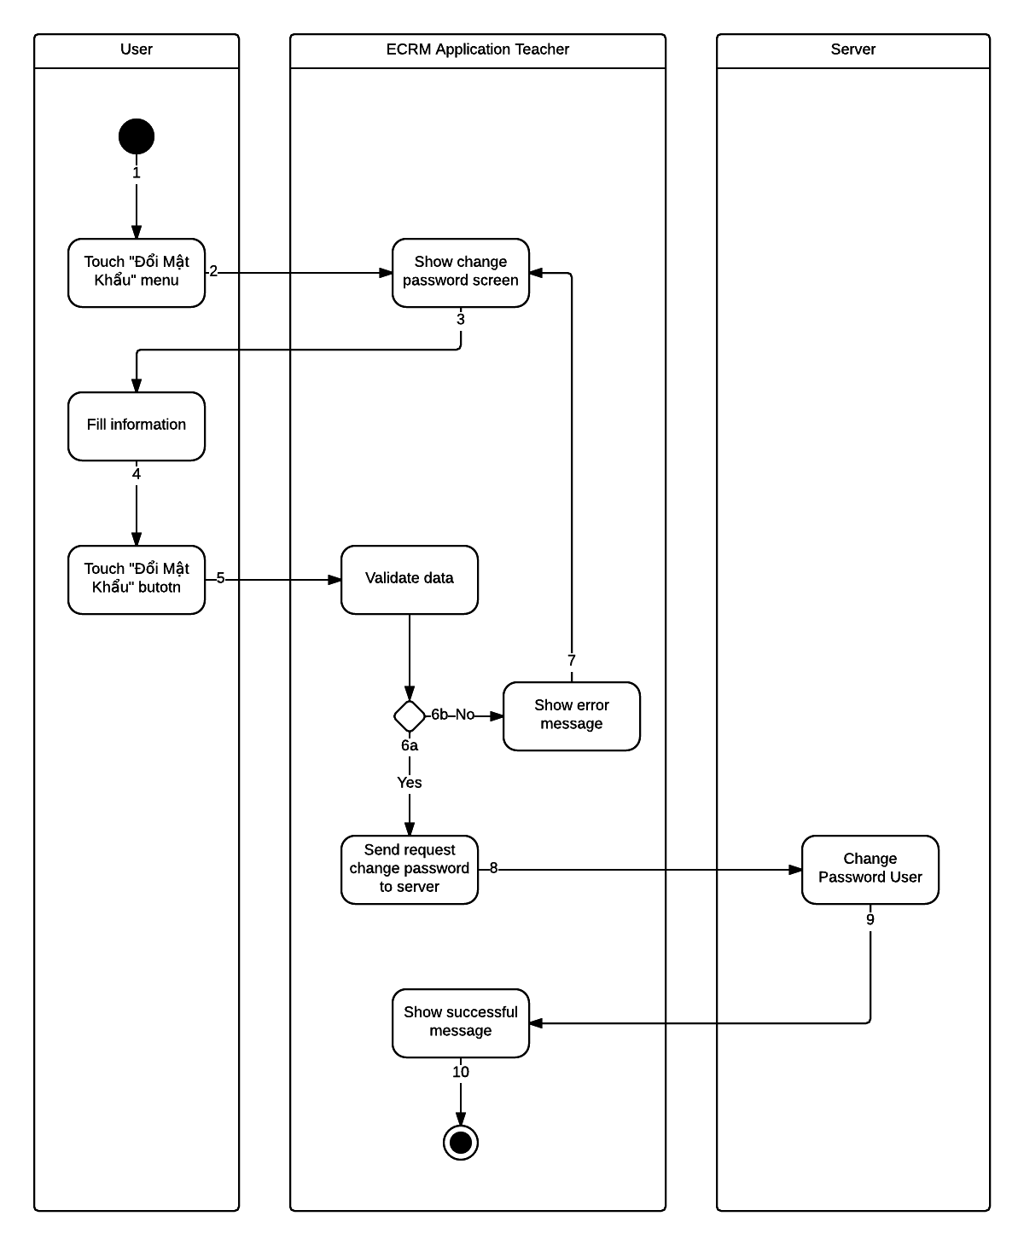

Figure : <Teacher> Change Password - Interactive Diagram

* 1. **Interface**
     1. **Component Interface**
        1. **Web Service Interface**

|  |  |  |  |  |  |
| --- | --- | --- | --- | --- | --- |
| Signature | Description | Input | Output | Output Format | Exception |
| public ResultDTO checkConnection() | Check server status | N/A | Json Boolean the status of server | Boolean | JsonProcessingException |
| Contractlean if the update is successntractpublic AccountDTO Login(String username, String password) | Login to system with account r | Request contains:  Username: String  Password: String | Json AccountEntity object | AccountEntity | JsonProcessingException  NoResultException |
| public List<CategoryDTO> getCategory(String username) | Get all equipment category in system | Request contains:  Username: String | Json String List of CategoryDTO | List CategoryEntity | JsonProcessingException  NoResultException |
| public List<ScheduleDTO> getSchedule(String username) | Get schedule in day of account | Request contains:  Username: String | Json String List of ScheduleDTO | List ScheduleEntity | JsonProcessingException  NoResultException |
| public List<EquipmentClassDTO> getEquipment(Integer classId) | Get equipment of classroom | Request contains:  classId: Integer | Json String List of EquipmentClassDTO | List EquipmentEntity | JsonProcessingException  NoResultException |
| public ResultDTO createReport(Report r) | Create report from mobile | Request object r contains:  Username: String  classId: Integer  listDamaged: String  listPosition: String  listDescription: String  evaluate: String  listEvaluate: String  createTime: String | Json String ResultDTO | ResultEntity | JsonProcessingException  NoResultException |
| public List<ReportDTO> getReportByUsername(String username, Integer offset, Integer limit) | Get limit report of user has username from offset | Request contains:  Username: String  Offset: Integer  Limit: Integer | Json String List ReportDTO | List ReportEntity | JsonProcessingException  NoResultException |
| public List<ReportClassDTO> getReportStaff(String status, Integer limit, Integer offset) | Get limi report of staff with status from offset | Request contains:  Status: String  Limit: Integer  Offset: Integer | Json String List ReportDTO | List ReportClassEntity | JsonProcessingException  NoResultException |
| public List<String> getAvailableRoom(Integer classId) | Get available room with same options with current room. | Request contains:  classId: Integer | Json String List Classroom | List String Classroom | JsonProcessingException  NoResultException |
| public ResultDTO changeRoom(IInteger from, Integer to) | Change schedule of user from current room to new room | Request contains:  from: Integer  to: Integer | Json String ResultDTO | ResultEntity | JsonProcessingException. |
| public ClassDTO getClassroom(Integer classId) | Get properties of classroom to save local | Request contains:  classId: Integer | Json String ClassDTO | ClassEntity | JsonProcessingException  NoResultException |
| public List<ScheduleDTO> getAllSchedule(String username) | Get all schedule in week of user | Request contains:  Username: String | Json String List ScheduleDTO | ScheduleEntity | JsonProcessingException  NoResultException |
| public ResultDTO remove(String username, Integer reportId) | Remove report | Request contains:  Username: String  reportId: Integer | Json String ResultDTO | ResultEntity | JsonProcessingException  NoResultException |
| public ResultDTO editReport | Edit report | Request contains:  reportId: String  Username: String  classId: Integer  listDamaged: String  listPosition: String  listDescription: String  evaluate: String  listEvaluate: String  createTime: String | Json String ResultDTO | ResultEntity | JsonProcessingException  NoResultException |
| public ResultDTO sendNotification (String message, String ListUser) | Send message to listUser by GCM notification | Request contains:  Message: String  ListUser: String | Json String ResultDTO | ResultEntity | JsonProcessingException  NoResultException |
| public ResultDTO sendSMS (String message, String listUser) | Send message to listUser by SMS | Request contains:  Message: String  ListUser: String | Json String ResultDTO | ResultEntity | JsonProcessingException  NoResultException |
| public boolean checkSchedule(Integer classId) | Check class has schedule after current time or not | Request contains:  classId: Integer | Json Boolean | Boolean | JsonProcessingException  NoResultException |
| public ResultDTO resolveReport (String listRoom) | Resolve report by room | Request contains:  listRoom: String | Json String ResultDTO | ResultEntity | JsonProcessingException  NoResultException |
| public int getFloor() | Get number of floor in school | N/A | Json String Integer | Integer | NoResultException |
| public List<List<ClassDTO>> getRoomInFloor() | Get all classroom in school. | N/A | Json String List of List ClassDTO | ClassEntity | JsonProcessingException  NoResultException |

Table : Web Service Interface

**Entity**

|  |  |
| --- | --- |
| Entity | Description |
| ResultEntity | Integer error_code  String error |
| AccountEntity | String username  String password  String fullname  String phone  String role  String lastLogin  String status |
| CategoryEntity | String id  String name  String imageUrl |
| ScheduleEntity | Integer classId  String className  String timeFrom  String timeTo  String date |
| ReportEntity | Integer reportId  String username  String fullname  Integer classId  String className  String createTime  String evaluate  Boolean status  Integer damageLevel  String changedRoom  List<ReportDetailEntity> listEquipments |
| EquipmentEntity | String equipmentName  String timeRemain  String company  Boolean isDamaged |
| ReportDetailEntity | String equipmentName  String description  String damaged  Boolean status  String solution  Timestamp resolveTime |
| ReportClassEntity | Integer roomId  String roomName  String timeReport  Integer damageLevel  String evaluate  String userReport  Integer systemEvaluate  String changeRoom  List<EquipmentReportEntity> listEquipments |
| EquipmentReportEntity | Integer reportId  Integer equipmentId  String equipmentName  Integer quantity  Boolean status  String evaluate  String damage |
| ClassEntity | Integer classId  String className  Integer damageLevel |

Table : Web Service Interface - Entity

**Exceptions**

|  |  |
| --- | --- |
| Exception | Description |
| JsonProcessingException | encountered when processing (parsing, generating) JSON content that are not pure I/O problems |
| NoResultException | Thrown by the persistence provider when getSingleResult() is executed on a query and there is no result to return |

Table : Web Service Interface - Exceptions

* + 1. **Web Application Design**
       1. **User Interface Design**
          1. **Home Page Screen**



Figure : Home Page Screen

**Fields**

|  |  |  |  |  |  |  |  |
| --- | --- | --- | --- | --- | --- | --- | --- |
| No | Field Name | Description | Read only | Mandatory | Control Type | Data Type | Length |
| 1 | lblTotal | Total schedule of teacher in day | Yes | Yes | Label | String | 0 – 10 |
| 2 | lblTimeStart | Time start of each schedule | Yes | Yes | Label | String | 0 – 10 |
| 3 | lblScheRoom | Room name of schedule | Yes | Yes | Label | String | 0 - 30 |
| 4 | lblRoom | Room name of report | Yes | Yes | Label | String | 0 – 30 |
| 5 | lblEquipment | List of equipment has reported | Yes | Yes | Label | String | 0 – 30 |
| 6 | lblTimeReport | Time user create report | Yes | Yes | Label | String | 0 – 30 |
| 7 | lblStatus | Current status of report | Yes | Yes | Label | String | 0 – 30 |

Table : Home Page Screen – Fields

**Buttons**

|  |  |  |  |  |
| --- | --- | --- | --- | --- |
| No | Function | Description | Validation | Outcome |
| 8 | btnView | View detail report | No | Show form include all information about report |
| 9 | btnCreate | Create new report | No | Navigate to create report screen. |

Table : Home Page Screen - Buttons

* + - * 1. **Create Report Screen**



Figure : Create Report Screen

**Fields**

|  |  |  |  |  |  |  |  |
| --- | --- | --- | --- | --- | --- | --- | --- |
| No | Field Name | Description | Read only | Mandatory | Control Type | Data Type | Length |
| 1 | ddlRoom | Room user want report | No | Yes | Dropdown list | String | 0 – 10 |
| 2 | ddlEvaluate | Evaluate of user about room | No | Yes | Dropdown list | String | 0 – 50 |
| 3 | imgEquipment | Equipment image | Yes | Yes | Image | Image | N/A |
| 5 | ddlDamage | Damage of equipment | No | Yes | Dropdown list | String | 0 – 50 |
| 6 | txtDetail | Detail damage of equipment | No | No | String | String | 0 – 50 |

Table : Create Report Screen – Fields

**Buttons**

|  |  |  |  |  |
| --- | --- | --- | --- | --- |
| No | Function | Description | Validation | Outcome |
| 4 | btnDamage | Check equipment has damaged | No | Show view for user to fill information about damaged |
| 7 | btnCreate | Create new report | No | Create report base on information has filled |
| 8 | btnBack | Back to previous page | No | Back to previous page |
| 9 | tabDetail | Show tab detail | No | Navigate to tab detail |
| 10 | tabMap | Show tab map | No | Navigate to tab map classroom. |

Table : Create Report Screen - Buttons

* + - 1. **Staff Interface Design**
         1. **Manage Report Screen**



Figure : Manage Report Screen

**Fields**

|  |  |  |  |  |  |  |  |
| --- | --- | --- | --- | --- | --- | --- | --- |
| No | Field Name | Description | Read only | Mandatory | Control Type | Data Type | Length |
| 1 | lblRoomName | Name of classroom | Yes | Yes | Label | String | 0 – 10 |
| 2 | lblEquipment | List equipment has reported in classroom | Yes | Yes | Label | String | 0 – 80 |
| 3 | lblUser | User create report | Yes | Yes | Label | String | 0 - 30 |

Table : Manage Report Screen – Fields

**Buttons**

|  |  |  |  |  |
| --- | --- | --- | --- | --- |
| No | Function | Description | Validation | Outcome |
| 4 | btnView | View detail report | No | Show form include all information about report |
| 5 | btnResolve | Resolve report | No | Change status of report to resolve. |

Table : Manage Report Screen - Buttons

* + - * 1. **Manage Classroom Screen**



Figure : Manage Classroom Screen

**Fields**

|  |  |  |  |  |  |  |  |
| --- | --- | --- | --- | --- | --- | --- | --- |
| No | Field Name | Description | Read only | Mandatory | Control Type | Data Type | Length |
| 3 | lblRoomName | Name of classroom | Yes | Yes | Label | String | 0 – 10 |
| 4 | lblType | Type of classroom | Yes | Yes | Label | String | 0 – 80 |
| 5.1 | lblStatus | Status of classroom | No | Yes | Link | String | 0 - 50 |
| 5.2 | lblStatus | Status of classroom | Yes | Yes | Label | String | 0 – 50 |

Table : Manage Classroom Screen - Fields

**Buttons**

|  |  |  |  |  |
| --- | --- | --- | --- | --- |
| No | Function | Description | Validation | Outcome |
| 1 | tabClassroom | View tab classroom | No | Change view to tab classroom |
| 2 | tabRoomType | View tab room type | No | Change view to tab room type |
| 6 | btnChange | Change room | No | Change from current room to new room |
| 7 | btnView | View detail of room | No | View detail of room |
| 8 | btnRemove | Remove room | No | Remove room from system |
| 9 | btnCreate | Create new room | No | Create new room to system |

Table : Manage Classroom Screen - Buttons

* + - * 1. **Schedule Screen**



Figure : Schedule Screen

**Fields**

|  |  |  |  |  |  |  |  |
| --- | --- | --- | --- | --- | --- | --- | --- |
| No | Field Name | Description | Read only | Mandatory | Control Type | Data Type | Length |
| 1 | ddlType | Type to search schedule | Yes | No | Dropdown list | String | 0 – 30 |
| 2 | txtKeyword | Keyword to search schedule | No | Yes | String | String | 0 – 20 |
| 3 | txtTimeFrom | Time start of schedule | No | No | DateTime | DateTime | 0 - 20 |
| 3 | txtTimeTo | Time end of schedule | No | No | DateTime | DateTime | 0 – 20 |
| 8 | txtRoom | Room name of schedule | Yes | Yes | String | String | 0 – 10 |
| 9 | txtTime | Time of schedule | Yes | Yes | String | String | 0 – 10 |
| 10 | txtUser | User of schedule | Yes | Yes | String | String | 0 – 10 |

Table : Schedule Screen – Fields

**Buttons**

|  |  |  |  |  |
| --- | --- | --- | --- | --- |
| No | Function | Description | Validation | Outcome |
| 5 | btnSearch | Search schedule from keyword, time from and time to | No | Search from system schedule base on keyword, time from, time to, and show in list bellow. |
| 6 | btnManual | Manual import schedule | No | Manual import schedule for user |
| 7 | btnFile | Import file schedule | No | Import schedule file to system with template create by system. |
| 11 | btnAdvanced | Advanced search schedule | No | Show text box TimeFrom and TimeTo to search detail. |

Table : Schedule Screen - Buttons

* + - * 1. **Manual Import Schedule Screen**



Figure : Manual Import Schedule Screen

**Fields**

|  |  |  |  |  |  |  |  |
| --- | --- | --- | --- | --- | --- | --- | --- |
| No | Field Name | Description | Read only | Mandatory | Control Type | Data Type | Length |
| 1 | txtUsername | Username of account for schedule | No | Yes | String | String | 0 – 50 |
| 2 | ddlTimeStart | Time start of schedule | No | Yes | Dropdown list | String | 0 – 80 |
| 3 | ddlNoSlots | Number of slot of schedule | No | Yes | Dropdown list | String | 0 – 30 |
| 4 | txtNoStudents | Number of student in schedule | No | Yes | String | String | 0 – 5 |
| 5 | txtTimeFrom | Date start schedule | No | Yes | DateTime | DateTime | 0 – 30 |
| 6 | txtTimeEnd | Date end schedule | No | Yes | DateTime | DateTime | 0 – 30 |
| 8 | txtRoom | Name of room for schedule | No | Yes | String | String | 0 – 10 |

Table : Manual Import Schedule Screen – Fields

**Buttons**

|  |  |  |  |  |
| --- | --- | --- | --- | --- |
| No | Function | Description | Validation | Outcome |
| 7 | ckFindRoom | Find available room | No | Show list room available from input schedule |
| 9 | ckSendSMS | Send SMS | No | Send SMS message to username. |
| 10 | btnCreate | Create schedule | No | Create new schedule from input to database |
| 11 | btnBack | Back to previous page | No | Close form |

Table : Manual Import Schedule Screen - Buttons

* + - 1. **Admin Interface Design**
         1. **Manage Account Screen**



Figure : Manage Account Screen

**Fields**

|  |  |  |  |  |  |  |  |
| --- | --- | --- | --- | --- | --- | --- | --- |
| No | Field Name | Description | Read only | Mandatory | Control Type | Data Type | Length |
| 1 | lblUsername | Username of account in system | Yes | Yes | String | String | 0 - 55 |
| 2 | lblPhone | Phone of account in system | Yes | Yes | Label | String | 0 - 15 |
| 3 | lblStatus | Status of account in system | Yes | Yes | Label | String | 0 - 30 |
| 4 | lblName | Page name | Yes | Yes | Label | String | 0 – 50 |

Table : Manage Account Screen – Fields

**Buttons**

|  |  |  |  |  |
| --- | --- | --- | --- | --- |
| No | Function | Description | Validation | Outcome |
| 5 | btnActive | Activate account in system | No | Change user status to activate |
| 6 | btnDeActivate | Deactive account in system | No | Change user status to deactivate |
| 7 | btnCreate | Create new account in system | No | Show form to create new account |

Table : Manage Account Screen - Buttons

* + - * 1. **Create Account Screen**



Figure : Create Account Screen

|  |  |  |  |  |  |  |  |
| --- | --- | --- | --- | --- | --- | --- | --- |
| No | Field Name | Description | Read only | Mandatory | Control Type | Data Type | Length |
| 1 | txtUsername | Username of account in system | Yes | Yes | String | String | 0 - 30 |
| 2 | txtFullname | Fullname of user in system | Yes | Yes | String | String | 0 - 50 |
| 3 | txtPhone | Phone of user in system | Yes | Yes | String | String | 0 - 15 |

Table : Create Account Screen – Fields

|  |  |  |  |  |
| --- | --- | --- | --- | --- |
| No | Function | Description | Validation | Outcome |
| 4 | btnCreate | Create new account in system | Yes | Insert new account to system |
| 5 | btnBack | Back to previous page | No | Close form |

Table : Create Account Screen - Buttons

* + 1. **ECRM Staff Design**
       1. **List Report Newest Screen**



Figure : List Report Newest Screen

**Fields**

|  |  |  |  |  |  |  |  |
| --- | --- | --- | --- | --- | --- | --- | --- |
| No | Field Name | Description | Read only | Mandatory | Control Type | Data Type | Length |
| 1 | txtKeyword | Keyword to search report | No | Yes | Textbox | String | 0 - 35 |
| 3 | lblRoomName | Name of classroom | Yes | Yes | Label | String | 0 - 35 |
| 4 | lblUser | User crate report | Yes | Yes | Label | String | 0 - 30 |
| 5 | lblDamageLevel | Damage Level analyze by system | Yes | Yes | Label | String | 0 – 10 |
| 6 | lblUserSuggest | Suggest of user when create report | Yes | Yes | Label | String | 0 - 50 |

Table : List Report Newest Screen – Fields

**Buttons**

|  |  |  |  |  |
| --- | --- | --- | --- | --- |
| No | Function | Description | Validation | Outcome |
| 2 | btnSearch | Search report by keyword | No | Show list report search by keyword |
| 7 | lstReport | Click to view report detail | No | Navigate to report detail screen |

Table : List Report Newest Screen - Buttons

* + - 1. **Report Detail Screen**



Figure : Report Detail Screen

**Fields**

|  |  |  |  |  |  |  |  |
| --- | --- | --- | --- | --- | --- | --- | --- |
| No | Field Name | Description | Read only | Mandatory | Control Type | Data Type | Length |
| 1 | lblRoomName | Name of classroom | Yes | Yes | Label | String | 0 - 35 |
| 2 | lblTimeReport | Time create report | Yes | Yes | Label | String | 0 - 35 |
| 3 | lblDamageLevel | Damage level analyze by system | Yes | Yes | Label | String | 0 - 35 |
| 4 | lblUserSuggest | Suggest of teacher | Yes | Yes | Label | String | 0 – 35 |
| 5 | lblUserReport | Username of user create report | Yes | Yes | Label | String | 0 – 35 |
| 6 | lblSystemSuggest | Recommend of system | Yes | Yes | Label | String | 0 – 35 |
| 7 | lblQuantity | Quantity of euquipment category | Yes | Yes | Label | String | 0 – 10 |
| 8 | lblEquipmentName | Name of damage equipment | Yes | Yes | Label | String | 0 – 50 |
| 9 | lblDamage | Damage of equipment | Yes | Yes | Label | String | 0 – 50 |
| 10 | lblEvaluate | Evaluate equipment | Yes | Yes | Label | String | 0 – 50 |
| 11 | imgEquipment | Image of equipment | Yes | Yes | Image | Bitmap | N/A |

Table : Report Detail Screen – Fields

**Buttons**

|  |  |  |  |  |
| --- | --- | --- | --- | --- |
| No | Function | Description | Validation | Outcome |
| 12 | btnChangeRoom | Click to change from current room to new room | No | Show dialog for staff to choose new room for changing |
| 13 | btnResolve | Click to check report has resolved | No | Change status of report to resolved |

Table : Report Detail Screen - Buttons

* + - 1. **Room Manage Screen**



Figure : Room Manage Screen

**Fields:**

|  |  |  |  |  |  |  |  |
| --- | --- | --- | --- | --- | --- | --- | --- |
| No | Field Name | Description | Read only | Mandatory | Control Type | Data Type | Length |
| 1 | lblRoomName | Name of classroom | No | Yes | Label | String | 0 - 35 |

Table : Room Manage Screen - Fields

**Buttons**

|  |  |  |  |  |
| --- | --- | --- | --- | --- |
| No | Function | Description | Validation | Outcome |
| 2 | tabFloor | Click to view class room in each floor | No | System navigate to floor user choose |
| 3 | lstRoom | Click to change room | No | Show dialog change room |

Table : Room Manage Screen - Buttons

* + 1. **ECRM Teacher Design**
       1. **Login Screen.**

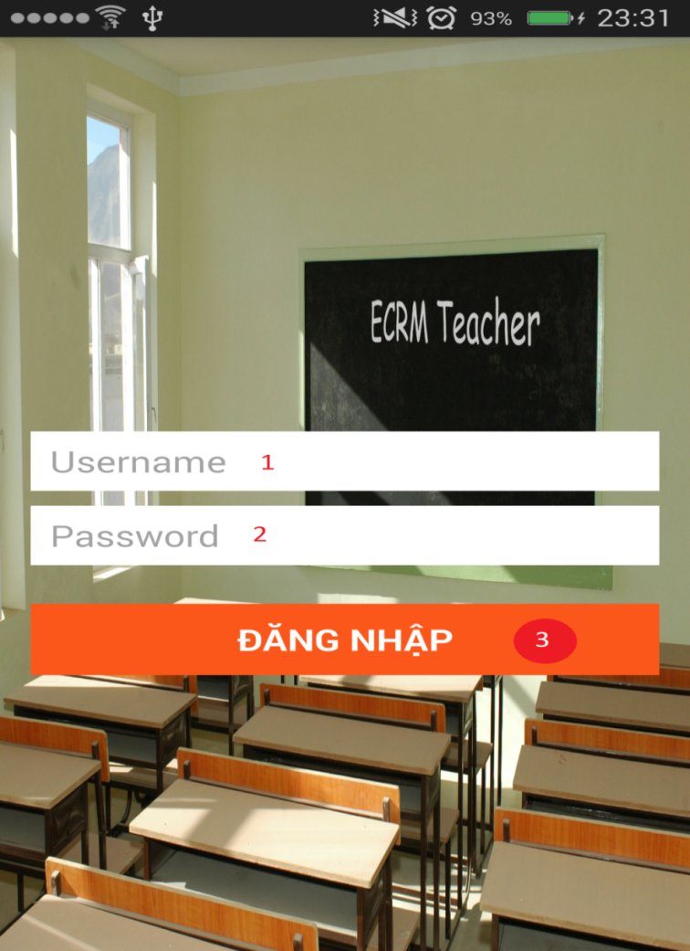

Figure : ECRM Teacher Login Screen

**Fields**

|  |  |  |  |  |  |  |  |
| --- | --- | --- | --- | --- | --- | --- | --- |
| No | Field Name | Description | Read only | Mandatory | Control Type | Data Type | Length |
| 1 | txtUsername | Username of account to login to application | No | No | Textbox | String | 0 - 35 |
| 2 | txtPassword | Password of account to login to application | No | No | Textbox | String | 0 - 35 |

Table : Login Screen – Fields

**Buttons**

|  |  |  |  |  |
| --- | --- | --- | --- | --- |
| No | Function | Description | Validation | Outcome |
| 3 | btnLogin | Login to application with username and password in textbox | No | Show list schedule of this account |

Table : Login Screen - Buttons

* + - 1. **Schedule Screen**



Figure : Schedule Screen

**Fields**

|  |  |  |  |  |  |  |  |
| --- | --- | --- | --- | --- | --- | --- | --- |
| No | Field Name | Description | Read only | Mandatory | Control Type | Data Type | Length |
| 1 | lblRoomName | Name of classroom | Yes | Yes | Label | String | 0 - 35 |
| 2 | lblTimeFrom | Time start of schedule | Yes | Yes | Label | String | 0 - 35 |
| 3 | lblTimeTo | Time end of schedule | Yes | Yes | Label | String | 0 - 35 |

Table : Schedule Screen - Fields

**Buttons**

|  |  |  |  |  |
| --- | --- | --- | --- | --- |
| No | Function | Description | Validation | Outcome |
| 4 | lstSchedule | Click to a row from list to create report in this classroom | N/A | Navigate to create report screen |

Table : Schedule Screen - Buttons

* + - 1. **Report Detail Screen**



Figure : Report Detail Screen

**Fields**

|  |  |  |  |  |  |  |  |
| --- | --- | --- | --- | --- | --- | --- | --- |
| No | Field Name | Description | Read only | Mandatory | Control Type | Data Type | Length |
| 1 | lblRoomName | Name of classroom | Yes | Yes | Label | String | 0 - 35 |
| 2 | lblTimeReport | Time create report | Yes | Yes | Label | String | 0 - 35 |
| 3 | lblDamageLevel | Damage level analyze by system | Yes | Yes | Label | String | 0 - 35 |
| 4 | lblUserSuggest | Suggest of teacher | Yes | Yes | Label | String | 0 – 35 |
| 5 | lblUserReport | Username of user create report | Yes | Yes | Label | String | 0 – 35 |
| 6 | lblSystemSuggest | Recommend of system | Yes | Yes | Label | String | 0 – 35 |
| 7 | lblEquipmentName | Name of damage equipment | Yes | Yes | Label | String | 0 – 50 |
| 8 | lblQuantity | Quantity of euquipment category | Yes | Yes | Label | String | 0 – 10 |
| 9 | lblDamage | Damage of equipment | Yes | Yes | Label | String | 0 – 50 |
| 10 | lblEvaluate | Evaluate equipment | Yes | Yes | Label | String | 0 – 50 |
| 11 | imgEquipment | Image of equipment | Yes | Yes | Image | Bitmap | N/A |

Table : Report Detail Screen - Fields

**Buttons**

|  |  |  |  |  |
| --- | --- | --- | --- | --- |
| No | Function | Description | Validation | Outcome |
| 12 | btnRemove | Click to remove report | N/A | Remove report from system |
| 13 | btnEdit | Click to edit report | N/A | Edit report and update to database |

Table : View Report History Screen - Buttons

* + - 1. **Create Report Screen**



Figure : Create Report Screen

**Fields**

|  |  |  |  |  |  |  |  |
| --- | --- | --- | --- | --- | --- | --- | --- |
| No | Field Name | Description | Read only | Mandatory | Control Type | Data Type | Length |
| 3 | imgEquipemt | Image thumbnail of equipment | Yes | Yes | Image | Image | N/A |
| 4 | lblEquipmentName | Name of equipment | Yes | Yes | Label | String | 0 - 35 |
| 5 | lblUserChoose | Check user has choose equipment | Yes | Yes | Label | String | 0 – 50 |
| 6 | lblTimeRemain | Time remain of equipment | Yes | Yes | Label | String | 0 – 10 |
| 7 | lblCompany | Company of equipment | Yes | Yes | Label | String | 0 - 50 |

Table : Create Report Screen - Fields

**Buttons**

|  |  |  |  |  |
| --- | --- | --- | --- | --- |
| No | Function | Description | Validation | Outcome |
| 1 | tabEquipment | Click to view equipment tab | N/A | Navigation screen to equipment tab |
| 2 | tabMap | Click to view map classroom | N/A | Navigation screen to map classroom tab |
| 8 | lstEquipment | Click to choose equipment to report | N/A | If user click show dialog to confirm damage, add equipment to report.  If user long click, change screen to multi select equipment. |

Table : Create Report Screen - Buttons

* + - 1. **Change Password Screen**
      2. **View Report History Screen**



Figure : View Report History Screen

**Fields**

|  |  |  |  |  |  |  |  |
| --- | --- | --- | --- | --- | --- | --- | --- |
| No | Field Name | Description | Read only | Mandatory | Control Type | Data Type | Length |
| 1 | lblRoomName | Classroom name | Yes | Yes | Label | Label | 0 – 10 |
| 2 | lblTimeReport | Time create report | Yes | Yes | Label | String | 0 - 35 |
| 3 | lblStatus | Status of report | Yes | Yes | Label | String | 0 – 50 |

Table : View Report History Screen – Fields

|  |  |  |  |  |
| --- | --- | --- | --- | --- |
| No | Function | Description | Validation | Outcome |
| 4 | lstReport | Click to view report detail | N/A | Navigate screen to view report detail screen |

Table : View Report History Screen - Buttons

* 1. **Database Design**
     1. **Entity Relationship Diagram**



Figure : Entity Relationship Diagram

* + 1. **Entity Dictionary**

|  |  |
| --- | --- |
| Data Dictionary | |
| Entity name | **Description** |
| Teacher | Abstract entity describes a user with role teacher in system. |
| Staff | Abstract entity describes a user with role staff in system. |
| UserNotification | Represent a notification sent for user. |
| Notification | Contain the notification information. |
| Message | Represent a message sent by teacher. |
| Schedule | Contain the schedule information. |
| ScheduleConfig | Contain the schedule configuration information |
| Classroom | Contain the classroom information. |
| RoomType | Contain the room type information. |
| EquipmentQuantity | Contain the equipment quantity information. |
| EquipmentCategory | Contain the equipment category information. |
| Equipment | Contain the equipment information. |
| ReportDetail | Contain the report detail information. |
| Report | Contain the report information. |

Table : Entity Dictionary

* 1. **Algorithms**
     1. **Notification**
        1. **Definition**

Notification is a feature of ECRM Application to notify teacher and staff when some important events occur.

* + - 1. **Notification methods**
* Show icon notification in web application
* Show notification using Google Cloud Message in mobile application
* Send SMS Message to user
  + - 1. **Notification use cases**

|  |  |  |  |  |
| --- | --- | --- | --- | --- |
| Type | Trigger | Receiver | Notify method | Close notify trigger |
| 1 | Teacher send report about damaged equipment | Staff | * Web * GCM * SMS (If damaged is critical) | * Mark as read * Touch to notification * Read SMS |
| 2 | System analyze room status and change room for teacher | All teacher in room | * Web * GCM * SMS | * Mark as read * Touch to notification * Read SMS |
| 3 | Staff change room manual | All teacher in room | * Web * GCM * SMS | * Mark as read * Touch to notification * Read SMS |
| 4 | Teacher create report offline | Server | * SMS | * System run job check SMS unread, resolve and mark as read. |
| 5 | System analyze time remain of equipment and count schedule remain | Staff | * SMS * GCM * Web | * Mark as read * Touch to notification * Read SMS |

Table : Notification Use Cases

* + 1. **System Scheduler Process**
       1. **Definition**

System scheduler is a main component of ECRM system. All the report will be checked by scheduler and give recommend for staff easy to make decision.

* + - 1. **Define Problems**

In web application:

* We need system schedule run every day at 06:00 and 12:00 to check status of room and change room if needed.
* We need system schedule run every day at 00:00 to check schedule in system.
* We need system schedule run every day at 07:00 to update equipment using time.
* We need system schedule run each 5 minutes to receive report from teacher and change room if needed.
  + - 1. **Solution**

We create schedule task by Spring Scheduler, it will run on the same server with web application and access to database server to check status, find available room to do change if need. It will run at specific time that administrator has defined.

The checking process is described as follow:

* + - 1. **Flow Chart**
    1. **Strategy for future plan**

1. **System Implementation & Test**
   1. **Introduction**
      1. **Overview**

This describes the approach and methodologies used by group to plan, organize and manage the testing of ECRM system. It provides in the detail all necessary information about the implementation and testing procedure of the system included test plans, test cases, test result, test environments, pass/fail criteria and risks estimations as well as a checklist to cover all possible cases.

* + 1. **Test Approach**
* Goal: Test all features in the whole ECRM system based on the core flow.
* Method: black-box testing
* Technique: check list

The testing for this project will consists of Integration System test level. Testing the program which was integrated and as a complete system to ensure that the software requirements have been met.

* Integration testing would be performed by all member of team and approved by team leader.
* System testing is focused on assessing the system’s reliability. This process is concerned with finding errors that result from unanticipated interactions between components and component interface problems.
  1. **Database Relationship Diagram**
     1. **Physical Diagram**

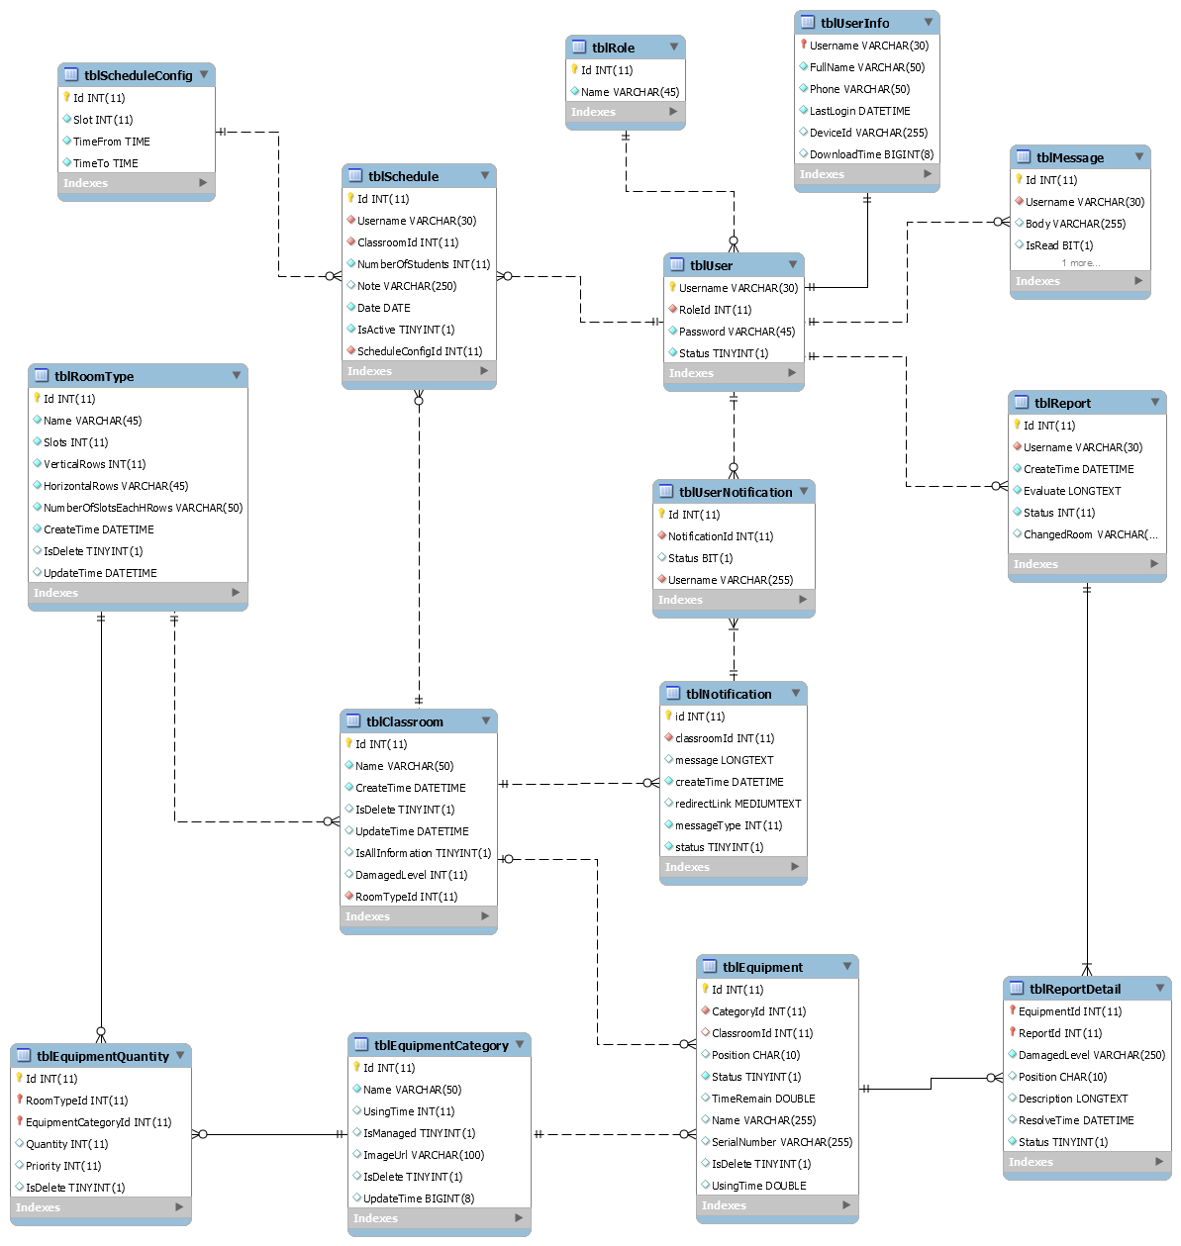

Figure : Physical Diagram

* + 1. **Data Dictionary**

|  |  |  |  |  |
| --- | --- | --- | --- | --- |
| Table Name | Attributes | Description | Domain | Null |
| tblUser | Username | Username to login system | VARCHAR(30) | No |
|  | Password | Password of account to login system | VARCHAR(45) | No |
|  | Status | Status of account | TINYINT(1) | No |
|  | RoleId | Role of account | INT(11) | No |
| tblRole | Id | Id of role | INT(11) | No |
|  | Name | Name of role | VARCHAR(45) | No |
| tblUserInfo | Username | Username of account | VARCHAR(30) | No |
|  | FullName | Fullname of account | VARCHAR(50) | No |
|  | Phone | Phone number of account | VARCHAR(50) | No |
|  | LastLogin | Last login of account to system | DATETIME | Yes |
|  | DeviceId | Device ID of account when using mobile application | VARCHAR(255) | Yes |
|  | DownloadTime | Last download time of user when using mobile application | BIGINT(8) | Yes |
| tblMessage | Id | Id of message | INT(11) | No |
|  | Body | Content of message | VARCHAR(255) | No |
|  | IsRead | Status of message | BIT(1) | No |
|  | Username | Username of user send message | VARCHAR (30) | No |
| tblReport | Id | Id of report | INT(11) | No |
|  | Username | Username of account create report | VARCHAR(30) | No |
|  | CreateTime | Time report has created | DATETIME | No |
|  | Evaluate | Evaluate of teacher about this report | LONGTEXT | No |
|  | Status | Status of report | INT(11) | No |
|  | ChangeRoom | Room number has changed | VARCHAR(45) | Yes |
| tblEquipmentCategory | Id | Id of equipment category | INT(11) | No |
|  | Name | Name of equipment category | VARCHAR(50) | No |
|  | UsingTime | Time using of equipment category | INT(11) | Yes |
|  | IsManaged | Check equipment has managed quantity or not | TINYINT(1) | No |
|  | ImageUrl | Link to image of equipment category | VARCHAR(100) | No |
|  | IsDelete | Check equipment is deleted or not | TINYINT(1) | No |
|  | UpdateTime | Time user update information of equipment category | BIGINT(8) | Yes |
| tblEquipment | Id | Id of equipment | INT(11) | No |
|  | CategoryId | Id of equipment category | INT(11) | No |
|  | ClassroomId | Id of classroom has equipment | INT(11) | No |
|  | Position | Position of equipment in classroom | CHAR(10) | No |
|  | Status | Status of equipment | TINYINT(1) | No |
|  | TimeRemain | Time remain of equipment | DOUBLE | No |
|  | Name | Name of equipment | VARCHAR(255) | No |
|  | SerialNumber | Serial Number of equipment | VARCHAR(255) | No |
|  | IsDelete | Check equipment has deleted or not | TINYINT(1) | No |
|  | UsingTime | Time using of equipment | DOUBLE | No |
| tblReportDetail | EquipmentId | Id of equipment has reported | INT(11) | No |
|  | ReportId | Id of report | INT(11) | No |
|  | DamagedLevel | Damage level of equipment | VARCHAR(250) | No |
|  | Position | Position of equipment in classroom | CHAR(10) | No |
|  | Description | Description of equipment | LONGTEXT | Yes |
|  | ResolveTime | Time resolve this equipment | DATETIME | Yes |
|  | Status | Status of this report detail | TINYINT(1) | No |
| tblUserNotification | Id | Id of user notification | INT(11) | No |
|  | NotificationId | Id of notification | INT(11) | No |
|  | Status | Status of notification | BIT(1) | No |
|  | Username | Username of account received this notification | VARCHAR(30) | No |
| tblNotification | Id | Id of notification | INT(11) | No |
|  | ClassroomId | Id of classroom | INT(11) | No |
|  | Message | Content of notification | LONGTEXT | No |
|  | CreateTime | Time notification has been created | DATETIME | No |
|  | RedirectLink | Link will redirect after user click to notification | MEDIUMTEXT | No |
|  | MessageType | Type of message | INT(11) | No |
|  | Status | Status of notification | TINYINT(1) | No |
| tblClassroom | Id | Id of classroom | INT(11) | No |
|  | RoomTypeId | Id of roomtype | INT(11) | No |
|  | Name | Name of classroom | VARCHAR(50) | No |
|  | CreateTime | Time create of classroom | DATETIME | No |
|  | IsDelete | Check classroom has been deleted | TINYINT(1) | No |
|  | UpdateTime | Time update classroom | DATETIME | No |
|  | IsAllInformation | Check classroom has full equipment | TINYINT(1) | No |
|  | DamageLevel | Damage level of classroom | INT(11) | No |
| tblSchedule | Id | Id of schedule | INT(11) | No |
|  | Username | User of schedule | VARCHAR(30) | No |
|  | ClassroomId | Classroom of schedule | INT(11) | No |
|  | NumberOfStudents | Number of student of classroom | INT(11) | No |
|  | Note | Note of schedule | VARCHAR(250) | Yes |
|  | TimeFrom | Time start schedule | TIME | No |
|  | Slots | Total slot of schedule | INT(11) | No |
|  | Date | Date of schedule | DATE | No |
|  | IsActive | Status of schedule | TINYINT(1) | No |
|  | ScheduleConfigId | Config of schedule | INT(11) | No |
| tblScheduleConfig | Id | Id of schedule config | INT(11) | No |
|  | Slot | Slot of schedule config | INT(11) | No |
|  | TimeFrom | Time start of schedule config | TIME | No |
|  | TimeTo | Time end of schedule config | TIME | No |
| tblRoomType | Id | Id of roomtype | INT(11) | No |
|  | Name | Name of roomtype | VARCHAR(100) | No |
|  | Slots | Number of slot of roomtype | INT(11) | No |
|  | VerticalRows |  | INT(11) | No |
|  | HorizontalRows |  | VARCHAR(50) | No |
|  | NoSlotEachHRows |  | VARCHAR(50) | No |
|  | CreateTime | Time create roomtype | DATETIME | No |
|  | IsDelete | Check roomtype has deleted or not | TINYINT(1) | No |
|  | UpdateTime | Time update roomtype | DATETIME | No |
| tblEquipmentQuantity | Id | Id of equipment quantity | INT(11) | No |
|  | RoomTypeId | Room Type Id | INT(11) | No |
|  | EquipmentCategoryId | Id of equipment category | INT(11) | No |
|  | Quantity | Quantity of equipment category in roomtype | INT(11) | No |
|  | Priority | Priority of equipment category | INT(11) | No |
|  | IsDelete | Check equipment category is delete or not | TINYINT(11) | No |

Table : Physical Diagram - Data Dictionary

* 1. **Performance Measures**
     1. **Web Application Page Load Speed**
        1. **Definition**

This section tests the general page load speed from all the page of the web application

* + - 1. **Test environment**

**Server:**

* Operating System: Ubuntu 14.04 Server 32 bit
* RAM: 512MB
* Storage: 40GB
* Network: 1Mbps
  + - 1. **Test cases**

Using browser from client side and request each page of web application. Record the page load time using Chrome Dev Tools at client side.

Test pages:

|  |  |
| --- | --- |
| Public | Login Page |
| User | Dashboard |
| Create Report |
| View History Report |
| Staff | Dashboard |
| Schedule Config   * Add new schedule config * Update schedule config * Remove schedule config |
| Schedule   * Search schedule by user in default time. * Search schedule by classroom in default time. * Search between time with all user and classroom * Search between time will specific user and classroom * Search between times with specific user in all classrooms. * Search between times with specific classroom with all users. * Import schedule excel file in 1 week of school (about 15KB) * Import manually 1 schedule |
| Statistic |
| Classroom   * Create new classroom * Remove classroom * Edit classroom * List all classroom * Search classroom by class name |
| Roomtype   * Create new roomtype * Remove roomtype * Edit roomtype * List all roomtype * Search roomtype by name |
| Equipment   * List all equipment * Create new equipment * Remove equipment |
|  | Report   * List all report * View report * Resolve report * Remove report |
| Admin | Account   * List all account * Activate/ Deactivate account * Create account * Edit account |

Table : Web Application Page Load - Test Pages

* + - 1. **Test result**

The test is run 10 times, in each time we go through all the pages listed above and log down the average page load time.

Figure : Web Application Page Load - Averange Page Load

|  |  |  |
| --- | --- | --- |
| Test No. | Average page load time (second) | Execute date |
| 1 | 1.85 | 25 July 2015 |
| 2 | 1.68 | 25 July 2015 |
| 3 | 2.94 | 25 July 2015 |
| 4 | 3.19 | 25 July 2015 |
| 5 | 2.63 | 25 July 2015 |
| 6 | 2.96 | 25 July 2015 |
| 7 | 2.48 | 25 July 2015 |
| 8 | 3.39 | 25 July 2015 |
| 9 | 2.73 | 25 July 2015 |
| 10 | 2.10 | 25 July 2015 |
|  | **Average: 2.59 (seconds)** |  |

Table : Web Application Page Load - Averange Page Load

* + 1. **Mobile Application API Load Speed**
       1. **Definition**

This section tests the load speed of mobile apps when connection to server through API

* + - 1. **Test environment**

**Server:**

* Operating System: Ubuntu 14.04 Server 32 bit
* RAM: 512MB
* Storage: 40GB
* Network: 1Mbps

**Client:**

|  |  |  |
| --- | --- | --- |
| Hardware Requirements | Minimum | Recommended |
| Internet Connection | 512Kbps | Wi-Fi Connection 12MB |
| Operating System | Android 4.0 | Android 4.0 |
| Memory | 128MB of RAM | 1GB of RAM or more |

* + - 1. **Test case**

Using mobile application to send the entire API request to web server.

List of APIs:

|  |  |  |
| --- | --- | --- |
| No. | API | Description |
| 1 | checkConnection | Check connection to server |
| 2 | login | Login to application |
| 3 | schedule | Get schedule of user |
| 4 | getEquipments | Get equipment of each classroom |
| 5 | createReport | Create new report |
| 6 | getCurrentTime | Get current time of server |
| 7 | getReportByUsername | Get report of user |
| 8 | remove | Remove report |
| 9 | editReport | Edit report |
| 10 | getReportStaff | Get all report of staff |
| 11 | getAvailableRoom | Get available room for change room function |
| 12 | changeRoom | Do change room function when needed |
| 13 | sendNotification | Send notification to user |
| 14 | sendSMS | Send SMS to user |
| 15 | map | Get map of classroom |
| 16 | getAllReport | Get all report |
| 17 | resolve | Resolve report |
| 18 | checkSchedule | Check classroom has user teacher after that slot. |
| 19 | getAllSchedule | Get all schedule of user in week |
| 20 | getClassroom | Get current status of classroom |
| 21 | getClassroomInFloor | Get all classroom of school. |

* + - 1. **Test result**

The test is run 10 times, each time we run all the test cases listed above and log down the average API response time.

|  |  |  |
| --- | --- | --- |
| Test No. | Average page load time (second) | Execute date |
| 1 | 3.04 | 25 July 2015 |
| 2 | 4.86 | 25 July 2015 |
| 3 | 3.78 | 25 July 2015 |
| 4 | 4.42 | 25 July 2015 |
| 5 | 4.45 | 25 July 2015 |
| 6 | 3.43 | 25 July 2015 |
| 7 | 4.05 | 25 July 2015 |
| 8 | 2.96 | 25 July 2015 |
| 9 | 4.13 | 25 July 2015 |
| 10 | 4.68 | 25 July 2015 |
|  | **Average: 3.98 (seconds)** |  |

* 1. **Test Plan**

The overall purpose of testing is to ensure ECRM system meets its entire technical, functional and business requirement. The purpose of this document is to describe the overall test plan and strategy for testing the ECRM system. The approach described in this document provides the framework for all testing related to this application. Individual test cases will be written for each version of the application that is released. This document will also be updated as required for each release.

* + 1. **Feature to be tested**
* Staff: View schedule, resolve report, remove report, change room, import file schedule, import schedule manual, create classroom, edit classroom, remove classroom, and create room type.
* User: Create report, edit report and remove report.
* Mobile Application: Create report, edit report, remove report, resolver report and change room.
* System: Automatically check damage and change room.
  + 1. **Feature no to be tested**
* Admin: Create account, update account, active/deactivate account.
* Staff: Create equipment, edit equipment, edit room type, and delete room type, configure schedule, statistic, search schedule.
* Login, logout, change profile
* View information: list room type, list classroom, list report.
  1. **System Testing Test Case**
     1. **Create Report**
        1. **Mobile Application**

|  |  |  |  |  |  |  |  |
| --- | --- | --- | --- | --- | --- | --- | --- |
| **ID** | **Test Case Description** | **Test Case Procedure** | **Expected output** | **Inter-test Case Dependence** | **Result** | **Test Date** | **Note** |
| CRM1 | User with role is teacher report some damaged equipmet in the classroom that he have schedule in, at the time before his schedule start. | * User login with account “HoangNT” on date: “21/07/2015” at time: “07:45 am”. * User choose classroom “113” with start time at “08:45 am”. | * After step 1, show list of classroom that user have schedule in. * After step 2, show message:”Bạn không thể báo cáo phòng này”. | N/A | Passed | 26/7/2015 |  |
| CRM2 | User with role is teacher report some damaged equipmet in the classroom that he have schedule in, at the time that schedule has already started for 5 minutes. | * User logins with account “HoangNT” on date: “21/07/2015” at time: “08:50 am”. * User chooses classroom “113” with start time at “08:45 am”. * User chooses “Máy lạnh” and “Máy chiếu” and then chooses “Tiếp tục”. * User chooses “Phải đổi phòng” and then chooses “Gửi báo cáo”. | * After step 1, show list of classroom that user have schedule in. * After step 2, show list equipment of classroom “113”. * After step 3, show evaluate damaged box. * After step 4, show message “Đã báo cáo thành công”. | N/A | Passed | 26/7/2015 |  |
| CRM3 | User with role is teacher report classroom that he have schedule in, at the time that schedule has already started for 5 minutes. But there are no euipment is choosen. | * User logins with account “HoangNT” on date: “21/07/2015” at time: “08:50 am”. * User chooses classroom “113” with start time at “08:45 am”. * User chooses “Tiếp tục”. | * After step 1, show list of classroom that user have schedule in. * After step 2, show list equipment of classroom “113”. * After step 3, show error message: “Bạn cần chọn 1 thiết bị trước khi báo cáo! ” | N/A | Passed | 26/7/2015 |  |
| CRM4 | User with role is teacher report some damaged equipmet in the classroom that he have schedule in, with no internet access. | * User logins with account “HoangNT” on date: “21/07/2015” at time: “08:50 am”. * User chooses classroom “113” with start time at “08:45 am”. * User chooses “Máy lạnh” and “Máy chiếu” and then chooses “Tiếp tục”. * User chooses “Phảiđổi phòng” and then chooses “Gửi báo cáo”. | * After step 1, show list of classroom that user have schedule in. * After step 2, show list equipment of classroom “113”. * After step 3, show evaluate damaged box. * After step 4, System wil evaluate damaged level of classroom “113” , if it’s more than 50%, show confirm message box “Hệ thống đánh giá phòng hư hại năng! Bạn có muốn gửi tin nhắn đến nhân viên? Việc này sẽ gây tốn phí!”. Otherwise, show message: “Gửi báo cáo thành công!”. | N/A | Passed | 26/7/2015 |  |

* + - 1. **Web Application**

|  |  |  |  |  |  |  |  |
| --- | --- | --- | --- | --- | --- | --- | --- |
| **ID** | **Test Case Description** | **Test Case Procedure** | **Expected output** | **Inter-test Case Dependence** | **Result** | **Test Date** | **Note** |
| CRM1 | User with role is teacher report some damaged equipmet in the classroom that he have schedule in, at the time before his schedule start. | 1. User login with account “HoangNT” on date: “21/07/2015” at time: “07:45 am”. 2. User clicks on button “Gửi báo cáo” | 1. After step 2, show message: “Hiện tại bạn không có lịch dạy”. | N/A | Passed | 26/7/2015 |  |
| CRM2 | User with role is teacher report some damaged equipmet in the classroom that he have schedule in, at the time that schedule has already started for 5 minutes. | 1. User logins with account “HoangNT” on date: “21/07/2015” at time: “08:50 am”. 2. User clicks on button “Gửi báo cáo” 3. User chooses classroom “113”. 4. User clicks on “Máy lạnh” and “Máy chiếu” and then clicks on “Gửi báo cáo”. | 1. After step 2, show list of classroom that user have schedule in. 2. After step 3, show list equipment of classroom “113”. 3. After step 4, show message: “Báo cáo đã gửi thành công!”. | N/A | Passed | 26/7/2015 |  |
| CRM3 | User with role is teacher report in the classroom that he have schedule in, at the time that schedule has already started for 5 minutes. But there are no euipment is choosen. | 1. User logins with account “HoangNT” on date: “21/07/2015” at time: “08:50 am”. 2. User clicks on button “Gửi báo cáo” 3. User chooses classroom “113”. 4. User clicks on “Gửi báo cáo”. | 1. After step 2, show list of classroom that user have schedule in. 2. After step 3, show list equipment of classroom “113”. 3. After step 4, show message: “Bạn cần chọn 1 thiết bị trước khi báo cáo! ”. | N/A | Passed | 26/7/2015 |  |

1. **Software User’s Manual**
   1. **Installation Guide**
      1. **Setting up environment at server side**

The following software must be installed into the server machine:

* + - 1. **Hardware requirement**

Personal computers for developing with the minimum configuration:

* Processor: Minimum Core 2 Duo 2.0GHz
* Memory: Minimum 1GB RAM
* Available Disk Space: Minimum 30GB hard disk
* Internet: Minimum speed 10Mbps
  + - 1. **Software requirement**
* Web Server: Apache Tomcat 7.0.55 with JRE 7
* OS: Microsoft Windows Server 2008
* MySQL Server 5.5
  + 1. **Deployment at server side**
       1. **Setup environment variable**

Please go following path: Click **Properties** of **Computer**, then click **Advanced System Setting**, in “**Advanced**” tab select **Environment** **variables**.



* Add variable **JRE_HOME**: Directory path of Java Runtime Environment.



* + - 1. **Prepare deployment package**

Copy the deployment package (**WAR** file) to a folder on the Tomcat server.



Figure : Copy file to Tomcat Server

* + - 1. **Configure Server before deploy**
* Open MySQL Workbench, connect to server
* Create new schema with name “ECRM”



Figure : Create Schema

* Select **Management** tab and choose **Data Import/Restore**



* Choose **Import From Self-Contained File** and enter path to “**ECRM_DATA.sql**”
* Choose **Default Target Schema** is **ECRM**
* Press **Start Import**



* + - 1. **Deploy web application at server**
* Copy the deployment package **ECRM.war** to a folder **webapps** in the directory of Tomcat server. Ex: C:\apache-tomcat-7.0.55\webapps



* Navigate to folder **bin** in the directory of Tomcat server. Then click **startup.bat** file to start the server and wait for server startup.



* + 1. **Setting up environment at client side**
       1. **Setting up for computer**

The client devices need to have one of the following browsers to access the website: Firefox (v30 or above), Google Chrome (v14 or above) browser… enables JavaScript.

* + - 1. **Setting up for Android device**

Change setting to install unknown source **apk files**. To do this, go to **Setting/Security**, tick check box **Unknown sources**.

Copy installation source into device external memory: **ECRM Teacher.apk** or **ECRM Staff.apk**

Open Android file explorer, navigate to external memory directory. Click on file to install.

* 1. **User Guide**